Telusko: Advance Java 02

Servlet

098 Servlet Intro

Different types of application built using java
====================================
a. Standalone applications(JSE)
1. CUI applications
2. GUI applications
b. Enterprise applications(JEE and frameworks)
1. Web applications
2. Distrubuted applications
Difference b/w Web applications vs Distrubuted applications?
webapplication
============
webapplication is a server side application, it will be designed without
distrubuting application logic over multiple jvm.
To build webapplication we need to use technologies like CGI,Servlet,JSP and so
on...
The main purpose of webapplication is to generate dynamic response from server
machine.
webapplication provides services to webclients only(using the browser we need to
send the request)
eg: BMS(webapp) -------> to send the request to this application u need
browser + internet
mobile based apps(internet)
Webapplication => client to server model
In case of webapplications to execute the program we need "webservers".
Distrubuted application
===================
Distrubutedapplication is a server side application, it will be designed by
distrubuting application logic over multiple jvm.
To build distrubuted application we need to use technolgies like RMI(remote method
invocation), EJB's, WebServices,.....
The main purpose of distrubuted application is to establish the communication b/w
local machine and remote machine
to access the remote services.
Distrubuted applications will provide service to any type of clients.
Distrubutedapplication => buisness to buisness model.
In case of distrubutedapplications to execute the program we need "application
servers".
webapplication
=============
The application which is developed only using web based technologies like
html,css,javascript,servlet,jsp etc is
called "webapplication"
application ===> collection of many programs
webserver
========
if we want webapplications to execute, we need one special software that special
software only we call it as "webserver".
webserve provides environment to run webapplications
eg: tomcat,resin,jetty,glassfish,jboss,oracleweblogic server,.....
Deployment and UnDeployment===========================
The process of placing the webapplication inside webserver is called "Deployment".
The process of removing webapplication from the webserver is called
"UnDeployment".
webclient
========
To send the request from the user we need to have special software installed in
the client machine.
The special software is only called as "browser".
eg: mozilla,chrome,safari,........
web programming for static response
===============================
static response
The response which won't be changed from person to person and time to time,
such type of response is called as
"static response".
eg: login page of gmail
home page of icici bank
dynamic response
The response which is varied from person to person and time to time, such
type of response is called as
"dynamic response".
eg: inbox page of gmail
balance information of icici bank.
Flow diagram of static response
==========================
1. client send the request for static files to the server
2. Server searches wheter the requested resource(html file) is available or not.
3. If the request resource(html file) is available then server will provide that
file as response.
4. If the requested resource(html file)is not available then we will get 404 status
code saying reqeusted resource not available.
Note: To server static files, no processing is required at the server side, hence
webserver always loves to serve static files.
web programming for dynamic response
==================================
1. client sends the request for webserver
2. webserver will check whether the request is for static resource or dynamic
resource(based on url)
3. if it is a static resource, then webserver only will search for static
resource,if it is available server will provide the static file
contents(copy and paste) as the response the client.
if it is not available, then 404 status code will be sent as the response to the
client saying the requested resource is not
available.
4. if the requested resource is for dynamic information, then webserver will
forward the request to webcontainer.
5. webcontainer will search for the helper application, which needs to be
executed.
6. if it is not available, then 404 status code will be sent as the response to
the client saying the requested resource is notavailable.
6. if it is available, then the requested helper application will be executed and
it will be sent as the response to the webserver
and webserver inturns will send as the response to the end user.
7. During the execution if any problem occurs then it would reuslt in exception
and status code 500 would be sent as a
response to the end user by the server.
Note: To generate the dynamic response at the server side we need some helper
applications. To build these applications
which are capable of generating dynamic response we need to learn
technologies like
a. CGI
b. Servlet
c. JSP
To design a webapplication, we already have CGI then what is the need to go for
Servlet?
CGI => it stands for Common Gateway Interface.
CGI is a server side webtechnology which is built on top of 'c' language, c
language is a process based language, which inturn
make CGI as "process based technology".
if we deploy any CGI application,then container will create a seperate process for
every request.
Process is heavy weight component, to handle single process system has to consume a
lot of memory and execution time.
Due to the above reason, more the request comes server would be getting a burden of
creating a process which inturn reduce
the system performance and increase the response time for the client.
To reduce the burden on server and to increase the performance we need to use
server side technology called "Servlet".
Servlet is a server side technology which is built on top on "Java language".
Java language is Thread based technology.
if we deploy a Servlet application at the server side then for every request
servlet container will generate a seperate thread
on the respecitve Servlet Object.
In the above context, if we increase the no of requests container will create a
separte thread instead of process.
When compared to process,threads are light weight,since it is light weight, server
would not be burdened.
server would provide quick response for client requests which increase the
peformance of the application.
To design a webapplication, we already have Servlet then what is the need to go for
JSP?
Servlet
1. To build web applications using Servlet, we need to have knowledge of Java
properly.
2. Servlet is mainly meant for Processing logic(pick the request and process
the request).
3. Any modification done in the Servlet, then we need to perform compilation
and reloading on the server explicitly.
4. If we build webapps using MVC design pattern, then Servlet will placed
inside Controller logic.
5. In case of Servlet, we are unable to seperate both presentation logic and
buisness logic.JSP
1. To build web applications using JSP, it is not required to have any java
knowledge only presentation skills are enough.
2. JSP is mainly meant for providing dynamic response to the client with good
look and feel (only presentation).
3. Any modification done in the JSP, then it is not required to do compilation
and reloading becoz jsp pages are
"Autocompiled".
4. If we build webapps using MVC design pattern, then JSP will placed inside
View logic.
5. In case of JSP, there will be a clear cut seperation b/w presentation logic
and buisness logic becoz presentation logic
deals with html tags and buisness logic deals with "JSP tags".
Architecture of webserver(tomcat)
=============================
Tomcat(https://tomcat.apache.org/download-90.cgi)
1. It is webserver provided by apache foundation.
2. Every webserver will have webcontainer
a. webcontainer is responsible to manage and execute servlet and jsps.
3. Internally webcontainer consists of 2 components
a. catalina container(servlet container)
b. jasper container(jsp container)
4. ServletContainer
It is also known as ServletEngine.
It is responsible for managing and executing servlet components.
Tomcat servlet container name is "CATALINA".
5. JSP container
It is also known as JSP Engine
It is responsible for managing and exeucting jsp componenets
Tomcat jsp container name is "JASPER".
Note:
click on it.
below
start the tomcat server by opening bin folder and select tomcat9.exe and double
now send the request by opening browser of ur choice and hit the request as shown
http://localhost:9999/
Servlet
======
It is an API which helps the programmer to build webapplications.
ServletAPI provides 2 packages
a. javax.servlet.*
b. javax.servlet.http.*
javax.servlet.*
===========
1. Servlet(I)
2. GenericServlet(AC)
3. ServletConfig(I)
4. ServletContext(I)
5. RequestDispatcher(I)
6. ServletRequest(I)
7. ServletResponse(I)javax.servlet.http.*
===============
1. HttpServletReqeust(I)
2. HttpServletResponse(I)
3. HttpSession
4. HttpServlet(AC)
Note:
Compiled from "Servlet.java"
public interface javax.servlet.Servlet {
public abstract void init(javax.servlet.ServletConfig) throws
javax.servlet.ServletException;
public abstract javax.servlet.ServletConfig getServletConfig();
public abstract void service(javax.servlet.ServletRequest,
javax.servlet.ServletResponse) throws javax.servlet.ServletException,
java.io.IOException;
public abstract java.lang.String getServletInfo();
public abstract void destroy();
}
C:\Users\nitin>javap javax.servlet.GenericServlet
Compiled from "GenericServlet.java"
public abstract class javax.servlet.GenericServlet implements
javax.servlet.Servlet,javax.servlet.ServletConfig,java.io.Serializable {
public javax.servlet.GenericServlet();
public void destroy();
public java.lang.String getInitParameter(java.lang.String);
public java.util.Enumeration<java.lang.String> getInitParameterNames();
public javax.servlet.ServletConfig getServletConfig();
public javax.servlet.ServletContext getServletContext();
public java.lang.String getServletInfo();
public void init(javax.servlet.ServletConfig) throws
javax.servlet.ServletException;
public void init() throws javax.servlet.ServletException;
public void log(java.lang.String);
public void log(java.lang.String, java.lang.Throwable);
public abstract void service(javax.servlet.ServletRequest,
javax.servlet.ServletResponse) throws javax.servlet.ServletException,
java.io.IOException;
public java.lang.String getServletName();
}
C:\Users\nitin>javap javax.servlet.http.HttpServlet
Compiled from "HttpServlet.java"
public abstract class javax.servlet.http.HttpServlet extends
javax.servlet.GenericServlet {
public javax.servlet.http.HttpServlet();
protected void doGet(javax.servlet.http.HttpServletRequest,
javax.servlet.http.HttpServletResponse) throws javax.servlet.ServletException,
java.io.IOException;
protected long getLastModified(javax.servlet.http.HttpServletRequest);
protected void doHead(javax.servlet.http.HttpServletRequest,
javax.servlet.http.HttpServletResponse) throws javax.servlet.ServletException,
java.io.IOException;
protected void doPost(javax.servlet.http.HttpServletRequest,
javax.servlet.http.HttpServletResponse) throws javax.servlet.ServletException,
java.io.IOException;
protected void doPut(javax.servlet.http.HttpServletRequest,javax.servlet.http.HttpServletResponse) throws javax.servlet.ServletException,
java.io.IOException;
protected void doDelete(javax.servlet.http.HttpServletRequest,
javax.servlet.http.HttpServletResponse) throws javax.servlet.ServletException,
java.io.IOException;
protected void doOptions(javax.servlet.http.HttpServletRequest,
javax.servlet.http.HttpServletResponse) throws javax.servlet.ServletException,
java.io.IOException;
protected void doTrace(javax.servlet.http.HttpServletRequest,
javax.servlet.http.HttpServletResponse) throws javax.servlet.ServletException,
java.io.IOException;
protected void service(javax.servlet.http.HttpServletRequest,
javax.servlet.http.HttpServletResponse) throws javax.servlet.ServletException,
java.io.IOException;
public void service(javax.servlet.ServletRequest, javax.servlet.ServletResponse)
throws javax.servlet.ServletException, java.io.IOException;
static {};
}
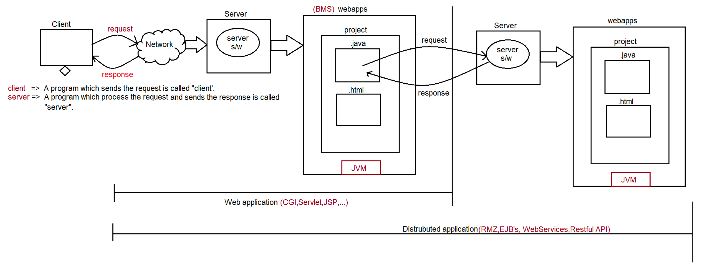
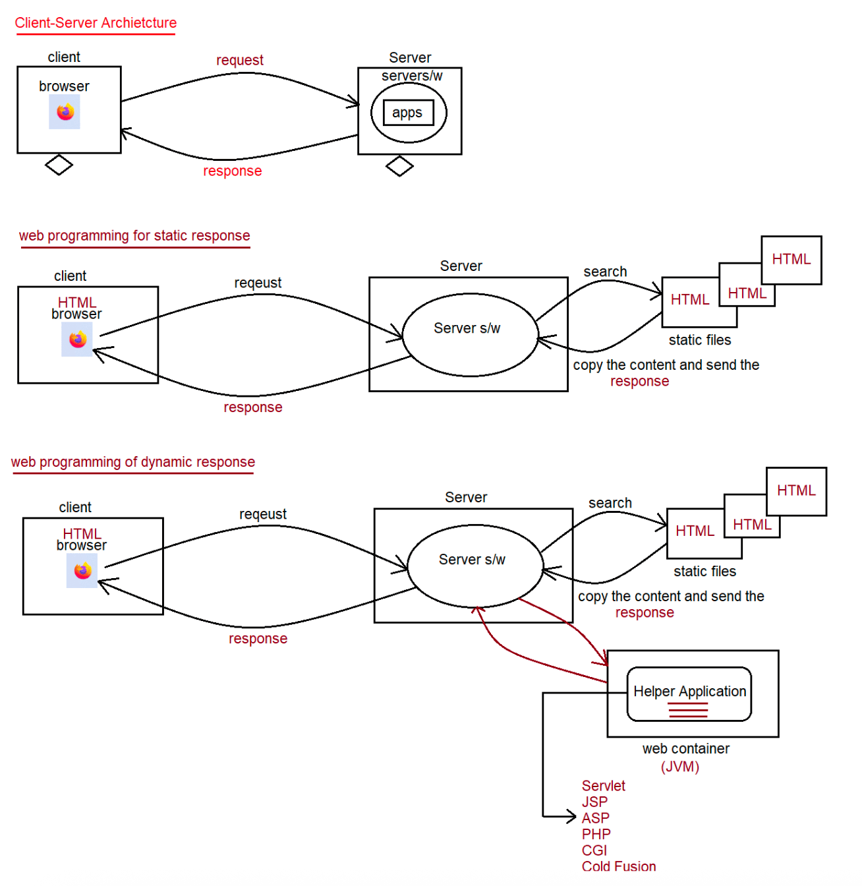
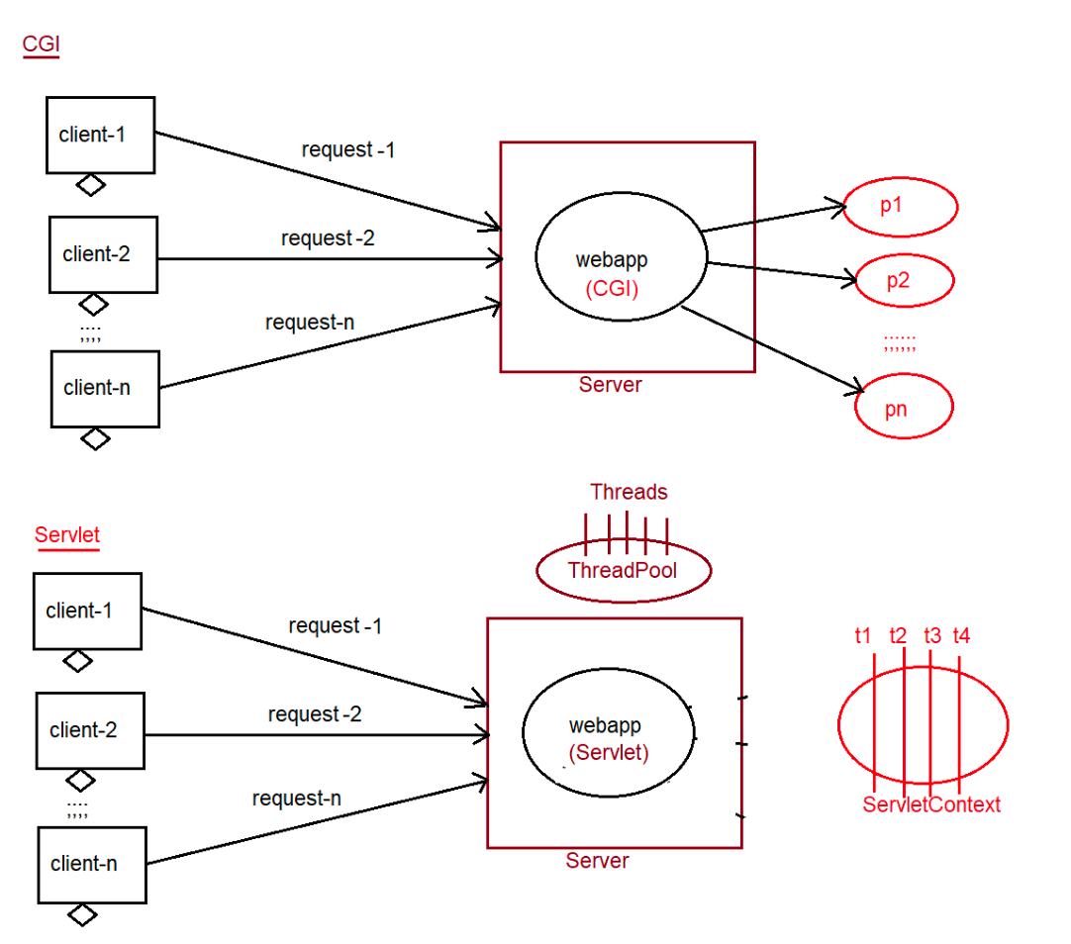
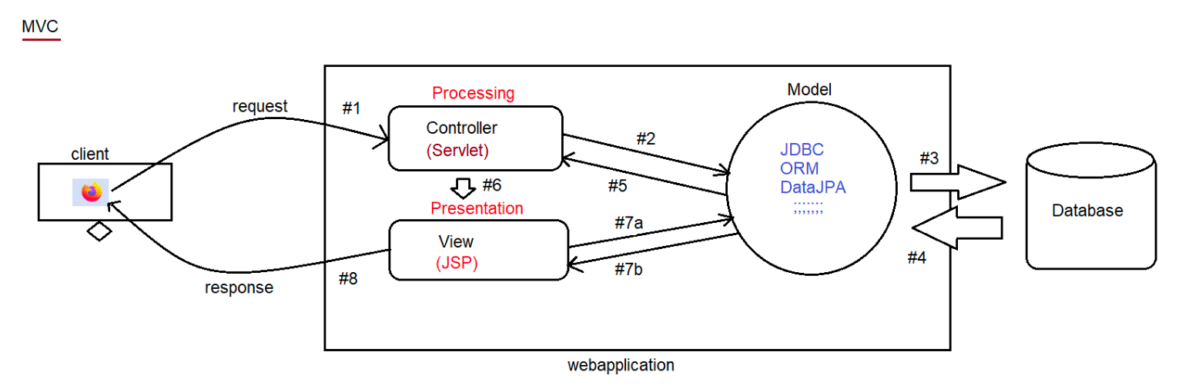
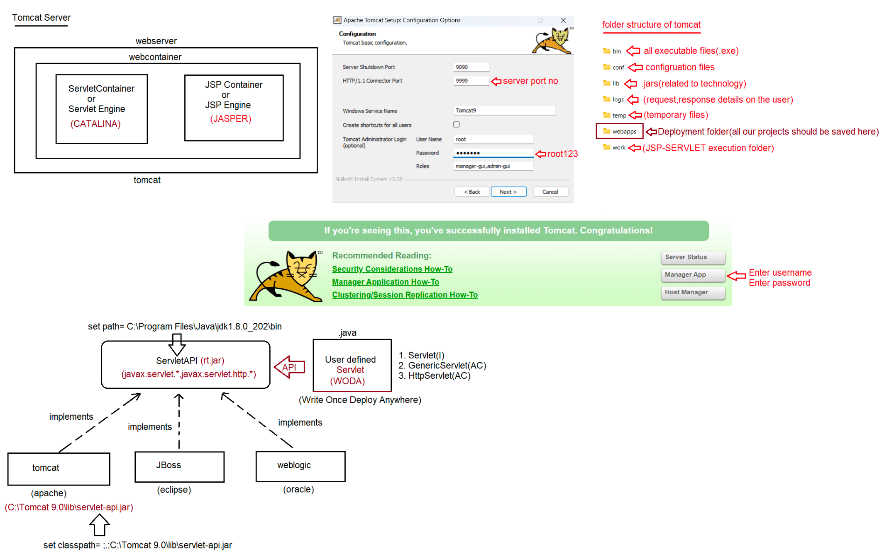

099 HTTPRequest and HTTResponse structure
BIG-7 methods
============
What is the difference b/w GET and POST request type?
GET
if we want to get some information from the server then we need to for GET
request.
eg:fetching the train ticket details by supllying source and
destination information.
usually get request are read only request and at the server side update
operation won't be performed.
In case of GET request,end user provided information will be attached to the
url in the form of "QueryString"
eg: http://localhost:9999/App-01/test ?
source=bengaluru&destination=shivamoghaa
In case of GET request,end user data is available inside url as query string,
it is less secured.
In case of GET request,since the data is attached in the url as querystring,
only small volume of data can be sent.
Bookmarking and caching is supported in case of GET request.
POST
we use POST request to send huge amount of data to the server.
eg: uploading resume
usally post request are write only request and at the server side
update/insert operation would be performed.
In case of POST request,end user provided information will be not be
attached to the url in the form of "QueryString"
eg: http://localhost:9999/App-01/test
In case of POST request,end user data is not available inside url as query
string, so it is more secured.
In case of POST request,since the data is not attached in the url as
querystring, large volume of data can be sent.4
Bookmarking and caching is not supported in case of POST request.
Note: What is idempotent request?
By repeating the request multiple times, if there is no change in the
response then such type of request we call
as "idempotent" request.
eg: GET request is idempotent request,but POST is not
Idempotent.
What is safe request?
By repeating the request multiple times,if there is no side effect at
the server side then such type of request we call
as "safe" request.
eg:GET request is safe request,but POST is not safe
request.
How to send GET request?
1. Type the address in the url bar and hit enter key(request is sent)
2. clicking the hyperlink.(<a href=" ">CLICK HERE</a>)
3. submit the form with method attribute as "GET".
<form method ="GET">
<!--- -->
</form>
4. submit the form without method attribute(default is GET only)<form>
<!--- -->
</form>
How to send POST request?
1. submit the form with method attribute as "POST".
eg: <form method ="POST">
<!--- -->
</form>
Note:
When we send the request,automatically the HTTPProtocol create the HTTPRequest
Object.
The relevant information will be assigned in the respective sections of
HTTPRequest object.
This HTTPRequest object will be taken by HTTP Protocol and it will send it to
the respective Server.
Upon sending the response, automatically the HTTPProtocol will create
HTTPResponse Object.
The relevant information will be assigned in the respective sections of
HTTPResponse Object.
This HTTPResponse object will be taken by HTTPProtocol to the browser and
browser uses this information for
displaying the output.
To build webaplication we need to follow standard directory structure given by
Server vendor
=============================================================================
ProjectName
|=> WEB-INF
|=> web.xml(deployment descriptor)
|=> classes
|=> .class
|=> lib
|=> *.jar
|=> src/main/java
|=> .java
|=> pages
|=> .jsp
How to create Servlet in Java?
To create Servlet in java there are 3 approaches
a. Servlet(I)
b. GenericServlet(AC)
c. HttpServlet(AC)
Servlet(I)
public interface Servlet {
public abstract void init(ServletConfig config) throws ServletException;
public abstract ServletConfig getServletConfig();
public abstract void service(ServletRequest request,ServletResponse response)
throws ServletException, IOException;
public abstract String getServletInfo();
public abstract void destroy();
}Whenever we write Servlet,Automatically for the written servlet container will
perform the following actions
1. Depending on the url pattern supplied by the user for a dynamic resource
a. Servlet Loading will happen ===========>static block will be
executed.
b. Servlet Instantiation will happen=======>constructor will be
called and object will be created.
c. Servlet Initialization will happen =======>void
init(ServletConfig config) throws ServletException
d. Serlvet Request Processing will happen==>void
service(ServletRequest request,ServletResponse response)
throws ServletException,IOException
e. Servlet De-Instantiation will happen ====>void destroy();
eg#1.
import java.io.*;
import javax.servlet.*;
public class FirstServlet implements Servlet
{
static
{
System.out.println("FirstServlet.class file is loading...");
}
{
public FirstServlet()
System.out.println("FirstServlet Object is instantiated...");
}
//For Servlet Initialization container calls this method
public void init(ServletConfig config) throws ServletException
{
System.out.println("Servlet initialziation...");
}
public ServletConfig getServletConfig()
{
return null;
}
//Request Processing logic
public void service(ServletRequest request,ServletResponse response)
throws ServletException, IOException
{
System.out.println("Servlet Request Processing ...");
}
public String getServletInfo()
{
return null;
}
//Servlet DeInstantion logic
public void destroy()
{
System.out.println("Servlet De-Instantiation...");
}
}
2.After creating a Servlet, for every servlet url-pattern matching should be provided
and it should be informed to the
container via XMl,Annoation.
XML
====
<web-app>
<servlet>
<servlet-name>DemoServlet</servlet-name>
<servlet-class>FirstServlet</servlet-class>
</servlet>
<servlet-mapping>
<servlet-name>DemoServlet</servlet-name>
<url-pattern>/test</url-pattern>
</servlet-mapping>
</web-app>
3. Before compilation set path and classpath environmental variable.
set path= C:\programfiles\jdk1.8\bin
set classpath=;.;C:\Tomcat 9.0\lib\servlet-api.jar
After compilation of FirstServlet.java copy the .class file to classes folder
present under WEB-INF/classes.
4. Now start the server by going to tomcat9.0/bin/tomcat9.exe file
5. Now send the request by typing the url as shown below
http://localhost:9999/FirstApp/test

100 Creation of servlet using annotation

Standard folder structure of webapps to deploy in tomcat server
====================================================
webapps(deployment folder)
|
SecondApp
|=> WEB-INF
|=> src/main/java
|=> web.xml(deployment descriptor)
|=> classes
|=> *.class
|=> .java
Any Servlet will be executed by the container with its life cycle actions
a. Loading
b. Instantiation
c. Initialization
d. RequestProcessing phase
e. De-Instantiation
What is the meaning of webapps(deployment folder)?
Once we start the server,server would automatically go to webapp's folder and scans
all the project present inside
that folder and deploys the project in the execution area.(meaning ready for
providing the service)
Since it scans for all the projects, we say webapp's folder as "Deployment folder".
Once the Tomcat engine loads all the project into execution area,It will create
sepearte object for every project
called "ServletContext" object.
Tomcat engine also scans web.xml file given by the user w.r.t every project.
It read the url-pattern for all the dynamic resource for future usage.
How to send the request to any application?
using the url pattern
eg:
http://localhost:9999/[NameOfTheApplication/ContextRoot]/[url_pattern of the
resource]
Assume the request is sent for a particular url_pattern, then what actions will be
taken care by tomcat engine?
eg: http://localhost:9999/SecondApp/demo
Step1: Browser will send the request with the follwing url pattern
http://localhost:9999/SecondApp/demo
Step2: HttpProtocol will create a HttpRequest object depending upon the
Request_TYPE to carry the request
data from client to server.
Step3: Once the Protocol hands over the HttpRequest Object to the tomcat server,
server will pick up the
RequestLine from the HttpRequestObject and take only
ContextName/urlpattern for furthe processing.
Step4: Depending upon the dynamic resource identified by urlpattern,tomcat engine
will hand over the control
to container for execution.
Container will scan for web.xml file and identifies for a particular
url_pattern which servlet should beexecuted,based on that the servlet will be executed by the container.
Step5: As per the container life cycle actions, the requested urlpattern servlet
will be executed.
1. Servlet Loading(.class file loading)
Class c = Class.forName("SecondServlet");
2. Servlet Instantiation(for loaded class create an Object)
SecondServlet
obj=(SecondServlet)c.newInstance();
3. Servlet Initalization(for the created object inject the
required values)
obj.init(ServletConfig config);
4. Request Processing phase(for client request this method will
obj.service(ServletRequest
be called)
request,ServletResponse response);
Note:
To get the inputs supplied by the user to the Servlet, we need to use
"ServletRequest" Object.
To write the output from the application to the browser, we need to use
"ServletResponse" Object.
Inside the ServletResponse object we have empty "PrintWriter" object,using
which we need to write the
Output to browser window.
If we use System.out.println() in the request processing logic, then output
will be available on the console of
the tomcat engine.
5. Once the server is stopped(undeployment)/for the same resource if
the request wont' come for some
period of time automatically container will execute "De-
Instantiation" event.
obj.destroy()
Before sending the request, we need to keep the compiled code in WEB-INF/classes
folder
C:\Tomcat 9.0\webapps\SecondApp>set path=C:\Program Files\Java\jdk1.8.0_202\bin
C:\Tomcat 9.0\webapps\SecondApp>set classpath=C:\Tomcat 9.0\lib\servlet-api.jar
C:\Tomcat 9.0\webapps\SecondApp>javac SecondServlet.java
Once the compiled code available then , we need to start a. c:\tomcat9.0\bin\tomcat9.exe
the server
Output For First Request
===================
SecondServlet .class file is loading...
SecondServlet Object is instantiated...
Servlet initialziation...
Servlet Request Processing ...
Output for Second Request
======================
Servlet Request Processing ...
As we noticed above, the processing time for second request is less when compared
to first request becoz only
requestprocessing logic is executed.How to maintain the uniformity of response time for all the request?
Ans.To uniform response time for all the request we need to configure the
tomcat engine.
Tomcat engine can be configured in 2 ways
a. XML(<load-on-startup>any+ve number<load-on-startup>)
b. Annotation
To maintain the uniform response time we need to use <load-on-startup> tag.
<web-app>
<servlet>
<servlet-name>DemoServlet</servlet-name>
<servlet-class>SecondServlet</servlet-class>
<load-on-startup>10</load-on-startup>
</servlet>
<servlet-mapping>
<servlet-name>DemoServlet</servlet-name>
<url-pattern>/demo</url-pattern>
</servlet-mapping>
</web-app>
At the time of Server startup
=======================
SecondServlet .class file is loading...
SecondServlet Object is instantiated...
Servlet initialziation...
Output for Firstrequest
==================
Servlet Request Processing ...
Output for Second Request
======================
Servlet Request Processing ...
Servlet Code w.r.t Annoatation
=========================
Use the following annotations on the top of Servlet class as shown below.
@WebServlet(urlPatterns="/test",loadOnStartup = 10)
Limitation of implementing Servlet interface
====================================
If we create a servlet using Servlet(I), then it is mandatory for us to give the
implementation for all the methods
of the interface whether it is required or not.
Becoz of this length of the code would increase and it decreases the readability.
To Overcome this problem we need to use "GenericServlet".
GenericServlet has already implemented Servlet Interface and it gives body for all
the methods of Servlet interface
except service().
if we use GenericServlet to create a Servlet, then we need to give body only for
service() as a result of which the
lines of code would be less, which increase the readablity of the application.
Compiled from "GenericServlet.java"public abstract class GenericServlet implements Servlet,ServletConfig,Serializable
{
public GenericServlet();
public void init(ServletConfig config) throws ServletException;
public void destroy();
public ServletConfig getServletConfig();
public ServletContext getServletContext();
public String getServletInfo();
public void init() throws javax.servlet.ServletException;
public abstract void service(ServletRequest req, ServletResponse resp) throws
ServletException,IOException;
public java.lang.String getServletName();
}
Note:
GenericSevlet is an best example for "Adapter class design pattern".
init() is overloaded in GenericServlet.
Note:
By default response type/content type is "text/html".
Code to demonstrate the creation of Servlet using GenericServlet
=====================================================
import java.io.*;
import javax.servlet.*;
import javax.servlet.annotation.*;
@WebServlet(urlPatterns="/disp")
public class FourthServlet extends GenericServlet
{
public void service(ServletRequest request, ServletResponse response) throws
ServletException,IOException
{
PrintWriter out = response.getWriter();
out.println("<h1 style='color:blue;'>Writing Servlet using
Generic Servlet is easy....</h1>");
out.close();
}
}
Behind the scenes
===============
In the above code 2 .class files will be used
a. FourthServlet.class
b. GenericServlet.class
=> Loading :: Container will load FourthServlet.class file for the url pattern
("/disp")
=> Instantiation :: Container will create an Object for FourthServlet.class
=> Initialization :: Container will call init(),First it will check in
FourthServlet.class if not, it would check in GenericServlet.
init() is available inside GenericServlet but it has 2
methods with the name
init(SC config)
init()
container will call init(SC config) which internally
makes a call to init().Can we override the init logic?
We can override, but it is a good practise to override only init(),but not
init(SC config) becoz config is local variable
in init(SC config),and the config variable memory would be gone once the
control comes out of the init(SC config)
so better override init() but not init(SC config).
Code in GenericServlet
===================
public abstract class GenericServlet implements Servlet,ServletConfig,Serializable
{
private transient SC config;
public void init(SC config)throws SE
{
this.config=config;
init();
}
{
public void init() throws SE
;;;;;;
}
;;;;;;;;
}
=> RequestProcessing phase :: Container will call service(req,resp) to provide
response to the client.
FourthServlet.class if not, it would check in GenericServlet.
GenericServlet as abstract and we need to give the body
First it will check in
service(req,resp) is available inside
of this method inside FourthServlet
as shown in the above program.
=> ServletDeInstantion=> Contianer will call destroy() to perform De-Instantion
action.
First it will check in FourthServlet.class
if not, it would check in GenericServlet.
destroy() is not avaialble in
FourtServlet.class,so it would take from GenericServlet.class and it
will execute.
Note:
1. If our servlet class does not contains init() method
a. GS: init(SC)
b. GS: init()
c. US: service(req,resp)
2. If our servlet class contains init(SC) method
a. US: init(SC)
b. US: service(req,resp)
3. If our servlet class contains init() method
a. GS: init(SC)
b. US: init(SC)
c. US: service(req,resp)
why 2 init(),init(SC config) in GenericServlet?init(SC config) -> container
init() -> developer
Which init method is best suited for developer?
init() => best suited for writing initialziation logic.
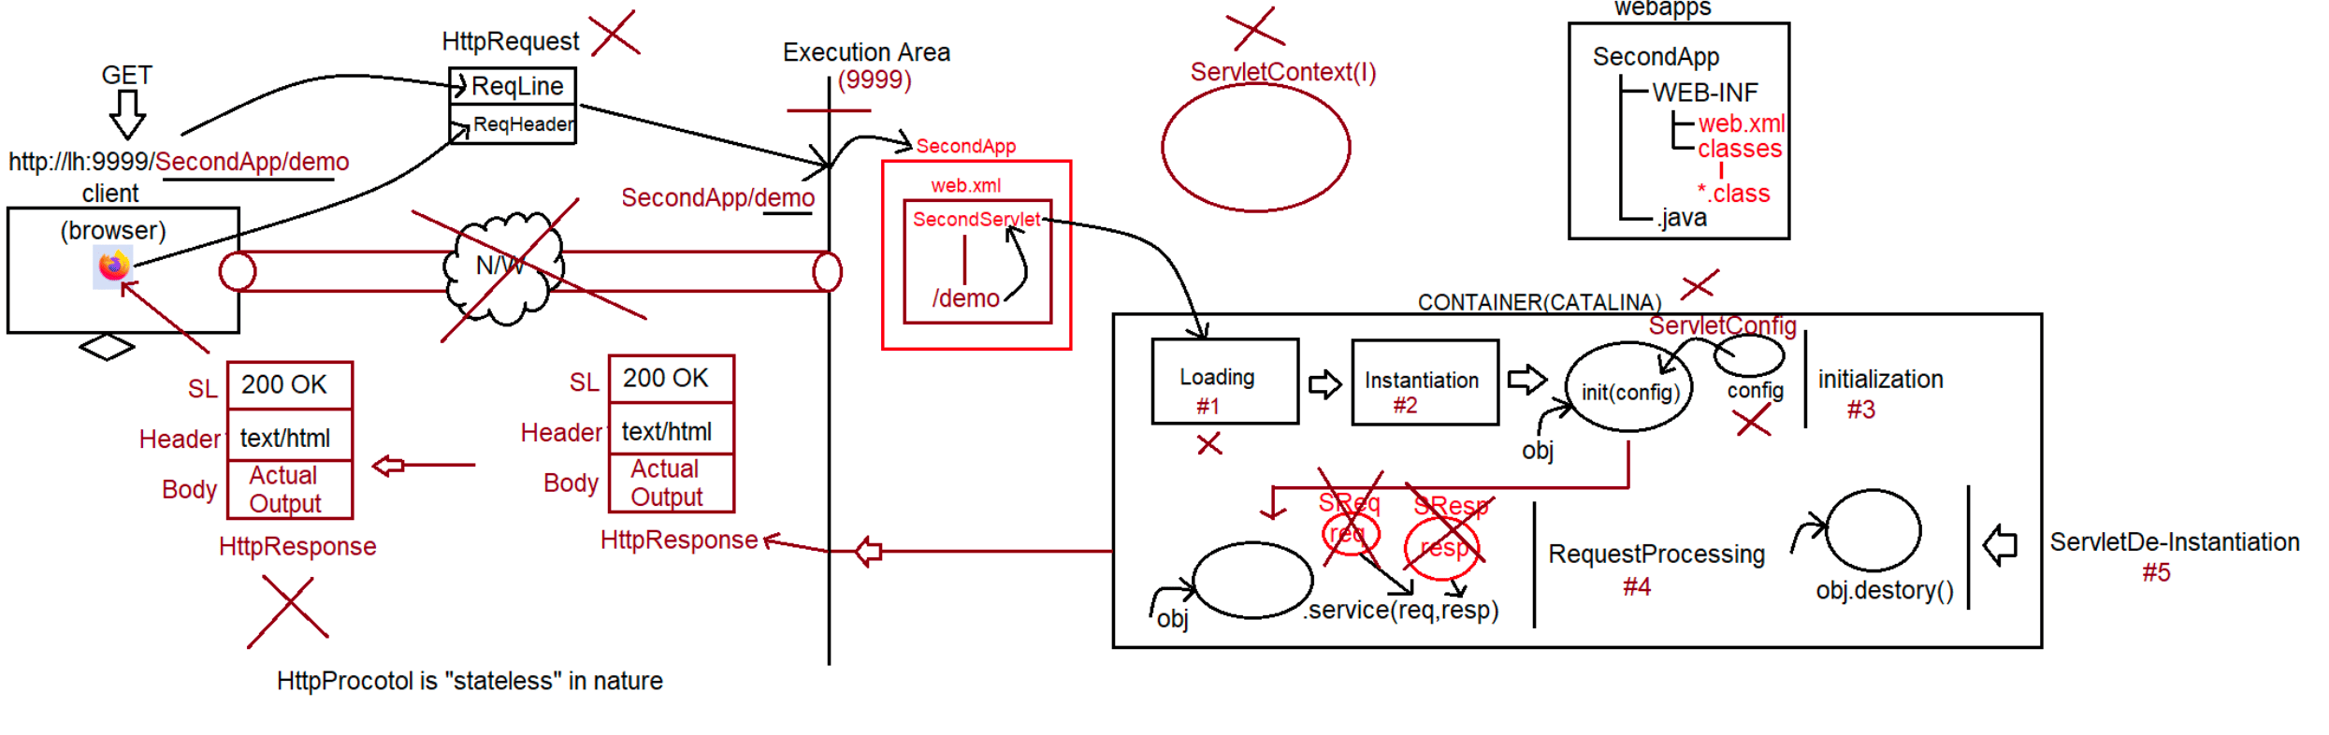

101 Creation of Servlet using HttpServlet and one JDBC Project using design pattern

Different ways of Creating a Servlet
=============================
1. Servlet(I) ==========> 5 abstract methods
2. GenericServlet(AC) ==> one abstract method (pvs(ServletRequest request,
ServletResponse response)
Note:
When we build webapplications, internally httpprotocol is used and while sending
the request , the request type can be
a. POST
b. GET
We can build Servlet in a easier way with the help of GenericServlet, then y need
HttpServlet(AC)?
Ans. In case of GenericServlet(AC), to process the request we have only one
method(pvs(req,resp)) which is generic for
any type of request like GET,POST,....
Becoz there is only one method available which is generic for any type
of request,Debugging the application becomes
difficult.
henceforth to deal with only Httpprotocol, we have a special approach
to create a servlet called "HttpServlet".
Note:
C:\Users\nitin>javap javax.servlet.http.HttpServlet
Compiled from "HttpServlet.java"
public abstract class HttpServlet extends GenericServlet {
protected void doGet(HttpServletRequest request, HttpServletResponse response)
throws ServletException,IOException;
protected void doPost(HttpServletRequest request,HttpServletResponse response)
throws ServletException,IOException;
protected void service(HttpServletRequest request, HttpServletResponse response)
throws ServletException,IOException;
public void service(ServletRequest request, ServletResponse response) throws
ServletException,IOException;
}
Note:
request method type is GET ===========> doGet(request,response)
request method type is POST ==========> doPost(request,response)
Note:
For a webapplication how to send GET request?
a. type url in the address bar of browser and hit the request.
b. by clicking the hyperlink in a webpage.
c. using <form method="GET">
d. default <form> method attribute is GET only.
For a webapplication how to send POST request?
a. using <form method="POST">
Life Cycle of HttpServlet
====================
1. when we submit the form browser prepares HttpRequest and sends to server.2. WebServer checks the request is for static/dynamic information.
3. If the request is for Static information then webserver provides required
information(copy and paste)
if available otherwise 404 Status Code(Saying the requested resource is not
available).
4. If the request is for dynamic information, then webserver hands over the control
to "catalina" container.
5. wecontainer identifies the request based on "web.xml" or through "annotation".
(/test)
6. webcontainer will check whether the ServletObject(TestServlet) is available or
not (/test====> TestServlet.class)
7. If the Servletobject(TestServlet.class) is not available, then it will perform
the following action
a. Loading ===> static block
b. instantiation ===> constructor
c. initialization ===> init()[same as GenericServlet lifecyle]
8.RequestProcessing phase
a. webcontainer will create ServletRequest,ServletResponse object by invoking
public void service(ServletRequest request, ServletResponse response)
throws ServletException,IOException;
container will check in our class service(ServletRequest,ServletResponse) is
available or not, if it is avaialble it will
execute our service() only and provides the response.
if our servlet class does not contain service(), then container will
execute HttpServlet
public void service(ServletRequest request,ServletResponse response)
HttpServlet
=========
{
public void service(ServletRequest request,ServletResponse response)
HttpServletRequest hreq = (HttpServletRequest)request;
HttpServletResponse hresp = (HttpServletResponse)response;
service(hreq,hresp);//protected void service(hreq,hresp)
}
webcontainer will call protected service(HttpServletRequest
hreq,HttpServletResponse hresp) throws SE,IOE
if our class contains protected void service(HttpServletRequest
hreq,HttpServletResponse hresp) throws SE,IOE
then container will call our class service() only.
if our class doesnot contains protected void service(HttpServletRequest
hreq,HttpServletResponse hresp) throws SE,IOE
then container will HttpServlet class service().
HttpServlet
=========
protected void service(HttpServletRequest request, HttpServletResponse response)
throws ServletException,IOException
{
String requestType = request.getMethod();
if(requestType.equals("GET")){
doGet(request,response);//protected/public void
doGet(request,response);
}
else if (requestType.equals("POST")){
doPost(request,response);//protected/public
doPost(request,response);
};;;;;
;;;;
else
return 501 status code saying Http method not implemented
}
webcontainer will check whether our servlet class contains doXXXX(req,resp).
if it contains doXXXX(req,resp) it will be executed and it provides the response.
if our servlet class does not contain doXXXX(req,resp) then HttpServlet class
doXXXX(req,resp) will be called.
HttpServlet
=========
SE,IOE
{
protected void doXXXX(HttpServlet request,HttpServletResponse response ) throws
return 405|400 status code saying HttpMethod GET is not supported by this
URL.
}
Note:
Hierachy of calling the methods
a. public service(SRreq,SResp)
b. protected service(HSReq,HSResp)
c. public void doXXXX(HSReq,HSResp)
case1:
If our servlet class contains public void service(SReq,SResp) then for every
type of request(POST,GET)
same method will be executed.
case2:
If our servlet class contains public void service(SReq,SResp) and protected void
servcie(HSReq,HSResp)
then for every type of request(POST,GET) public void service(SReq,SResp) same
method will be executed.
case3:
If our servlet class contains protected void servcie(HSReq,HSResp) and doGet()
then for every type of
request(POST,GET) protected void service(HSReq,HSResp) same method will be
executed.
case4:
we are sending GET request,but our servlet doesnot contain doGet(),it
contains doPost() then which method would be
called?
it calls HttpServlet doGet() which would send 405 status code.
case5:
we are sending POSt request,but our servlet doesnot contain doPost(),it
contains doGet() then which method would be
called?
it calls HttpServlet doPost() which would send 405 status code.
case6:
code?
eg:
Assume we need to give common response for both the request type, then how toimport javax.servlet.*;
import javax.servlet.http.*;
import javax.servlet.annotation.*;
import java.io.*;
@WebServlet(urlPatterns="/test")
public class TestServlet extends HttpServlet
{
@Override
public void doGet(HttpServletRequest request, HttpServletResponse response)
throws ServletException,IOException
{
doProcess(request,response);
}
@Override
public void doPost(HttpServletRequest request, HttpServletResponse response)
throws ServletException,IOException
{
doProcess(request,response);
}
public void doProcess(HttpServletRequest request,HttpServletResponse
response)throws ServletException,IOException
{
System.out.println("Request method is of type ::
"+request.getMethod());
String userName = request.getParameter("username");
System.out.println("username is :: "+userName);
}
}
Playing with request Object
=======================
To retrieve only one value from request object
public abstract java.lang.String getParameter(java.lang.String);
To retrive multiple values from request object
public abstract java.lang.String[] getParameterValues(java.lang.String);
To know the type of request from request object
public abstract java.lang.String getMethod();
import javax.servlet.*;
import javax.servlet.http.*;
import javax.servlet.annotation.*;
import java.io.*;
@WebServlet(urlPatterns="/reg")
public class TestServlet extends HttpServlet
{
@Override
public void doPost(HttpServletRequest request, HttpServletResponse response)
throws ServletException,IOException
{
response.setContentType("text/html");
System.out.println("Request type is :: "+request.getMethod());String username = request.getParameter("username");
String useremail = request.getParameter("useremail");
String useraddr = request.getParameter("useraddr");
String[] courses = request.getParameterValues("course");
PrintWriter out = response.getWriter();
out.println("<html><head><title>OUTPUT</title></head>");
out.println("<body>");
out.println("<center>");
out.println("<h1>Student Registration details</h1>");
out.println("<table border='1'>");
out.println("<tr><th>NAME</th><td>"+username+"</td></tr>");
out.println("<tr><th>EMAIL</th><td>"+useremail+"</td></tr>");
out.println("<tr><th>ADDR</th><td>"+useraddr+"</td></tr>");
out.println("<tr><th>COURSE</th>");
String data = "";
for(String course: courses)
data +=course+" ";
out.println("<td>"+data+"</td>");
out.println("</tr>");
out.println("</table>");
out.println("</center>");
out.println("</body>");
out.println("</html>");
out.close();
}
}
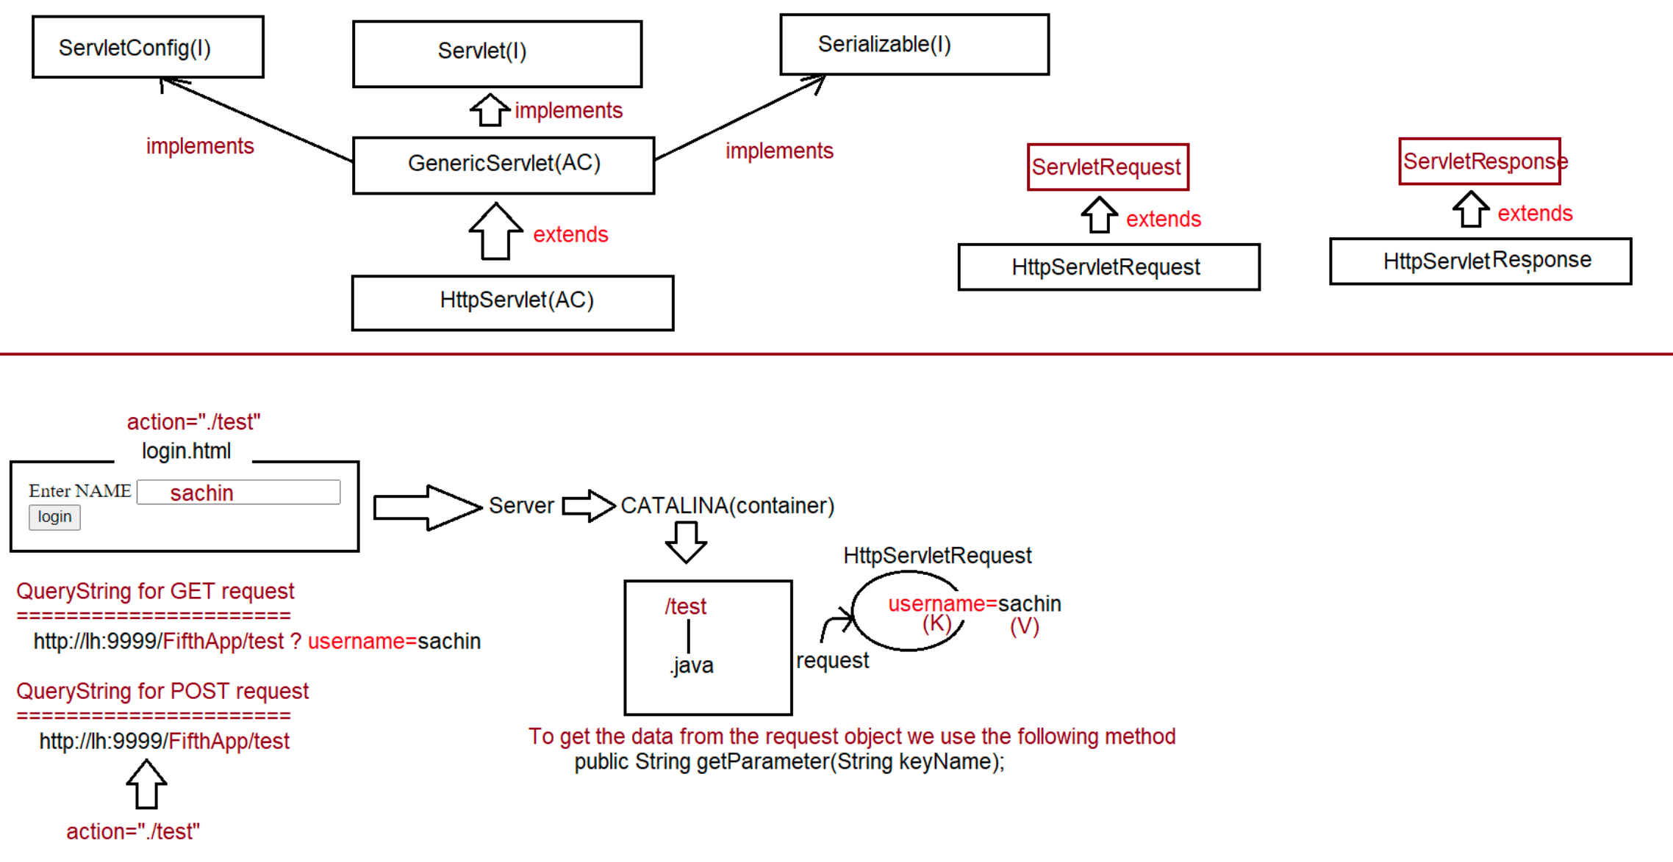

102 HttpServletRequest vs HttpServletResponse, ServletConfig object and ServletConnecting to database

Different ways of Creating a Servlet
=============================
1.Servlet(I)
2.GenericServlet(AC)
3.HttpServlet(AC)
Dynamic response will be generated by Servlet.
Mapping a resource to particular urlpattern for the webcontainer can be configured
in 2 ways
a. XML(legacy approach)
b. Annotation(Available from Servlet3.0V)
Note:
User input will be sent in the form of QueryString from the browser to protocol,
and container will store in request object.
ServletRequest(I)
| extends
HttpServletRequest(I)
HttpRequest Structure
a.RequestLine(request type,resourcename,protocolversion)
b.RequestHeader(information about the client)
c.RequestBody(actual data(QueryString))
Methods
=======
public abstract Enumeration<String> getHeaderNames();
public abstract String getHeader(String keyName);
refer: RequestHeaderApp
Working with ServletResponse/HttpServletResponse
===========================================
1. public abstract PrintWriter getWriter() throws IOException;
To send character type of Response
2. To send binary information like videos,audio,images etc response will be through
"Stream".
public abstract ServletOutputStream getOutputStream() throws IOException;
refer: ResponseInfoApp
Note:
PrintWriter => only character type of data.
ServletOutputStream => we can send both character type and binary type of
data.
Q> In single application can we use both PrintWriter object and ServletOutputStream
to send the response?
Ans. Not possible, it would result in "java.lang.IllegalStateException: getWriter()
has already been called for this response".
MultiThreading technology used in servlet
==================================
refer: diagram....
ServletContext(I) vs ServletConfig(I)
=============================ServletConfig(I)
=============
1. Loading ======> static block
2. Instantiation ===> Object obj = Class.forName(String
urlPattern).newInstance();
Object will be created for the loaded class
using Zero parameterized constructor.
3. Initialization ====> For the created Servlet object, we can initialize the
value using init(ServletConfig config)
ServletConfig
===========
This object will be used to initialize the values for the loaded servlet.
How to initialize the value of ServletConfig object?
To initalize the value of ServletConfig object, we need to configure the
container.
Container can be configured in 2 ways
a. XML
web.xml
------------
<servlet>
<servlet-name>InitializationParamterApp</servlet-name>
<servlet-class>in.ineuron.controller.InitializationParamterApp</servlet-
class>
<init-param>
<param-name>name</param-name>
<param-value>sachin</param-value>
</init-param>
<init-param>
<param-name>age</param-name>
<param-value>49</param-value>
</init-param>
<init-param>
<param-name>address</param-name>
<param-value>MI</param-value>
</init-param>
</servlet>
methods
=======
public Enumeration<String> getInitParameterNames();
public String getInitParameter(String key);
refer: ServletConfigApp
Note:
=> ServletConfig object is unique w.r.t every Servlet.
=> ServletConfig object stores the data in the form of Key,Value pair.
=> Assume we want the dbconfiguration details for a servlet like
url => jdbc:mysql:///octbatch
username=> root
password => root123
After adding the jar, jars will available to jdks/w configure for eclipse, not for
tomcat server.
To make those jars available for tomcat server(catalina container) we need to put
in deployment assembly(/WEB-INF/lib)refer: ServletDBCommunication
Assignment
==========
Create a html form with fields like name,age,address for student
a. perform insertion operation(use db credentials in config object)

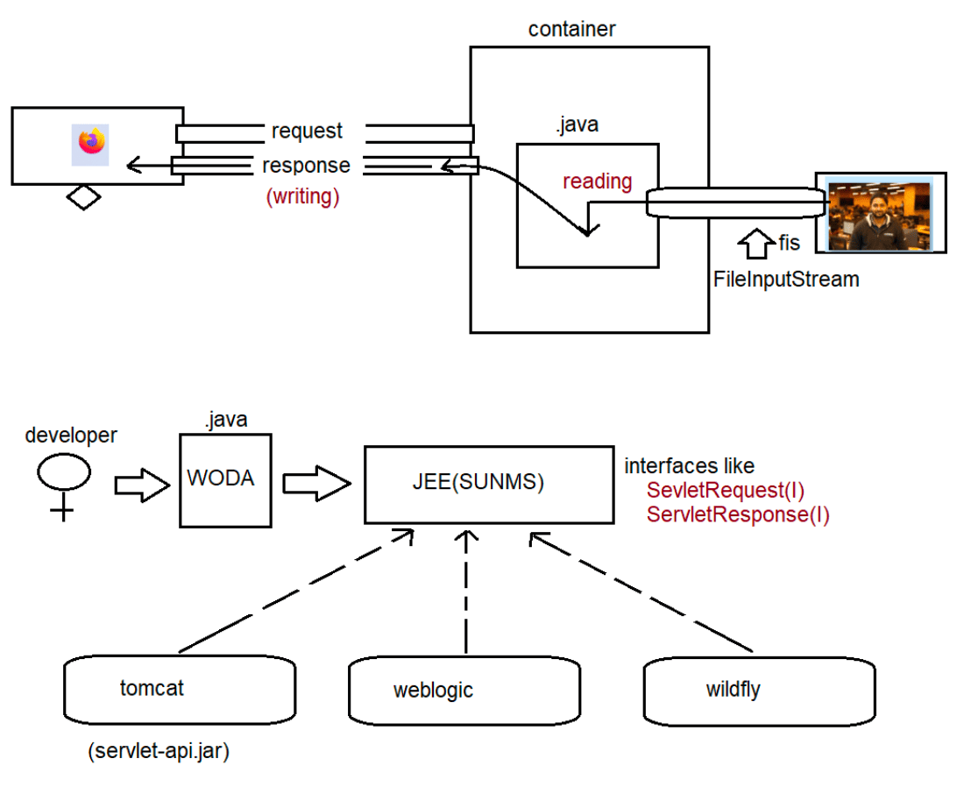
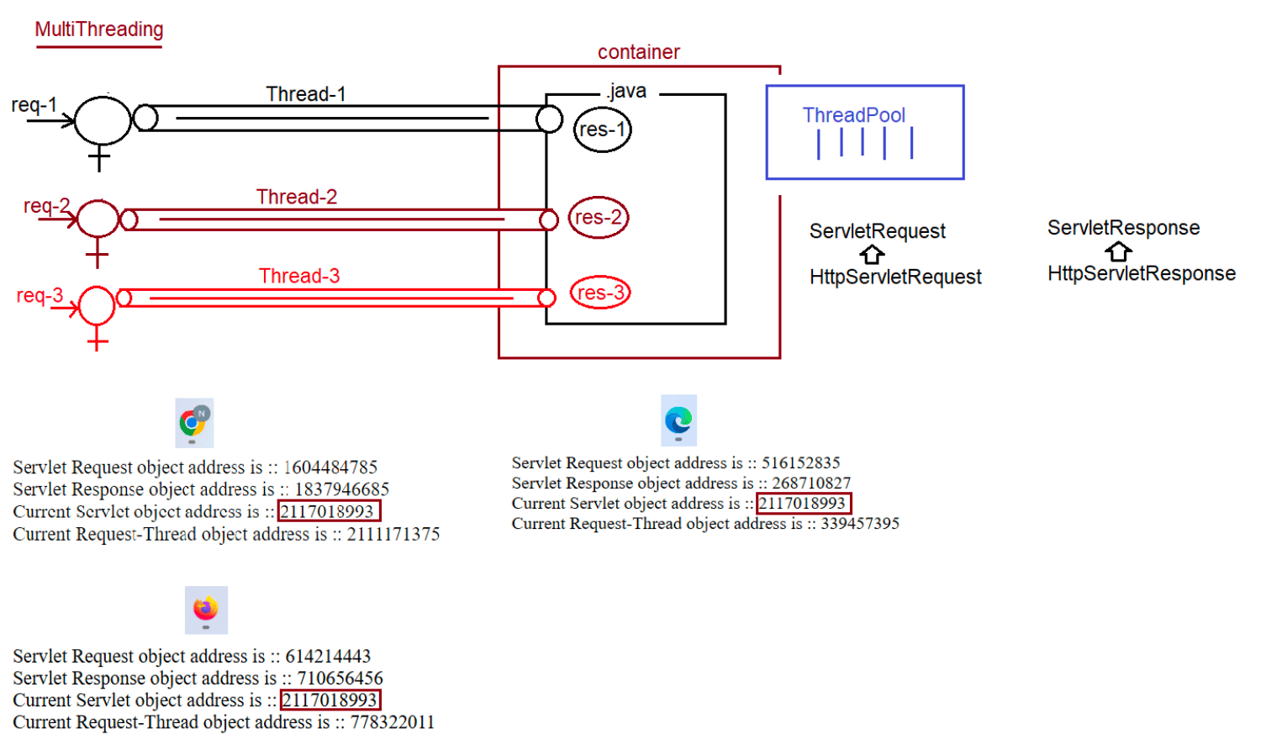
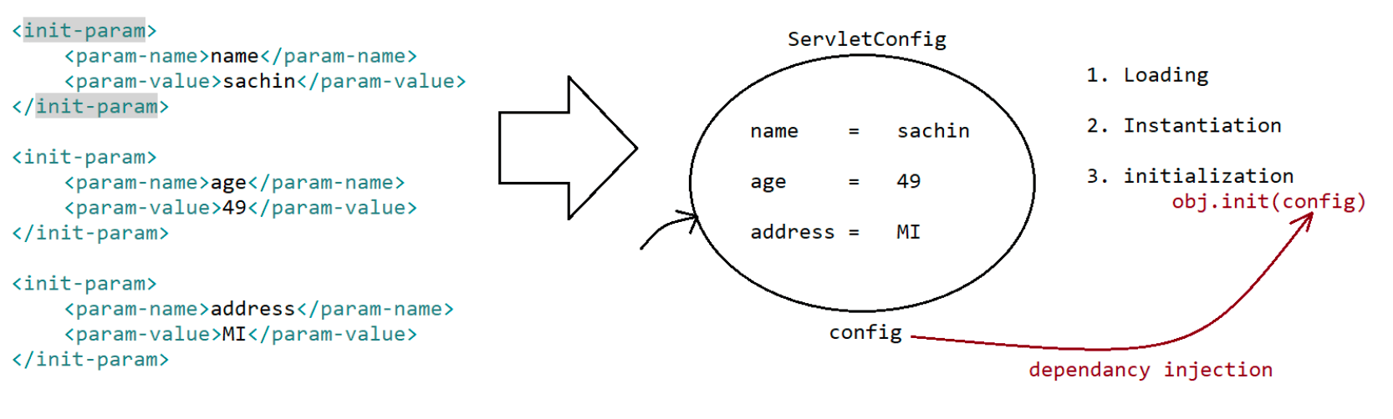

103 ServletContext vs ServletConfig, different ways of load on startup and snippets on MultiThreading

1.why there is no main method in Servlets??
Answer: JVM has be designed to make a call to main method with the following
prototype to start the execution
public static void main(String[] args)
If the application is standalone application then jvm will come into
picture so we need main method to start the
execution.
if the application is webapplication, then container will execute our
java code based on its life cycle actions like
a. Loading
b. Instantiation
c. Initalization
d. RequestProcessing
e. De-Instantiation
Since jvm does not play vital role to start the execution we don't need
"main method" in Servlets.
2.Eclipse Shortcuts
ctrl+2, L => to genreate the return type of method,constructor,....
Alt+ctrl+arrowup -> To Duplicate the lines.
Alt+arrowup -> To move the line upwards.
Alt+arrowdonw -> To move the line downwards.
Alt+shift+m -> To move the selected lines to be a part of the method.
Alt+shift+R -> To replace the varaible name in every place of java
code.
Alt+shift+s,r => To generate setters and getters
Alt+shift+s,S => To generate toString()
Alt+shift+s,v => To do override for any methods of the class.
cntrl+shift+o => To organize the import statements/import particular
class
ctrl+a => To select everything
ctrl+shift+I=> To perform indentation.
ctrl+shift+f => To perform formatting.
ctrl+shift+/ => To perform commenting.
ctrl+shift+\ => To perform uncommenting.
ctrl+shfit+t => To open particular class from the jar.
ctrl+ o => To list all the methods of the class.
ctrl+spacebar => To give assistance for our code.
ctrl+d => To delete the line
ctrl+c => To copy
ctr+v => To paste
ctrl+shift+L => To list all the shortcuts of the eclipse
ctrl+2,f => To generate a instance variable
ctrl+shift+x => to make upper case
ctrl+shift+y => to change to lower case
3.ServletConfig InitParameters Using
1.Xml
2.Annotations
"jdbc:mysql:///octbatch"),
a. @WebServlet(urlPatterns = {}, loadOnStartup= 10,
initParams = {
@WebInitParam(name = "url", value =
@WebInitParam(name = "user", value = "root"),
@WebInitParam(name = "password", value =
"root123")
}Note:
Servlet initialization parameters are key-value pair where both key and value
are of type String.
From the Servlet we can access these parameters but we can't modify.
since we can't modify we just have only getXXXX() but not setXXXX().
So we say Servlet Initialization parameters as "Deploy time constants".
For every Servlet we will have only one ServletConfig object to hold its
configuration information.
ServletContext(I)
=============
For every webapplication web container will create only one ServletContext
object to hold the configuration details.
By using context object we can get configuration information like context
paramters, requestdispatcher etc...
Assume there are 3 servlets and for all the servlets if the configuration details
is common can we keep in config object?
Ans. we can keep, but it is not a good practise because if we keep the data
inside Context object it will be available to
all the servlets of the application.
How to keep the data in ServletContext object?
Ans. We can keep in only 1 way that is through XML.
Annotation support not available becoz when container gets
started only ServletContext object is created and
no java code is coming into pitcure to give the information
through Annotation.
web.xml
=======
<web-app>
<context-param>
<param-name>jdbcUrl</param-name>
<param-value>jdbc:mysql:///octbatch</param-value>
</context-param>
<context-param>
<param-name>user</param-name>
<param-value>root</param-value>
</context-param>
<context-param>
<param-name>password</param-name>
<param-value>root123</param-value>
</context-param>
<servlet>
;;;
;;;
</servlet>
</web-app>
Inside servlet we can get the ServletContext data in 2 ways
a. ServletConfig config = getServletConfig();
ServletContext context= config.getServletContext();
methods
public String getInitParameter(String name)
public Enumeration getInitParamterNames()b. ServletContext context = getServletContext();
methods
public String getInitParameter(String name)
public Enumeration getInitParamterNames()
Note:
when 2 servlets have different load-on-startup then
a. lower load-on-startup will get chance first for execution
when 2 servlets have same load-on-startup then
a. it depends on container(not in the hands of the programmer)
if we give negative value for load-on-startup then the container will not load any
of the servlet.
we should give only positive value (zero can also can be given)
Difference b/w ServletContext vs ServletConfig object
============================================
ServletContext
a. For every webapplication, container will create only one ServletContext
object to hold the data at application level.
b. It will be created at the time of application deployment and destroyed at
the time of application undeployment.
c. <context-param>
<param-name></param-name>
<param-value></param-value>
</context-param>
d. 2 ways to get the Context Object
ServletContext context = getServletContext();
ServletConfig config = getServletConfig();
ServletContext context = config.getServletContext();
e. Configuration can be done only in one way through XML
ServletConfig
a. For every Servlet, container will create only seperate ServletConfig
object to hold the data at servlet level.
b. It will be created at the time of Servlet object creation and destroyed at
the time of Servlet Object Destruction.
c. <init-param>
<param-name></param-name>
<param-value></param-value>
</init-param>
d. Approach to get ServletConfig object
ServletConfig config = getServletConfig()
e. Configuration can be done in 2 ways
a. XML
b. Annotation
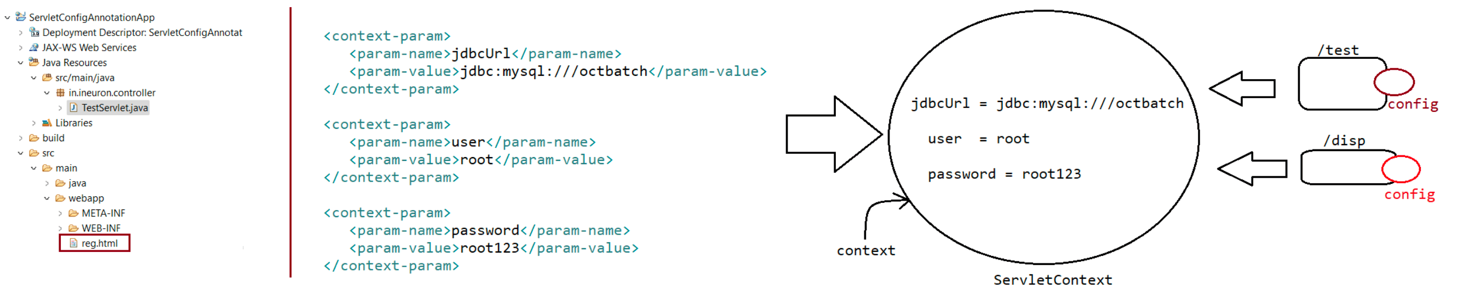

105 Demonstrating WODA, working with request object extra features, different types of scope and attribute data, MVCDesign pattern project

commonly used packages in servlet coding
javax.servlet.*
javax.servlet.http.*
=================
using these interfaces abstraction is promoted through which WODA is achieved
ServletRequest(I)
ServletResponse(I)
HttpServletRequest(I)
HttpServletResponse(I)
ServletContext(I)
ServletConfig(I)
void init(ServletConfig config) throws SE,IOE
{
}
{
void doXXXX(HttpServletRequest request, HttpServletResponse response)throws SE,IOE
//request => QueryString data in the form of key-value pair
//response=> PrintWriter object will be there with empty response
}
w.r.t tomcat server the implementation classnames are as shown below
===========================================================
Implementation class of config is :: org.apache.catalina.core.StandardWrapperFacade
Implementation class of context is ::
org.apache.catalina.core.ApplicationContextFacade
Implementation class of request is :: org.apache.catalina.connector.RequestFacade
Implementation class of response is :: org.apache.catalina.connector.ResponseFacade
Different types of scope and attributes in Servlet
========================================
scope refers to the accessability of a variable.
a. local scope => restricted inside method
b. global scope=> avaialble in all the methods of a particular task.
There are 3 types of parameters(k,v) possible in servlet
a. Form parameters(QueryString[k,v])
b. ServletInitializationParameters(ServletConfig[k,v])
c. ContextInitializationParamters(ServletContext[k,v])
The above 3 parameters type are read-only.from the servlet we can perform only read
operation, we cannot modify remove
values based on our requirement.so we say parameter type of data is not best suited
for sharing the data between
component of the webapplication.
parameter data => both key and value should be String.
To resolve this problem we should go for "attributes" type of data.based on our
requirement we can add the data,
remove the data and we can share the data between the components of the
application.
attribute data => key should be String, value can be any Object.
Based on our requirement we need to store the attributes in particular scope.
In Servlet we have 3 types of scope
1. request
2. session(HttpSessionTracking)
3. application/context .1.request
=> This scope is maintained by ServletRequest /HttpServletRequest object.
=> This scope will start at the time of request object creation(before
calling service())
=> This scope will destroy at the time of request object destruction(after
calling service())
=> The data stored in the request object will be available for all components
which are procesing that request.
3. application/context
=> This scope is maintained by ServletContext object.
=> This scope will start at the time of context objet creation(during
deployment)
=> This scope will destroy at the time of context object destruction(during
undeployment)
=> The data stored in the context object will be available for all the
components of the application,irrespetive of
request and the user.
write a program to display hit count(number of requests) of a webapplication?
firstreq = > hitcount = 1
refer: ScopeApp
Write a program to display all the attribute information present in application
scope?
Note: In ApplicationScope container will add some attributes for internal
purpose.
Getting information from the url
===========================
1. getRequestURI()
2. getQueryString()
3. getServletPath()
4. getPathInfo()
5. getContextPath()
package in.ineuron.controller;
import java.io.IOException;
import java.io.PrintWriter;
import javax.servlet.ServletException;
import javax.servlet.annotation.WebServlet;
import javax.servlet.http.HttpServlet;
import javax.servlet.http.HttpServletRequest;
import javax.servlet.http.HttpServletResponse;
@WebServlet("/test/iNeuron/*")
public class TestServlet extends HttpServlet {
private static final long serialVersionUID = 1L;
@Override
public void doGet(HttpServletRequest request, HttpServletResponse response)
throws ServletException, IOException {
PrintWriter out = response.getWriter();out.println("<h1>Request URI :: "+request.getRequestURI()+"</h1>");
out.println("<h1>Context Path ::"+request.getContextPath()+"</h1>");
out.println("<h1>Servlet Path ::"+request.getServletPath()+"</h1>");
out.println("<h1>Path Info ::"+request.getPathInfo()+"</h1>");
out.println("<h1>Query String ::"+request.getQueryString()+"</h1>");
out.close();
}
}
request
http://localhost:9999/RequestAppInfo/test/iNeuron/hyder/java?
name=sachin&password=tendulkar
response
Request URI :: /RequestAppInfo/test/iNeuron/hyder/java
Context Path ::/RequestAppInfo
Servlet Path ::/test/iNeuron
Path Info ::/hyder/java
Query String ::name=sachin&password=tendulkar
Deployment
==========
Harddeployment
Creating an webapplication inside webapps folder of tomcat and starting
the server manually is called
"hard-deployment".
Smoothdeployment
Creating an application outside the webapps folder of tomcat and
starting the server through some additional
set up is called "smooth-deployment".
Note:
webapps(deployment folder)
In case of eclipse integration with tomcat, internally eclipse uses "smooth"
deployment through which it clones
our project and perfoms deployment as shown in the following path
*\.metadata\.plugins\org.eclipse.wst.server.core\tmp0\wtpwebapps
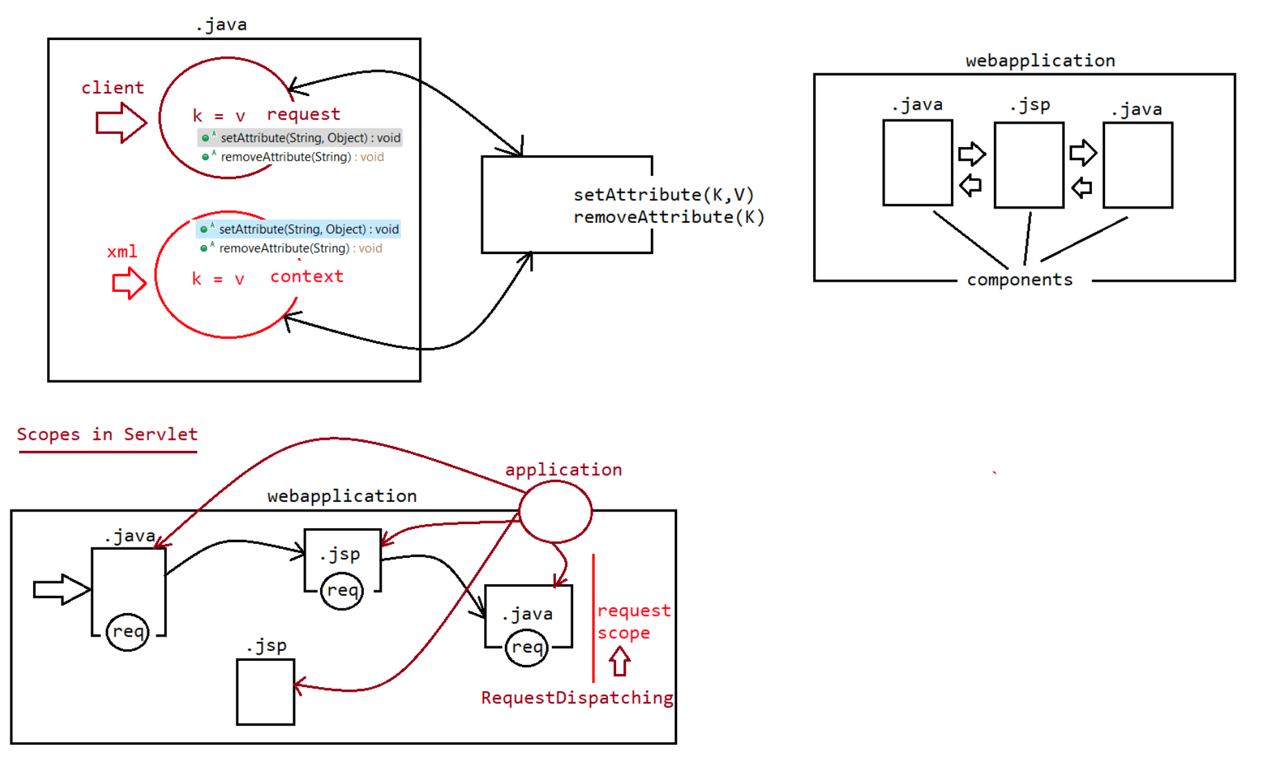
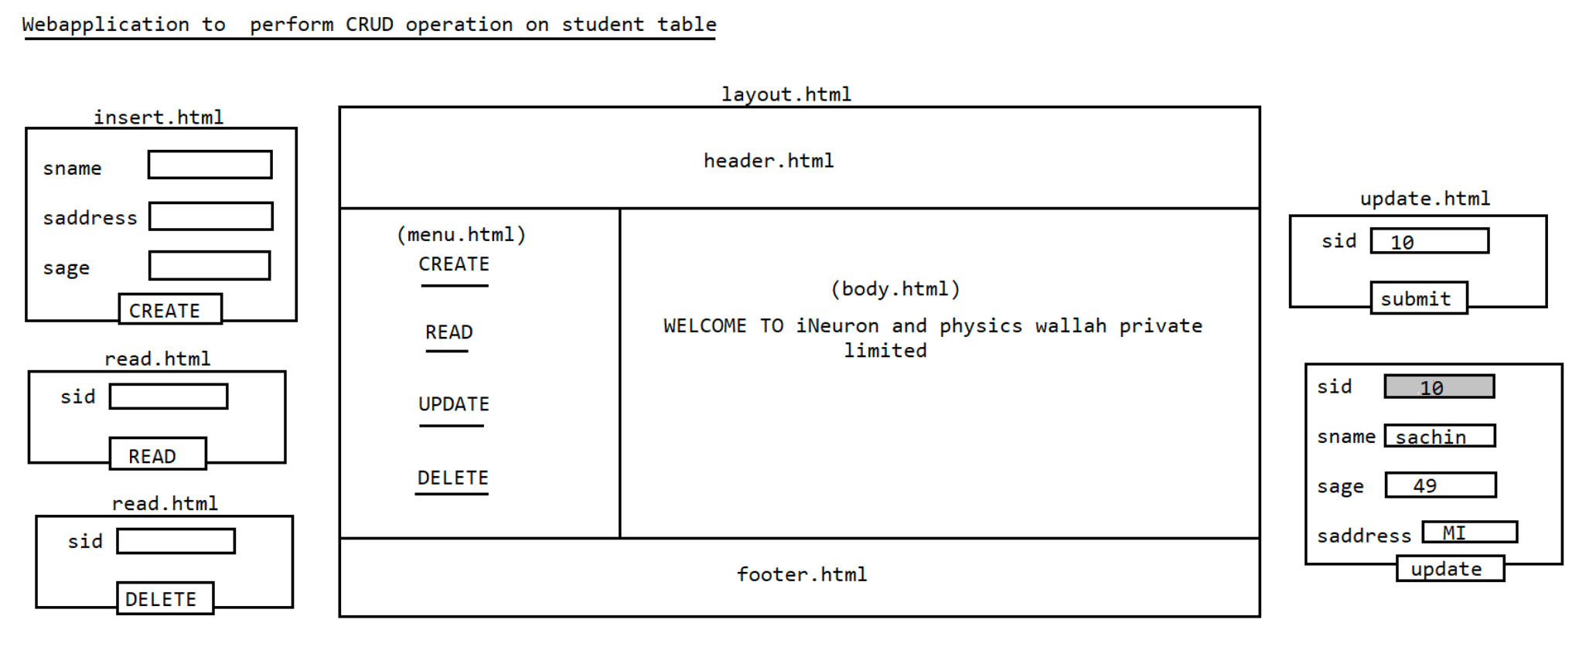

106 MVCCRUD APP using Hikaricp and design pattern approach

107 MVCCrud app using Request Dispatching mechanism and need of jsp when we already have html

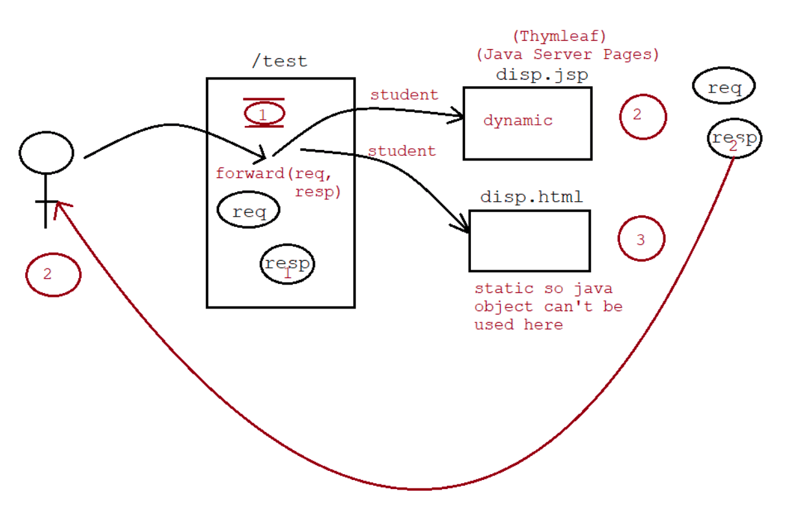

108 Session tracking mechanism and it's internal workflow

Session Tracking mechanism
=======================
As a part of webapplication,it is essential to manage the client previous request
data at the time of processing later request.
Solution-1
usage of request object
request object gets created, when we send the request to the
application and it gets destroyed at the time of
sending the response, so we can't keep track of the client previous
request data using "request object".
Solution-2
usage of context object
If we use context object, then the data will be shared to all
components of the application and to all the users of
the application where we can't differentiate the data between the user,
so it is not a good approach.
In webapplication to manage the client previous request data at the time of
processing later request , we need to have a
clear cut seperation b/w the clients data.
To manage this, we need to go for Server side mechanism called
"SessionTracking".
Session
======
It refers to the amount of time the client spend with the server.
State of the Session
The data which is transferred b/w client and server through multiple no
of requests during a particular session then
that data is called "State of the Session".
In webapplication as soon as we start the server ,ServletContext object is
created, when we send the request to the
application HttpServletRequest object is created, similarly w.r.t we need to
write a code to create "HttpSession" object.
If multiple users uses the application, then we need to write a code to
create seperate "HttpSession" object and we need
to manage the object, to manage these session objects we need to learn
"SessionTracking mechanism".
There are 4 SessionTracking mechanism
=================================
1. HttpSessionTracking mechanism.
2. Cookie Session Tracking mechanism.
3. URL-ReWriting Session Tracking mechanism.
4. Hidden Form Field Session Tracking mechanism.(developer specification)
As per SUN specification for ServletApi, we have only 3 mechanism for
SessionTracking.
HttpSession Tracking mechanism
===========================
What is the difference b/w getSession() and getSession(false)?
Answer: Both the method will return HttpSession object only.
getSession() => container will check whether session object existed w.r.t the
particular user or not.
if HttpSession object existed then it would return
the same object, otherwise
it will create a new HttpSession object w.r.t theuser and that object will be returned.
getSession(false) => container will check whether session object existed
w.r.t the particular user or not.
if HttpSession object existed then it would return
the same object, otherwise then container
will return null.
note: getSession() and getSession(true) both are same.
Q> If we allow mulitple users to access webapplication then to container we need to
instruct the creation of HttpSession
objects,In this case how container will identify user specific HttpSession
object in order to put the user specific attributes
and get the attributes?
Answer: HttpSession objects are created manually, and for these objects container
will maintain unique ID in the form of
HexaDecimal value called SessionID.
Container will prepare Session id value in the form of key called
"JSessionID".
Container will create a cookie and attach the session id to send it as
a response to the browser every time when
the interaction happens b/w client and server.
when we use request.getSession(), container will get the sessionid
and checks whether that user specific object is
available or not, if avaiable it will identify that object to process
the data.
Note: we can destroy the HttpSession object manually using the method called
public void invalidate()
Limitations of HttpSession Tracking mechanism
=======================================
1. Creating HttpSession object w.r.t client at the server side is too costly which
would decrease the performance of
the application(managing the session object at the server side).
2. HttpSession object is exchanged b/w the client and server through cookie file,if
client disables cookie at the client side
then this mechanism won't work effectively.
To resolve this issue, we have a new mechanism called "Cookie Session
Tracking".
refer: HttpSessionTrackingApp
Cookie Session Tracking
====================
In case of Cookie Session Tracking mechanism, we need to create a cookie for
every request data w.r.t every user.
After creating a cookie, we need to send this cookie along with response object.
These cookies will be exchanged b/w client and server in the form "request-
response" object.
To Create a cookie we use
public Cookie(String key,String value)
To retreive the cookies we use request object
public Cookies[] getCookies()
To add the cookies to response object we use
public void addCookie(Cookie c)
refer: CookieSessionTrackingApp
Drawback========
1. In case of Cookie Session tracking,cookies are maintained at the client side. if
browser disables the cookie then this
mechanism wont' work effectively.
2. Since cookies are stored in the client machine(browser), there is every
possibility that client can misuse the data sent
from the server.(security breach can happen)
To overcome this limiation we need to use "URLReWriting Mechanism".

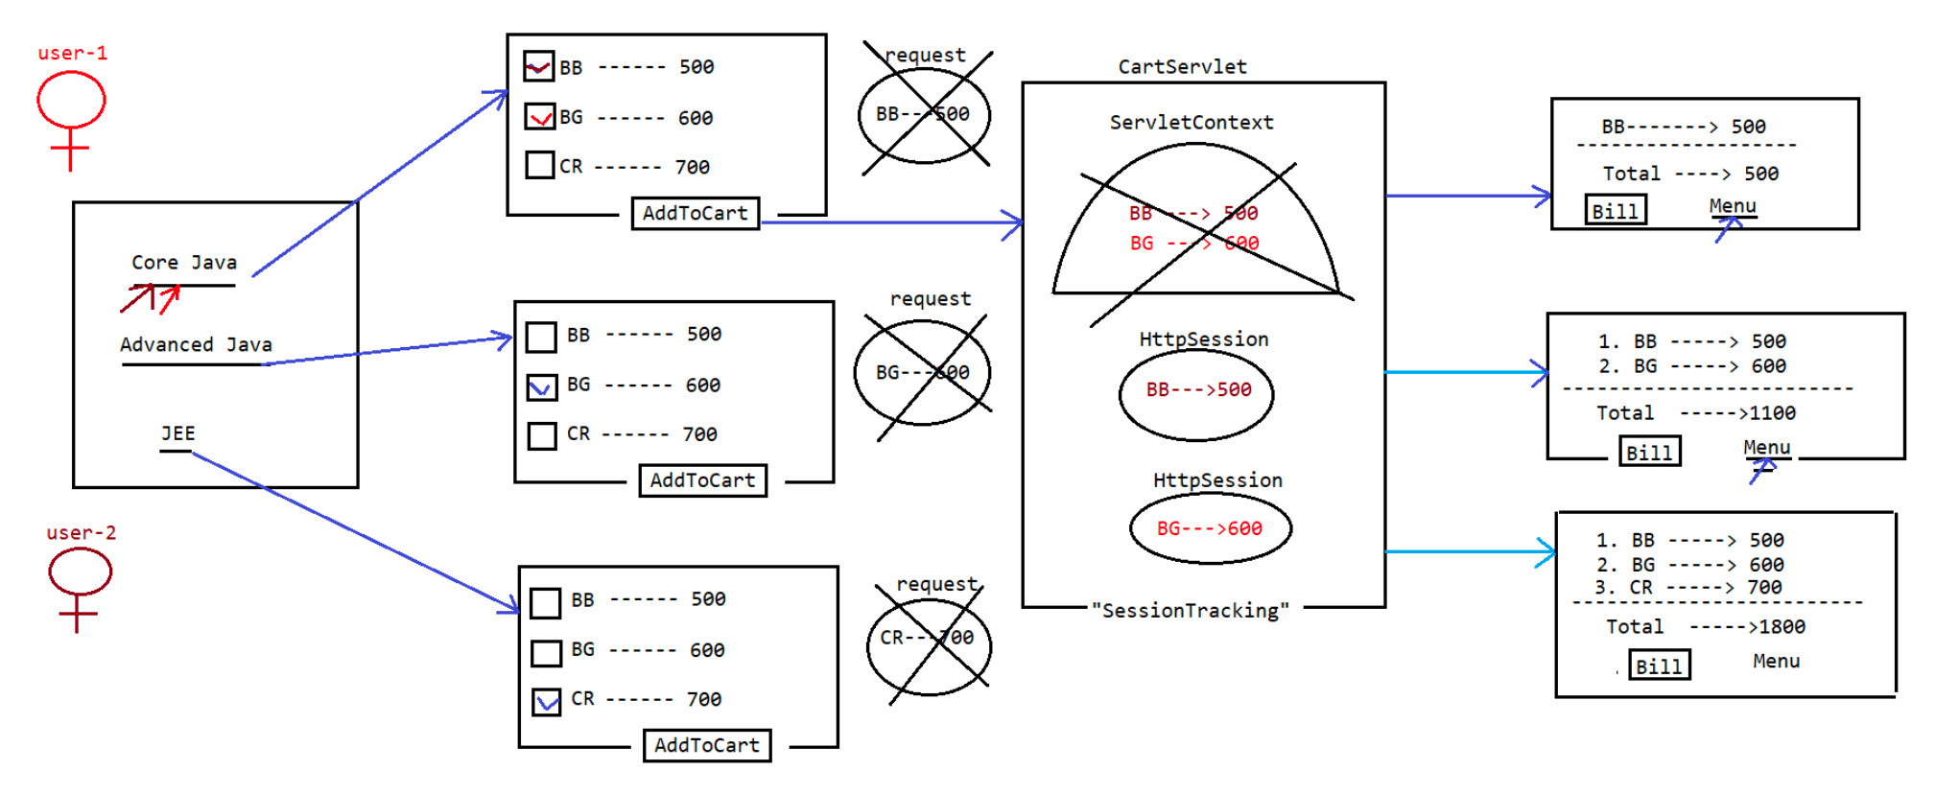
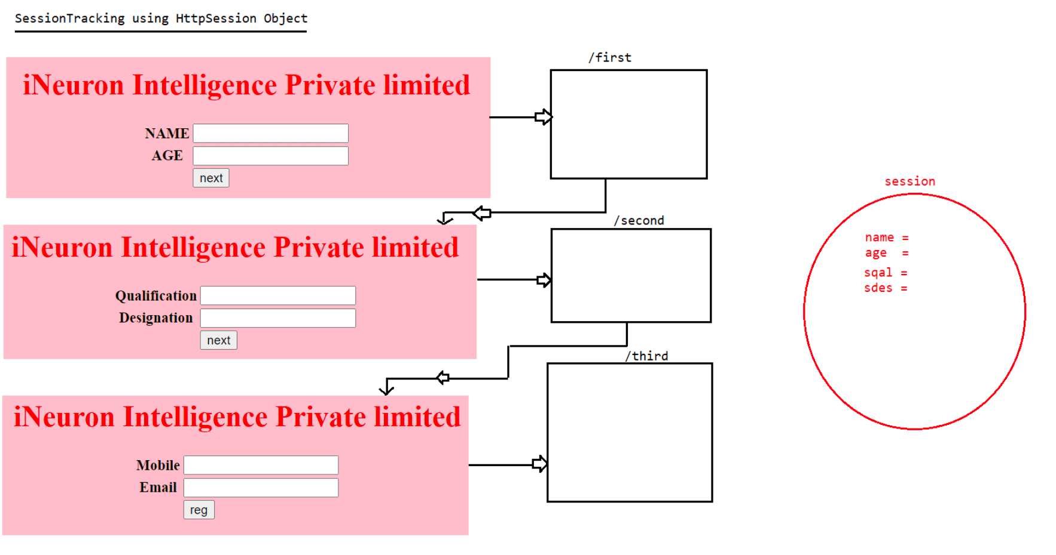
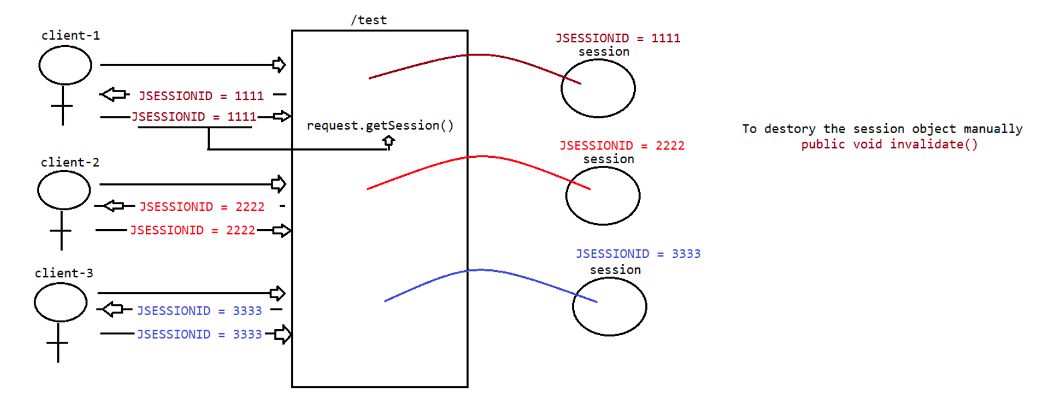
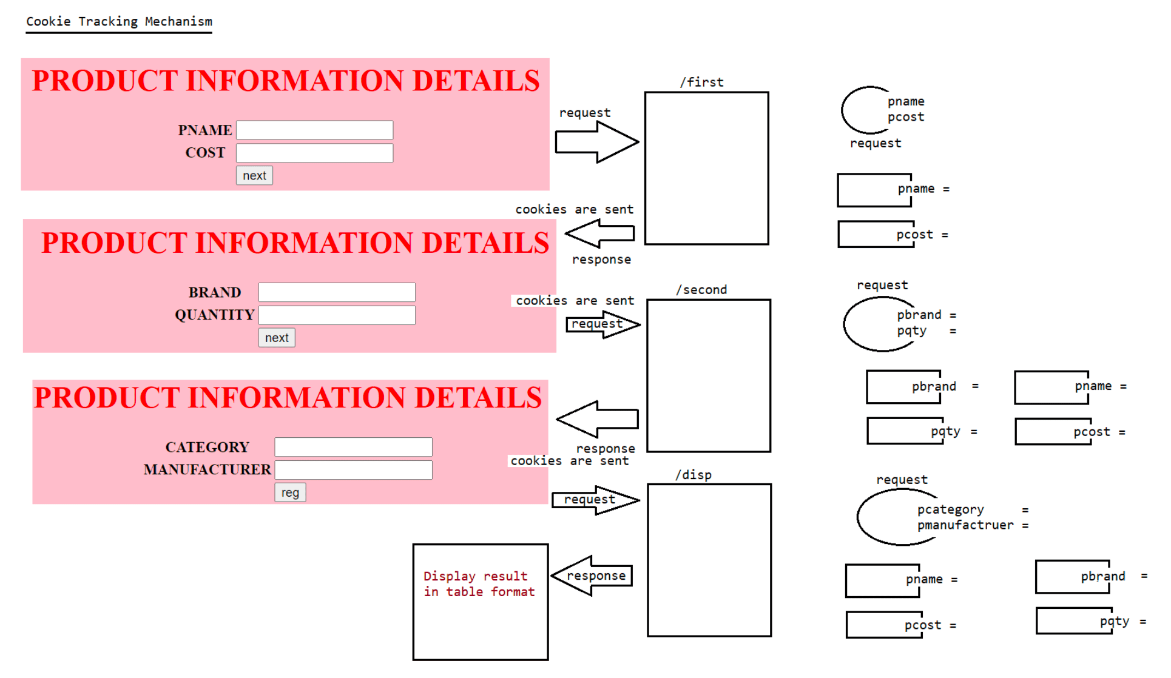

109 Session Tracking continuation, welcome file list, private area and public area in web application

Servlet-api
=========
1. HttpSessionTracking
2. CookieSessionTracking
3. URLReWriting Tracking
HttpSessionTracking
================
1. Session id will stored in the form of cookie and in client side if browser
disables the cookie HttpSessionTracking mechanism
won't work.
2. Maintainence of Session object is at the server side which would be burden to
the server.
eg: jSESSIONID = .........DBEFH
CookieSessionTracking
===================
1. Cookies will be stored in the client side and if browser disables the cookies
then we can't keep track of client data.
2. Since cookies are used to store the client data,it might result in "Security
Breach".
URLRe-Writing Mechanism
======================
=> This mechanism is same as "HttpSessionTracking" mechanism,but sessionid won't be
stored inside cookie rather the
sessionId will be appended to the url everytime when the request-response
happens b/w client and server.
eg: <form method ="get" action='"+response.encodeURL('./second')
+"'>
</form>
|
./second?JSESSIONID = .......
Note: In Realtime project we don't use technologies directly,we use framework to
improve the productivity,so by default
Framework support SessionTracking Mechanism through "URL-ReWriting" only.
Invented by Developer
===================
1. HiddenFormField
Not used in realtime as it increases the lines of code.
URLPatternTypes
==============
As per Servlet specification, we have 4 different ways of mapping the URLPattern
a. Exact match URL Pattern => eg: /test
b. Longest Path URL Pattern => eg: /controller/servlet/*
c. URL Pattern by extension => eg: *.do
d. Default URL Pattern => eg: /
Which of the following are valid url patterns?
1. /test (valid)
2. /test/*/test(invalid)
3. /test/test/*(valid)
4. *.test(valid)
5. /(valid)6. /test/test/*.do (valid)
Patterns for Servlet
================
/ => FourthServlet
/test => FirstServlet
/test/test/* => SecondServlet
*.do => ThirdServlet
http://localhost:9999/URLPatternTypesApp/test/test/navindReddy.do => SS
http://localhost:9999/URLPatternTypesApp/test/test/navinReddy => SS
http://localhost:9999/URLPatternTypesApp/
=> DS
http://localhost:9999/URLPatternTypesApp/navinReddy.do => TS
http://localhost:9999/URLPatternTypesApp/test/hyder =>
DS
Note: When none of the Servlet is getting mapped, then default Servlet will get a
chance once again.
Webcontainer will always gives preference in the following order
a. Exact match UrlPattern
b. Longest Path prefix UrlPattern
c. UrlPattern by Extension
d. Default UrlPattern
In realtime projects which type of url pattern is preferred?
URLPattern by extension is prefered(*.do).
In SpringMVC for inbuilt servlet called "DispatcherServlet(FC)", we configure
it through "URL-pattern by extension".
Configuring welcome pages
=======================
It is highly recomended to configure the welcome-page/landingpage for our
webapplication.
Advantage
1. It increses the easyness of the use of the webapplication for the end user.
Configuration can be done in XML only for html files, jsp files
==================================================
<web-app>
<welcome-file-list>
<welcome-file>home.jsp</welcome-file>
<welcome-file>welcome.jsp</welcome-file>
<welcome-file>index.jsp</welcome-file>
</welcome-file-list>
</web-app>
Note:
1. The order of searching a landingpage would be from top to bottom
2. In any webapplication index.html acts as a default welcome file,if index.html is
not avaialable then index.jsp acts a default
welcome file.
eg:
http://localhost:9999/FirstApp/ ===========> search for index.html/index.jsp and
load as the response to the client.
As per JEE specification, when we are configuring jsp pages inside <welcome-file>,
we need to just specify the file name notwith "/".
eg: <welcome-file>index.jsp</welcome-file>(valid)
<welcome-file>/index.jsp</welcome-file>(error)
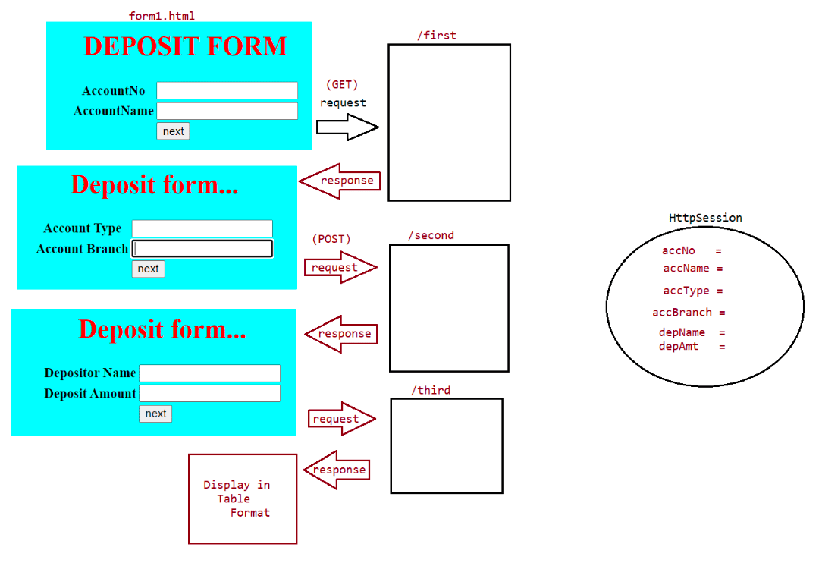
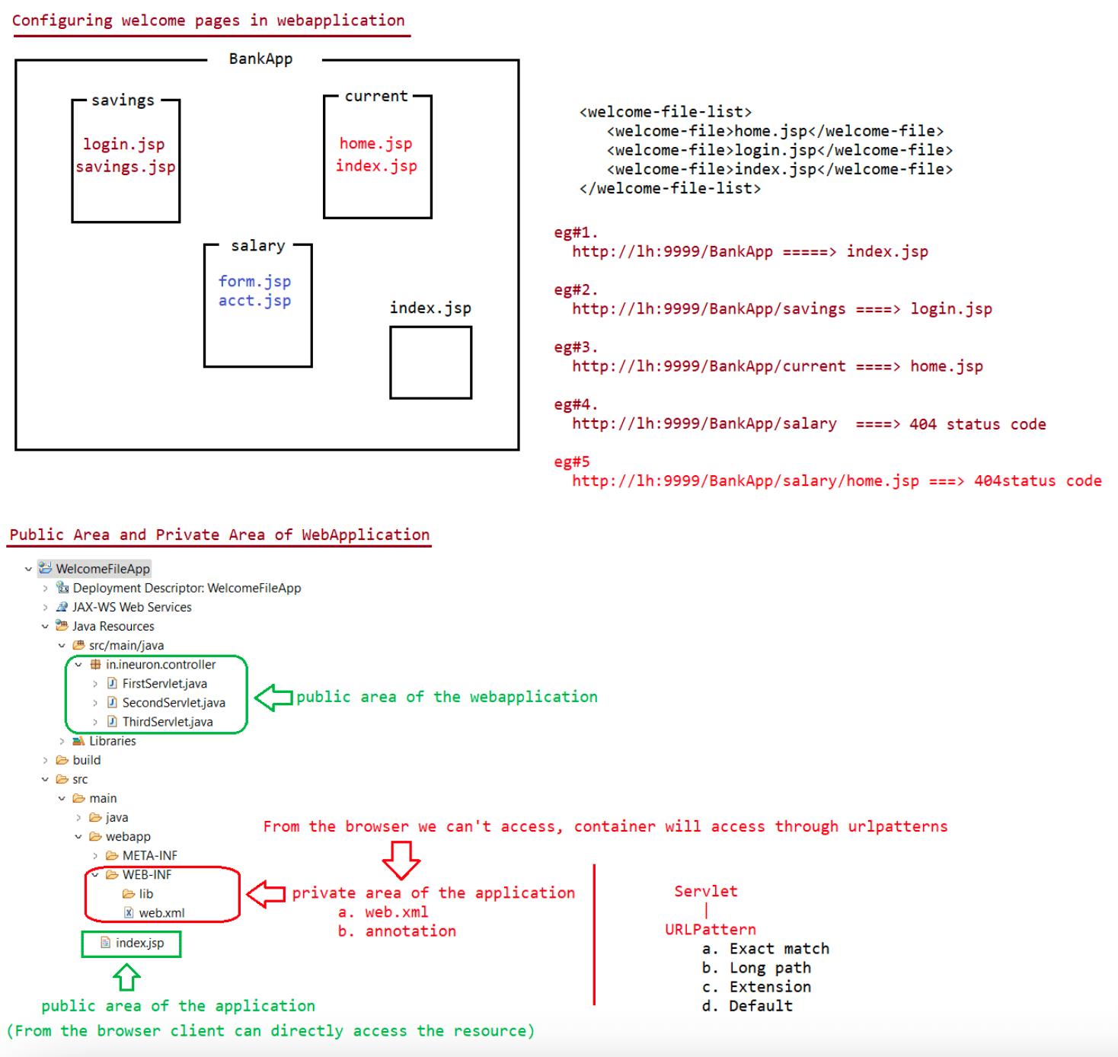

111 ServletFilters and ServletListeners,RequestWrapper and ResponseWrappers, full core java notes

Filters/Interceptors
================
It can be used for PreProcessing and PostProcessing of the request before they
reach the target resource in the
web application.
Areas of Application
================
Logging, Security,Altering Request information, Compressing
response,encryption of response,authenication etc...
Filters Concpets introduced in Servlet 2.3V
FilterApi contains 3 interfaces
1. Filter(I)
2. FilterConfig(I)
3. FilterChain(I)
To create a filter we need to implement Filter(I)
=======================================
public interface Filter {
public void init(FilterConfig config) throws ServletException;
public abstract void doFilter(ServletRequest request, ServletResponse response,
FilterChain chain) throws IOException,
ServletException;
public void destroy();
}
refer: FilterApp
Behind the Scenes
===============
1. Whenever we are sending the request to TargetServlet, web container will check
if any filter is configured for this servlet
or not.
2. If any Filter is configured, web container forwards the request to Filter
instead of Servlet.
3. After completing the Filter logic, Filter forwards the request to TargetServlet.
4. After processing the TargertServlet, the response will be forwarded to Filter
instead of browser.
5. After executing the Filtering logic, filter forwards the total response to the
browser.
eg: http://localhost:9999/Filterapp/test
output
This line is added by DemoFilter before processing the request...
This is Target Servlet...
This line is added by DemoFilter after processing the request...
FilterMapping to particular url-pattern
===============================
<filter-mapping>
<filter-name>DemoFilter</filter-name>
<url-pattern>/test</url-pattern>
</filter-mapping>
FilterMapping to Total WebApplication
================================<filter-mapping>
<filter-mapping>
<filter-name>DemoFilter</filter-name><url-pattern>*</url-pattern>
</filter-mapping>
FilterChaining
===========
Dividing the Request Pre-Processing tasks into mulitple filters
Webcontainers rule for ordering the filter in FilterChain
=============================================
It is depended on the container can't be predicted by the user.
What is the difference b/w Filter doFilter() and FilterChain doFilter()?
Filter===> doFilter()
doFilter(ServletRequest, ServletResponse, FilterChain)throws SE,IOE
Total Filtering logic(pre+post) processing logic.
It is a call back method as it is called by the container automatically.
FilterChain===>doFilter()
doFilter(ServletRequest,ServletResponse) throws IOException,
ServletException;
Forwarding the request to another filter/servlet.
It is not a callback method,because we have to call explicitly.
Wrappers and Listeners
===================
Sometimes we need to alter the request and response object inside filters, to do
this we need to use "Wrappers" class.
eg1:
within the filter, we have to convert resume information from wordformat to
pdfformat.(upload)
eg2:
within the filer, we have to compress the response and that compressed
response we can send to browser so that
download time can be reduced.
There are 2 types of Wrappers
a. Request Wrappers
b. Response Wrappers
note:
1. No configuration is required for wrappers.
2. Annotation used to represent filter is :@WebFilter(urlPatterns={})

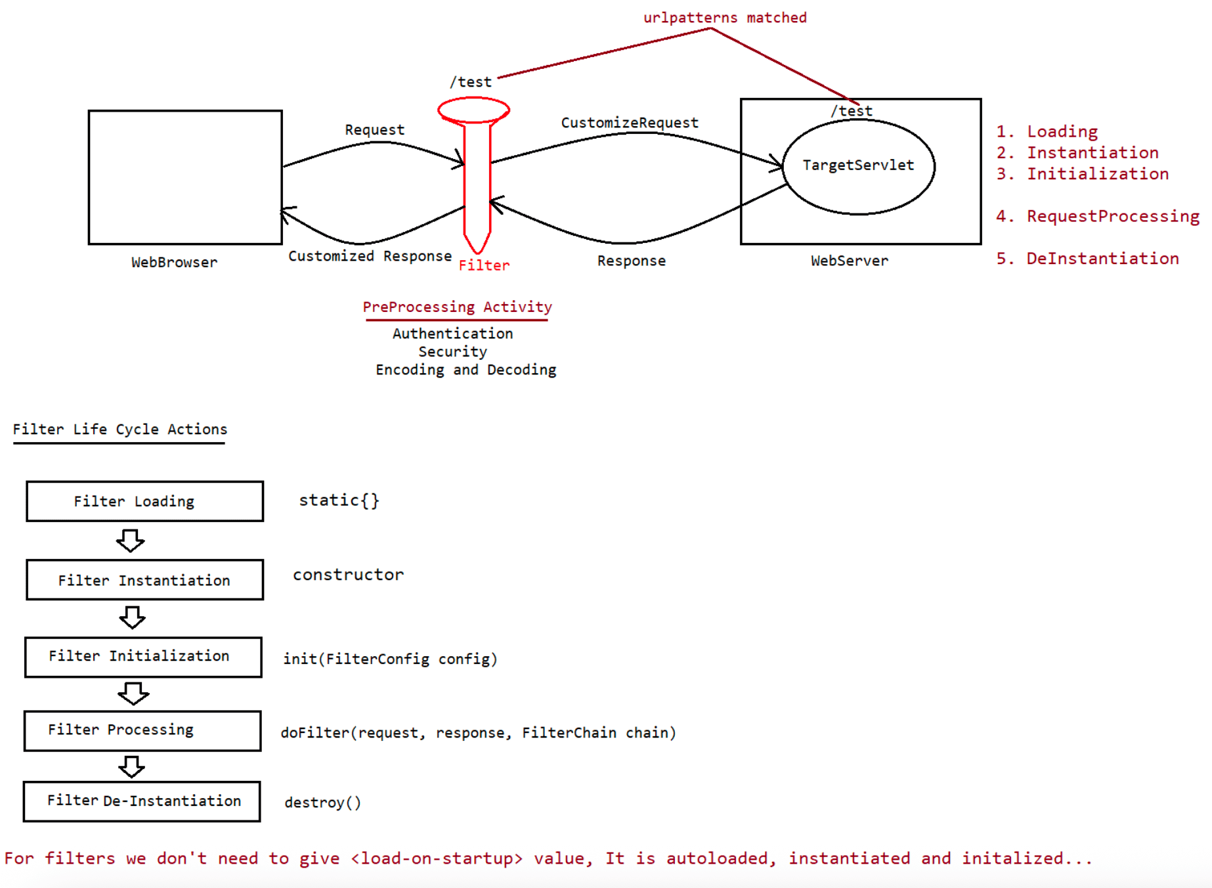
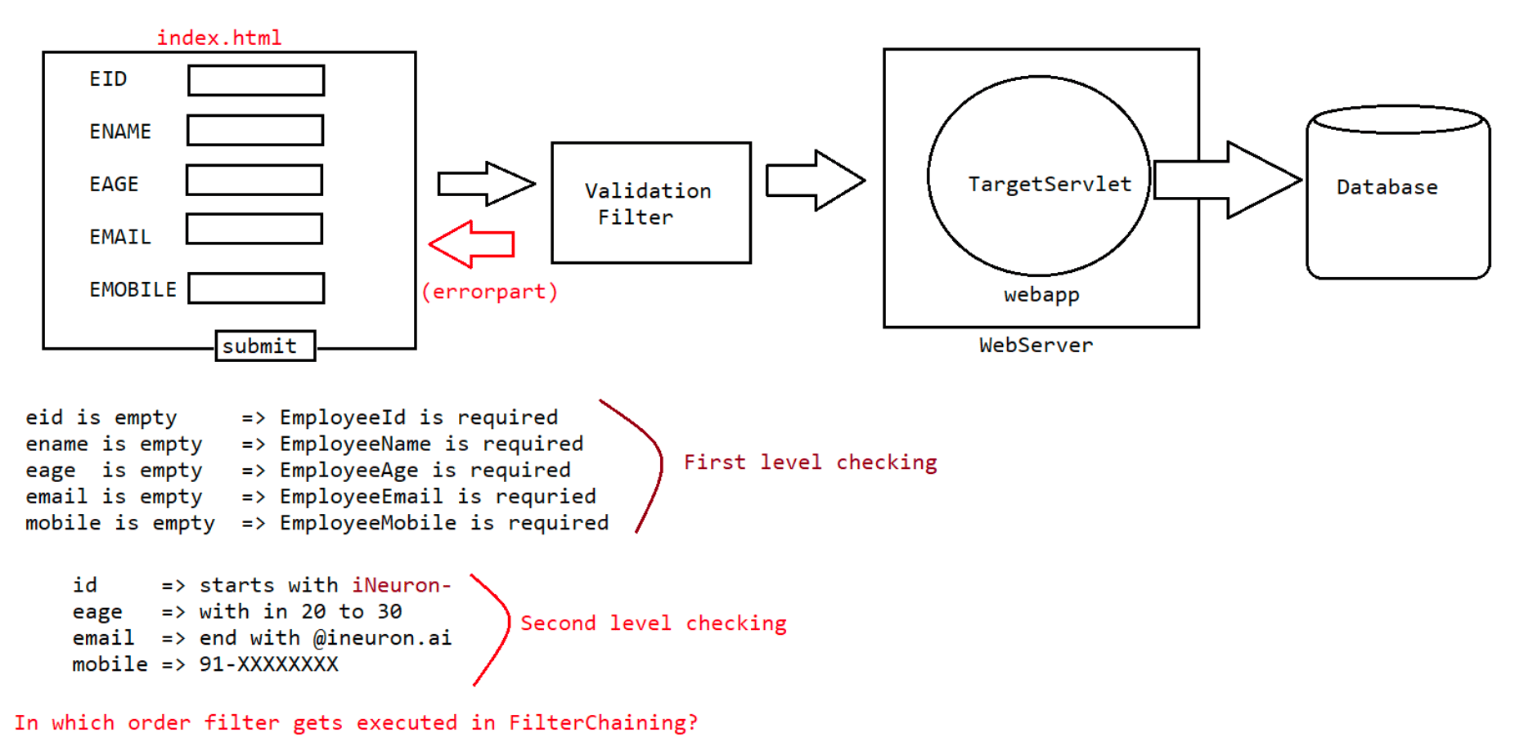
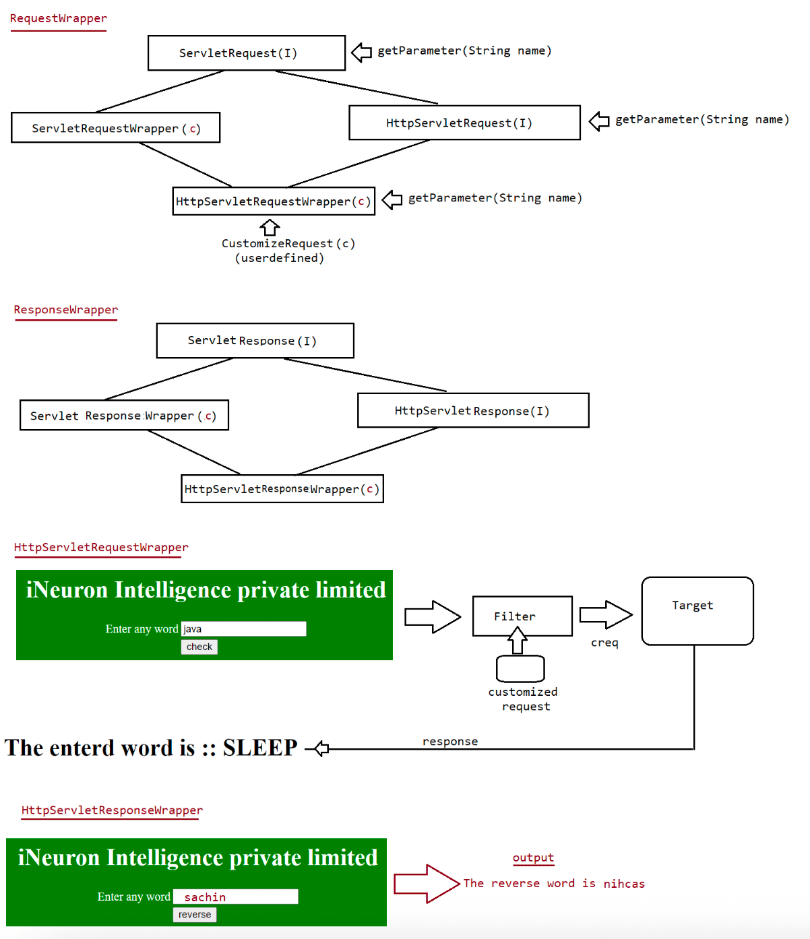

112 ServletListeners, SerlverResponseWrapper,Project of filter interceptors

In case of webapplications there would be a chance of occuring several events like
a. Request Object creation
b. Request Object destruction
c. Session object creation
d. Session object destruction
e. Context object creation
f. Context Object destruction
g. Attribute added in request scope
;;;;;;;;;;
;;;;;;;;;
;;;;;;;;
Whenever these events occur and if we want perform some specific operations then we
need to go for "Listeners".
Listeners will listen to the Event and will perform action/operation automatically.
In Servlet Api Listeners are classified into 3 types
a. RequestListener(related to request object)
1. SerlvetRequestListener
2. ServletRequestAttributeListener
b. SessionListener(related to session object)
1. HttpSessionlListener
2. HttpSessionAttrributeListener
3. HttpSessionBindingListener
4. HttpSessionActivationListener
c. ContextListener(related to context)
1. ServletContextListener
2. ServletContextAttributeListener
ServletRequestListener
===================
public interface ServletRequestListener extends EventListener {
public void requestDestroyed(ServletRequestEvent reqEvent);//it gets called
at the time of request object destruction
public void requestInitialized(ServletRequestEvent reqEvent);//it gets called
at the time of request object creation
}
refer: ServletRequestListenerApp
Note: listeners information is configured in web.xml file using
<listener>
</listener>
<listener-class>in.ineuron.listener.RequestDemoListener</listener-class>
ServletRequestAttributeListener
==========================
public interface ServletRequestAttributeListener extends EventListener {
public void attributeAdded(ServletRequestAttributeEvent event);//adding the
attribute to request object.s
public void attributeRemoved(ServletRequestAttributeEvent event);//removing the
attributes from request object.
public void attributeReplaced(ServletRequestAttributeEvent event);//updating the
attributes in the request object.
}
refer: ServletRequestAttributeListenerApp
Note: using annotation if we want to represent a Listener we use "@WebListener".

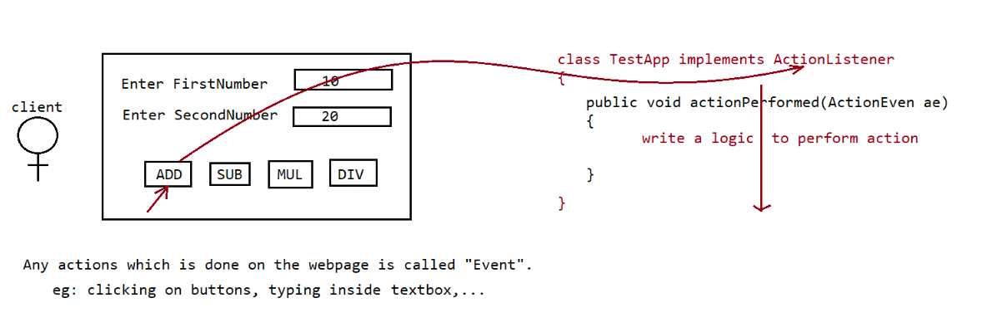

114 JSP Architecture, JSP life cycle actions, JSP Directives, JSP vs Servlet difference
Servlet vs JSP(Java Server Pages)
===========================
Servlet => meant for processing logic
eg: verify the user, checking account balance, collecting data
from database,....
JSP => meant for Presentation logic, to display something to the end user
eg: Display login page, display inbox page, display error page
Note:
1. Inside Servlet(java code) we should not write presentation logic(no usage
of println()).
2. Inside JSP we should not write buisness logic meant for presentation logic
only (no usage of java code inside jsp's).
3. JSP program consists of only tags.
4. JSP programs are autocompiled and autoloaded.
5. Servlet programs are executed by "CATALINA" container vs JSP programs are
executed by "JASPER" container.
6. JSP is a technology which is built on top of Servlet Technology.
Writing the code using jsp technology is so easy compared to writing the code using
Servlet?
Ans. JSP is easy because of its abstraction from the programmer.
JSP API
======
1. It contains 2 interfaces
a. JspPage(I)
b. HttpJspPage(I)
JspPage(I)
a. It contains 2 methods jspInit(), jspDestroy()
HttpJspPage(I)
throws SE,IOE
It is an interface which contains only one method _jspService(HSR,HSResp)
Note:
public abstract class HttpJspBase{
public final void init(ServletConfig config) throws
javax.servlet.ServletException{
jspInit();
}
public final void destroy(){
jspDestroy();
}
public final void service(HttpServletRequest request,HttpServletResponse
response) throws SE,IOE{
_jspService(request,response);//inside this method automatically
our logic written in jsp will be placed in translated servlet
}
}
Is it possible to write init(), destroy(),service() in our jsp code?
Answer: No, not possible becoz these methods are final in HttpJspBase class.
Is it possible to write _jspService(requese,response) method explicitly inside JSP?
Answer: No, if we write inside the translated servlet there will be 2 _jspService()
method which would lead to
compile time error.What is the significance of _ symbol in _jspService()?
Answer: It indicates this method is generated automatically by JSP engine/jasper
container and we cannot write it explicitly.
Life Cycle of JSP
============
1. Translation phase(.jsp -> .java)
2. Compilation phase(.java -> .class)
3. Servlet loading
4. Servlet Instantiation
5. Servlet Initialization (jspInit())
6. Request Processing(_jspService(request,response))
7. Servlet DeInstantiation(jspDestroy())
refer: FirstApp
In case of JSP
execution,Translation,Compilation,Loading,Instantiation,Initialization will happen
for firstrequest where as
from second request only "RequestProcessing" will happen.
This would increase the response time for the first request and would not bring
uniformity in the response time for clients.
To avoid this we need to go "Precompilation" of jsp code as shown below
http://localhost:9999/FirstApp/index.jsp?jsp_precompile=true
Translation,Compilation,Servlet loading,Servlet
Instantiation,ServletInitialization
After compilation of jsp code we can send the request as shown below
first request => http://localhost:9999/FirstApp/index.jsp----->
only request processing
second request => http://localhost:9999/FirstApp/index.jsp----> only
request processing
JSP Scripting Elements
==================
1. Template Text
2. Scripting Elements
3. Standard and custom actions
4. Express language elements
1. Template Text
It contains plain text with html tags
For this processing is not required and it will become argument to write()
inside _jspService() method.
eg:
<h1>The server time is <%= new java.util.Date() %></h1>
The translated servlet code is
public final class index_jsp extends HttpJspBase....
{
public void _jspService(){
out.write("<h1>The server time is ");
out.print(new java.util.Date());
out.write("</h1>");
}
}Q>Template text will become argument to write() method where as expression value
will become argument to print(), what
is the reason?
Answer: write() -> it can take only character data as a argument.
print() -> It can take any type of data as an argument.
Directives
========
Directives are used to provide general information about jsp page to the
JSPEngine.
Directives are translation time instructions to JSP Engine.
There are 3 types of directives
a. page directive
b. include directive
c. taglib directive
page directive
============
=> This directive is used to specify overall properties of jsp page to JSP Engine.
=> syntax: <%@ page [attribute_Name]=[attribute_Value] %>
=> There are 13 attributes associated with page directive
a. import
b. session
c. contentType
d. isElIgnored
e. isThreadSafe
f. language
g. extends
h. buffer
i. autoFlush
j. info
k. pageEncoding
l. isErrorPage
m. errorPage
1. import
This attribute is used to import the classes being used in our jsp pages.
We can use import attribute as shown below
1. <%@ page import = "java.util.*"%>
2. <%@ page import = "java.util.Date, java.util.ArrayList" %>
3. <%@ page import = "java.util.Date" import =
"java.util.ArrayList"%>
4. <%@ page import ="java.util.Date"%>
<%@ page import = "java.util.ArrayList"%>
Default value of import attribute is
import javax.servlet.*;
import javax.servlet.http.*;
import javax.servlet.jsp.*;
import java.lang.*;
Note: with in jsp page, we are not allowed to take any attribute multiple times
with mulitple values.
But we can take multiple times with same value, This rule is not
applicable only for "import" attribute.
eg:
%>
<%@ page language ="java" import = "java.util.Date" import = "java.util.ArrayList"
<h1>The server time is :: <%= new Date()%></h1><h2>Array List object creation is :: <%= new ArrayList().size()%></h2>
output
The server time is :: Tue Feb 14 22:37:24 IST 2023
Array List object creation is :: 0
2. session
By default session object is available in every jsp page.
session -> HttpSession
If we don't want session object to be used inside jsp page then we can make
it unavilable using page directive
<%@ page session = "true" %>
|
javax.servlet.http.HttpSession session = null;
session = pageContext.getSession();
<%@ page sesion = "false" %>
Then the above 2 lines won't be available in the translated servlet code.
Note:
1. <%@ page session = "true" session = "true" %>(valid)
2. <%@ page session = "true" session = "false" %>(invalid)
3. <%@ page import = "java.util.Date" import = "java.util.ArrayList"%>(valid)
4. <%@ page session ="true" %>(valid)
5. <%@ page imoprt = 'java.util.Date' %>(valid)
6. <%@ page session = "divya" %>(invalid)
7. <%@ page session = "False" %>(invalid)
8. <%@ page session = "TRUE" %>(invalid)
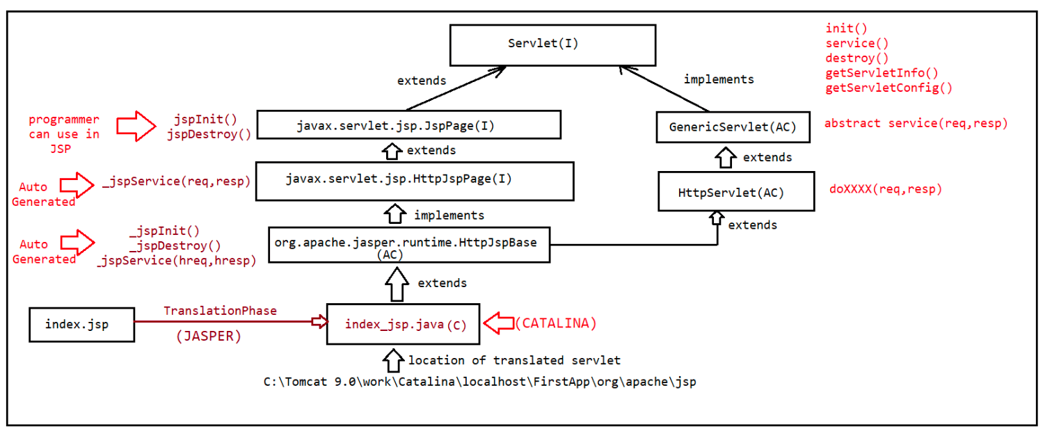
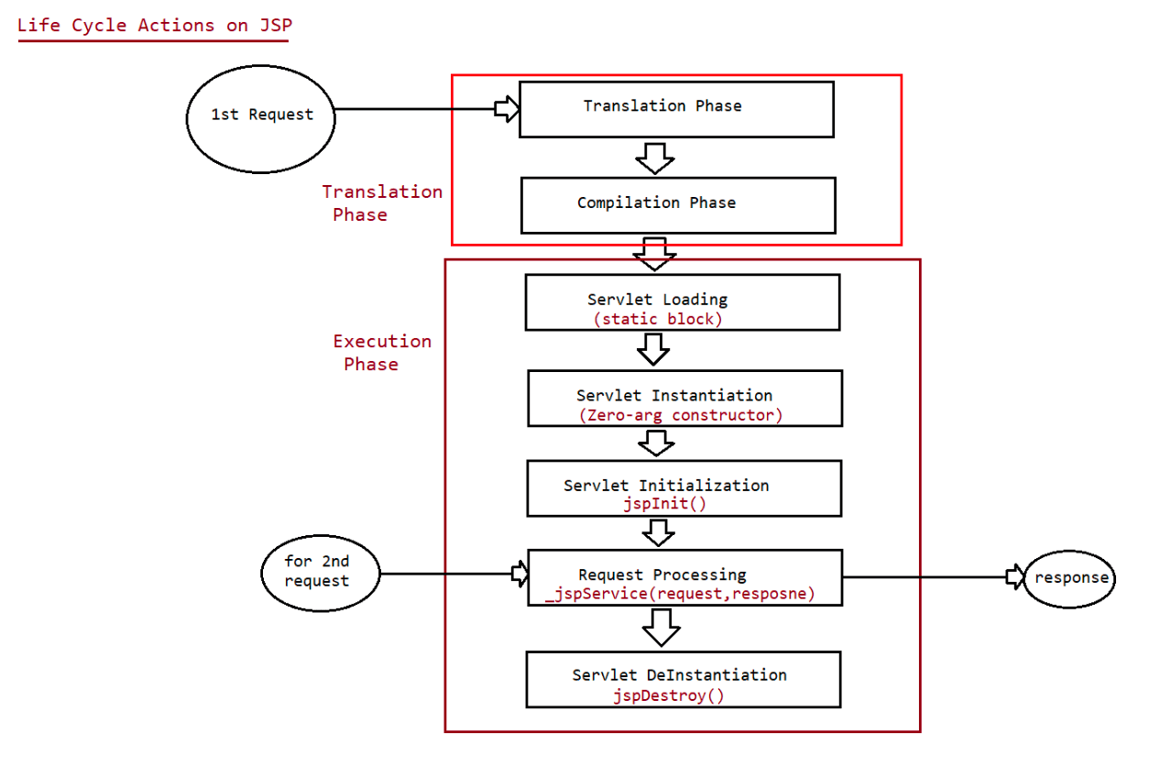
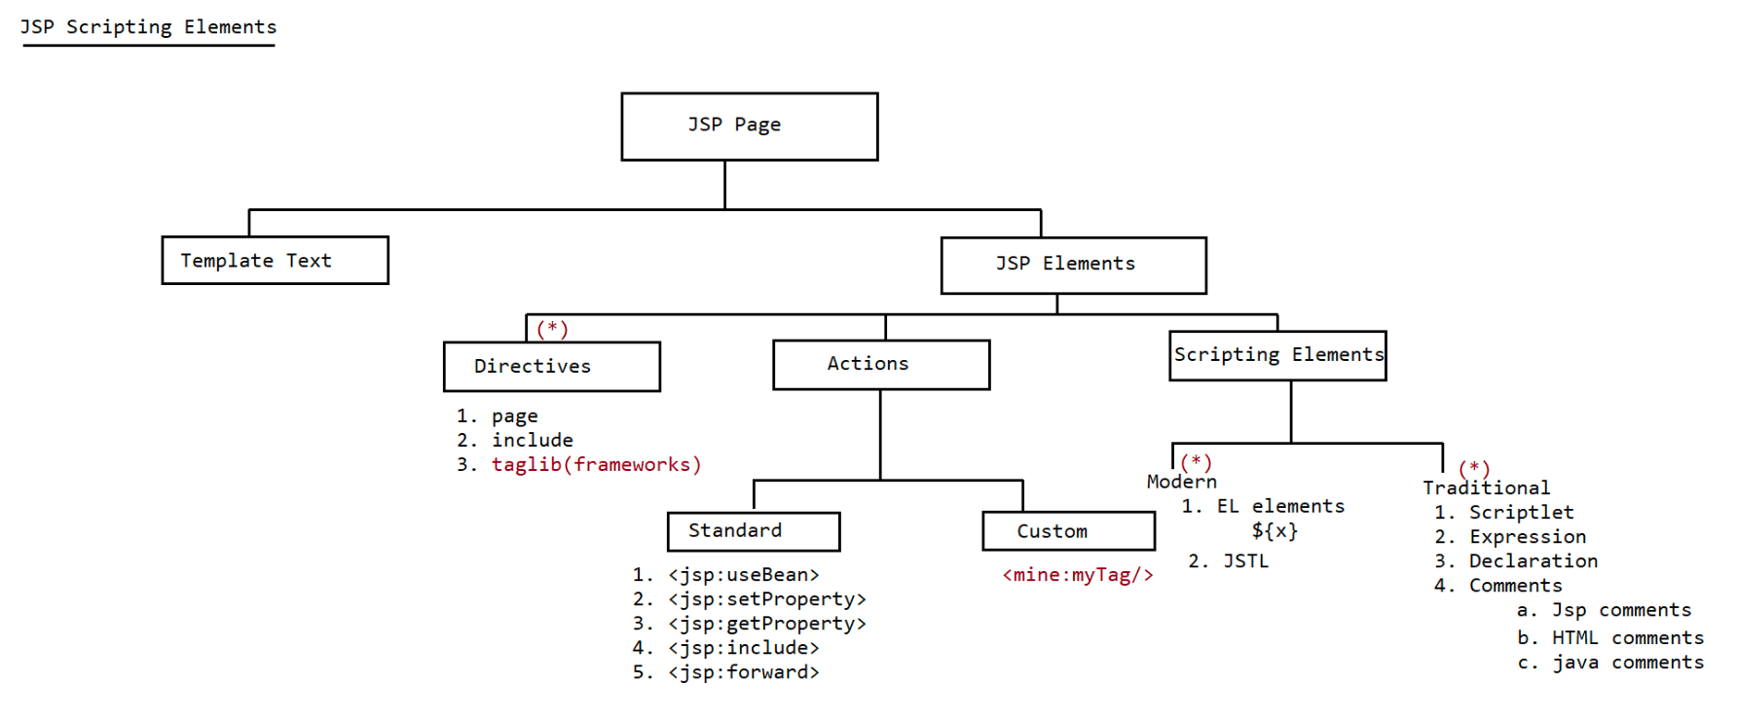

115 JSP implicit objects, jsp directives

JSP------> To attract frontend developers to build webapplication without having
knowledge of java
They should be comfortable only with presentation skills.
page directive attributes
===================
1. import
2. session
3. contentType
4. buffer
5. autoFlush
6. isELIgnored
7. errorPage
8. isErrorpage
9. info
10 .language
3. contentType
<%@ page contentType='application/pdf'%>
We can use this attrribute to set the response type(MIME type of response)
Default value is : text/html
4. isELIgnored
Inside jsp page if we want to use modern elements syntax (EL) syntax , then
we need to use
isELIgnored attribute.
1. <%@ page isELIgnored = 'true' %>
EL syntax won't be processed and just treated as plain
text.
2. <%@ page isELIgnored = 'false' %>
El syntax will be processed and prints its value.
eg::
<%@ page language ="java" isELIgnored ='false'%>
<h1>Working with Page Directives...</h1>
<h1>
Username is :: <%= request.getParameter("username") %>
</h1>
<h1>
Accessing Username through EL Syntax :: ${param.username}
</h1>
output
=====
http://localhost:9999/FirstApp/index.jsp?username=sachin
Working with Page Directives...
Username is :: sachin
Accessing Username through EL Syntax :: sachin
Note:
if isELIgnored = 'true', then EL won't be evaulated it would be treated as a plain
text
Default value of isELIgnored = false.
Output
======
http://localhost:9999/FirstApp/index.jsp?username=sachin
Working with Page Directives...
Username is :: sachin
Accessing Username through EL Syntax :: ${param.username}5. info
<%@ page info = "Application developed by iNeuron" %>
To get this value we use a method called "getServletInfo()".
The default value of info is "Jasper JSP 2.3 Engine".
eg:
<%@ page language ="java" info = "Application developed by iNeuron"%>
<h1>Working with Page Directives...</h1>
<h1>
<%= getServletInfo() %>
</h1>
6. buffer,autoFlush
<%@ page buffer='52kb' %>
The default value of buffers is 8kb.
autoFlush ->It is a boolean attribute which is used to give an information to
the container about flushing the
dynamic response to the client automatically or not.
if autoFlush value is true, then container will flush the complete response to
the client from the buffer when it
reaches the maximum capacity.
if autoFlush value is false, then container will raise an exception when the
buffer is filled with the response.
eg:
<%@ page language ="java" buffer='52kb' autoFlush='true'%>
<h1>Working with Page Directives...</h1>
<%
for(int i = 0;i<=100000000;i++)
out.println("iNeuron");
%>
7. errorPage,isErrorPage
forward the exception object to
errorPage -> if any exception occurs in the jsp page then we need to
other jsp page, to do so we need to use the
attribute called "errorpage".
inside the jsp page or not.
isErrorPage-> It helps the jsp container to allow exception object
By default the value is 'false', so implicit
object exception is not allowed inside jsp page.
To make it accessible inside jsp page we need to
use 'true' value.
index.jsp
=======
<%@ page language ="java" errorPage = 'error.jsp'%>
<h1>Working with Page Directives...</h1>
<%
java.util.Date d =null;
out.println(d.toString());
%>
error.jsp
=======
<html>
<%@ page language ='java' isErrorPage='true'%>
<body bgcolor='cyan'><center>
<b>
<font size='5' color='red'>
<%=exception%>
</font>
</b>
</center>
</body>
</html>
JSP implicit objects
================
To make the coding easy in jsp there are few object which are readily available to
programmers.
There are 9 jsp objects available
1. request -------> HttpServletRequest(I)
2. response------> HttpServletResponse(I)
3. config ---------> ServletConfig(I)
4. application---> ServletContext(I)
5. session -------> HttpSession(I)
6. out-------------> JspWriter(AC)
7. page-----------> Object(CC)
8. pageContext---> PageContext(AC)
9. exception-------> Throwable(CC)
request,response
==============
These object are directly available inside jsp, where we can call the methods
associated with HttpServletReqeust,
HttpServletResponse.
eg:
<%@ page language ="java" isELIgnored='false'%>
<h1>Working with Implicit object(9)...</h1>
<h1>
Request method type is :: <%= request.getMethod()%><br/>
Request parameter is :: <%= request.getParameter("username") %><br/>
Client ip address is :: <%= request.getRemoteAddr() %><br/>
Content type info is :: <%= response.getContentType() %>
</h1>
input
=====
http://localhost:9999/FirstApp/index.jsp?username=sachin
output
======
Working with Implicit object(9)...
Request method type is :: GET
Request parameter is :: sachin
Client ip address is :: 0:0:0:0:0:0:0:1
Content type info is :: text/html
application
=========
The data should be configured in "ServletContext" object.
It can be configured only in XML approach.
web.xml-----------
<web-app>
<display-name>JSP IMPLICIT OBJECT</display-name>
<context-param>
<param-name>username</param-name>
<param-value>iNeuron</param-value>
</context-param>
</web-app>
index.jsp
------------
<%@ page language ="java" isELIgnored='false'%>
<h1>Working with Implicit object(9)...</h1>
<h1>
The context parameter UserName is ::
<%=application.getInitParameter("username")%><br/><br/>
The application name is :: <%= application.getServletContextName()%>
</h1>
output
---------
Working with Implicit object(9)...
The context parameter UserName is :: iNeuron
The application name is :: JSP IMPLICIT OBJECT
session
======
It is of type HttpSession,by default available to every jsp page.
HttpSession methods can be called using "session" object.
index.jsp
------------
<%@ page language ="java" isELIgnored='false'%>
<h1>Working with Implicit object(9)...</h1>
<h1>
Session id is :: <%= session.getId() %><br/>
Is Session newly Created :: <%= session.isNew() %> <br/>
Session Time out is :: <%= session.getMaxInactiveInterval() %> seconds<br/>
</h1>
output
=====
Working with Implicit object(9)...
Session id is :: 0D4130EFB9D3705C8A978998DF79AD1A
Is Session newly Created :: false
Session Time out is :: 1800 seconds
config
--------
It is of type ServletConfig.
methods applied on config object
a. getServletName()
b. getInitParameter(String name)
c. getInitParameterNames()
d. getServletContext()
web.xml
-----------<web-app>
<display-name>JSP IMPLICIT OBJECT</display-name>
<servlet>
<servlet-name>DemoJsp</servlet-name>
<jsp-file>/config.jsp</jsp-file>
<init-param>
<param-name>username</param-name>
<param-value>iNeuron</param-value>
</init-param>
</servlet>
<servlet-mapping>
<servlet-name>DemoJsp</servlet-name>
<url-pattern>/test</url-pattern>
</servlet-mapping>
</web-app>
config.jsp
========
<%@ page language ="java" isELIgnored='false'%>
<h1>Working with Implicit object(9)...</h1>
<h1>
The logical name of the servlet is :: <%= config.getServletName()%><br/><br/>
The initialization parameter is :: <%= config.getInitParameter("username")%>
</h1>
Scene1:
request
======
http://localhost:9999/FirstApp/config.jsp
response
========
Working with Implicit object(9)...
The logical name of the servlet is :: jsp
The initialization parameter is :: null
Scene2:
request
---------
http://localhost:9999/FirstApp/test
response
------------
Working with Implicit object(9)...
The logical name of the servlet is :: DemoJsp
The initialization parameter is :: iNeuron
note: To reflect servlet level web.xml file configuration in jsp ,compulsorily we
should access it through 'url-pattern'.
pageContext
===========
It is a implicit object of type PageContext.
using pageContext object we can perform 3 things
a. We can get all the other implicit objects not in jsp ,but in "custom
action tags".
b. To peform attribute management in scope(Jsp scopes).
c. To perform request dispatching mechanism we use pageContext.RequestDispatching mechanism in jsp
===============================
public void forward(String target)
public void include(String target)
note: Target resource can be supplied either using relative path or
absolute path.
first.jsp
---------
<h1>This is First JSP</h1>
<%
pageContext.include("second.jsp");
%>
second.jsp
--------------
<h1>Hello This is Second JSP page...</h1>
output
======
request
----------
http://localhost:9999/SecondApp/First.jsp
response
-----------
This is First JSP
Hello This is Second JSP page...
page implicit object
================
1. This implicit object always points to Current Servlet object
Object page = this;
2. Since page is of type Object, can we make a call to Servlet specific methods?
Answer. Not possible , we can make a call only to Object class methods.
If we want to make a call then we need to do explicit
TypeCasting.
Which of the following statements are valid?
1. <%= page.getServletInfo() %>//invalid
2. <%= this.getServletInfo() %>//valid
3. <%= getServletInfo() %>//valid
4. <%= ((HttpServlet)page).getServletInfo() %>//valid
note: since on page object we can't make a call to servlet methods, so page object
is rarely used object.
2. include directive
If several jsp pages contains the same code, then it is recomended to
seperate that common code in a seperate file.
Wherever that common code is requried we can "include" that file.
This mechanism is only called as "include" mechanism, and commonly used
nature of include is to add
"header" and "footer" information which is common in every jsp pages.
Advantages
=========
a. It promotes code Reusability.b. It improves the maintainence of the code.
c. Enhancements will become easy.
include directive
==============
<%@ include file='' %>

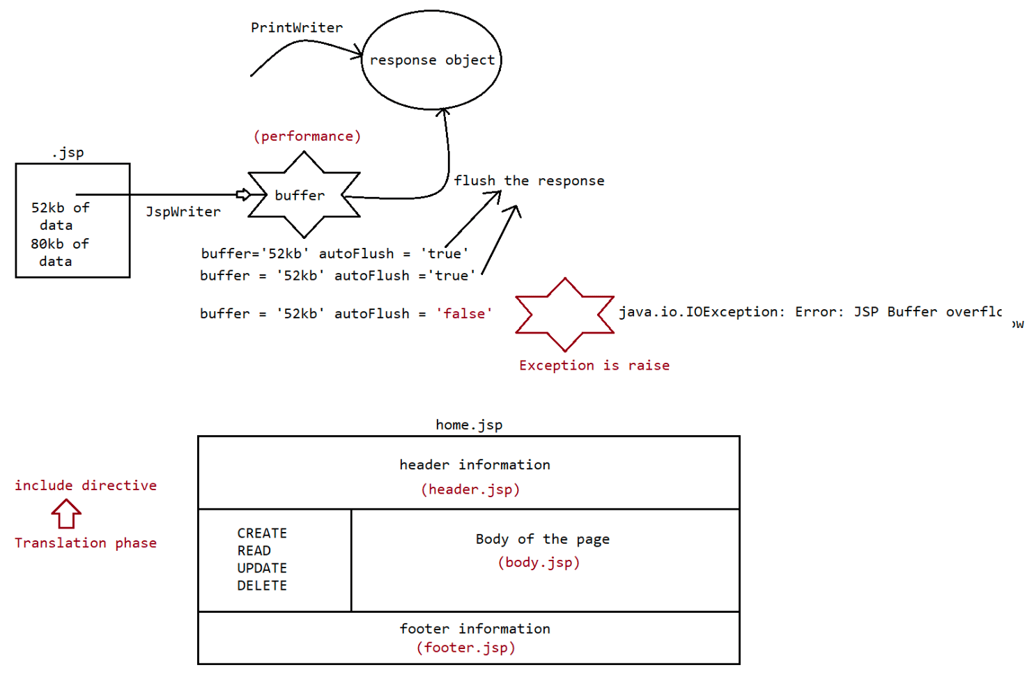
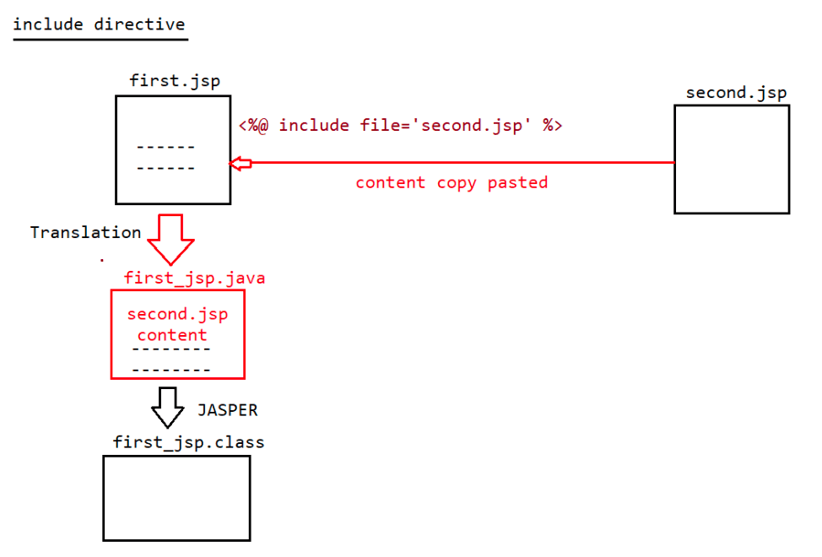

117 jsp scripting elements, project of html jsp db communication using scripting elements

Directives
========
1. page directive
2. include directive
3. taglib directive
taglib directive
============
=> We can use taglib directive to make custom tags available to our jsp page.
=> <%@ taglib uri = ''Location of TLD file" prefix=''[prefixName for a tag]" %>
=> taglib directive contains 2 attributes prefix and uri.
=> uri represents the location of TLD file which inturn represents the TagHandler
class.
eg::In SpringMVC to design a view using jsp we prefer working with form tag library
given by pivotal team
index.jsp
=======
<form:form>
<table>
<tr>
<%@ taglib uri ='http://www.springframework.org/tags/form' prefix='form'%>
<td>First Name:</td>
<td><form:input path="firstName" /></td>
</tr>
<tr>
<td>Last Name:</td>
<td><form:input path="lastName" /></td>
</tr>
<tr>
<td colspan="2">
<input type="submit" value="Save Changes" />
</td>
</tr>
</table>
</form:form>
JSP Scripting Elements
==================
There are 2 types of Scripting elements
a. Traditional Scripting elements.
b. Modern Scripting elements.
Traditional Scripting elements
a. Expression (<%= expression%>)
b. Scriptlet(<% any java code%>)
c. Declarative(<%! any java declarations %>)
d. Comments(<%-- JSP comments --%>)
1. Expression tag
This tag is used to print java expression values to the JSP.
syntax: <%= expression %>
Inside the servlet the code would be replaced as
_ jspService(request,response)
{
out.print(expression);
}index.jsp
=======
<h1 style='color:blue;text-align:center;'>Working with Expression tag</h1>
<h1 style='color:green;text-align:center;'>
Username is :: <%= request.getParameter("username")%><br/>
Password is :: <%= request.getParameter("password")%><br/>
</h1>
request ===> http://localhost:9999/ThirdApp/index.jsp?
username=sachin&password=tendulkar
Conclusions
==========
1. Inside the expression tag, we are not supposed to keep ; symbol,if we keep it
would result in 500 server error.
<%= new java.util.Date(); %>//invalid
2. Inside an expression tag we can use method calls also,but void return type
method calls are not allowed.
<%= new java.util.ArrayList().size() %>//valid
<%= new java.util.ArrayList().clear() %>//invalid
3. Inside an expression tag space is not allowed between % and = , it would result
in 500 server error.
<% =request.getParamter("username") %>//invalid
4. Inside an expression tag declaration statements are not allowed.
<%= String name ="dhoni" %>//invalid
which of the following are valid java expression?
1. <%= 27 %> //valid
2. <%= "27" %>//valid
3. <%= Math.random()%>//valid
4. <%= 10*20 %>//valid
5. <%= 10>20 %>//valid
6. <%= new Student() %>//valid
7. <%= String name= "Apeksha"%>//invalid
Scriptlet tag
==========
Syntax:
<%
We use this tag to write java code inside jsp.
Any java code
%>
Java code inside Scriptlet tag will be placed directly inside _ jspService()
method of generated servlet.
Every java statement present inside Scriptlet tag should be terminated with ;
symobl.
eg:
index.jsp
=======
<%
<h1 style='color:blue;text-align:center;'>Working with Scriptlet tag</h1>
int x =10;
out.println(x);
%>
request -> http://localhost:9999/ThirdApp/Note: It is not recomended to use Scriptlet tag inside jsp.
Declarative Tag(<%! %>)
====================
We can use Declarative tag to declare instance variables, static block, instance
block, methods etc...
Syntax:
<%!
Any java declarations
%>
Note: Any java declarations written inside declarative tag would be placed directly
in the generated servlet but outside
_ jspService() method.
index.jsp
=======
<%!
<h1 style='color:blue;text-align:center;'>Working with Declarative tag</h1>
int x =10;
static int y = 20;
int[] a = {10,20,30};
public String m1(){
System.out.println(a[0]);
System.out.println(x);
return "working with Declarative tag";
}
%>
<%= m1()%>
request=> http://localhost:9999/ThirdApp/
index.jsp
=======
<%!
public String m1(){
int x = 10;
out.println(x);
return "working with Declarative tag";
}
%>
<%= m1()%>
request=>http://localhost:9999/ThirdApp/
output: CE: out can't be resolved.
Note: All jsp implicit objects are local to _ jspService() method,but declaration
tag code will be placed outside of _ jspService()
method.so we can't use jsp implicit objects inside declartion tag.
Where as scriptlet and expression tag code will be placed directly inside
_ jspService(),so jsp implicit objects are
accessible inside scriptlet and expression tag.
index.jsp
=======
<%!
<h1 style='color:blue;text-align:center;'>Working with Scripting Elements</h1>
java.util.Date d = null;String date =null;
%>
<%
d = new java.util.Date();
date = d.toString();
%>
<html>
<head><title>Output</title></head>
<body bgcolor='lightyellow'>
<center>
<b>
<font size='6' color='red'>
Today date is <%= date%>
</font>
</b>
</center>
</body>
</html>
4. Comments inside JSP
code(jsp comments).
Inside jsp can we write html code(html comments),java code(java comments),jsp
1. JSP comments
<%-- jsp comments --%>
2. HTML comments
<!-- HTML comments -->
3. Java comments
1. // single line comments
2. /*
multiline comments
*/
3. /**
Java documentation comments
*/
summary of jsp comments
======================
a. jsp comments
Is it visible in jsp ==================> yes
Is it visible in translated servlet =======> no
Is it visible in end user response source code ======> no
b. html comments
Is it visible in jsp ==================> yes
Is it visible in translated servlet ======> yes
Is it visible in end user response source code =====> yes
c. java comments
Is it visible in jsp ==================> yes
Is it visible in translated servlet ======> yes
Is it visible in end user response source code=====> no
Note: Among expression,scriptlet,declaration and jsp comments, we cannot use one
inside another.ie, nesting of these scripting elements is not possible, if we try to do
it would result in 'CompileTimeError'.
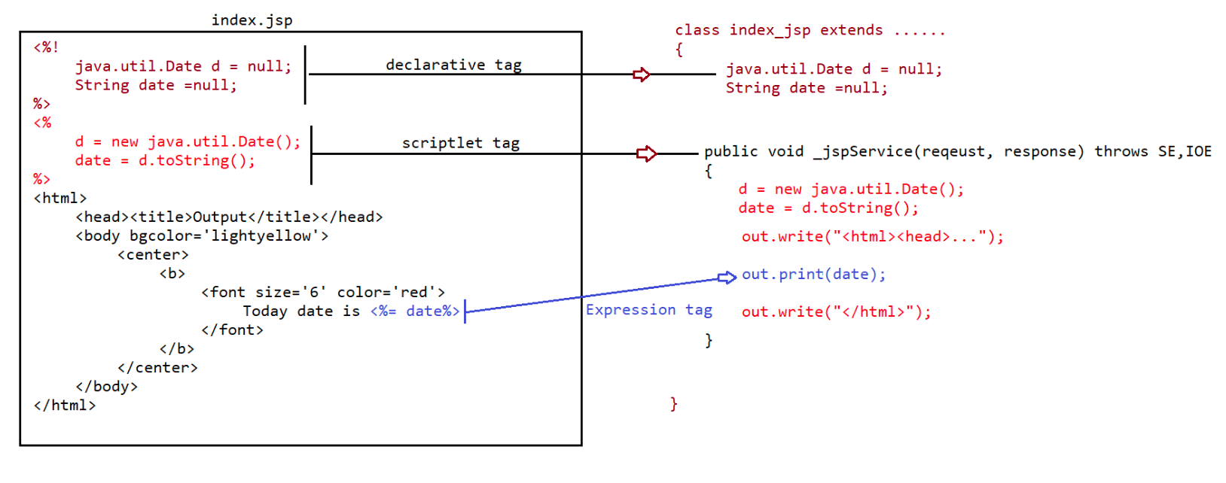
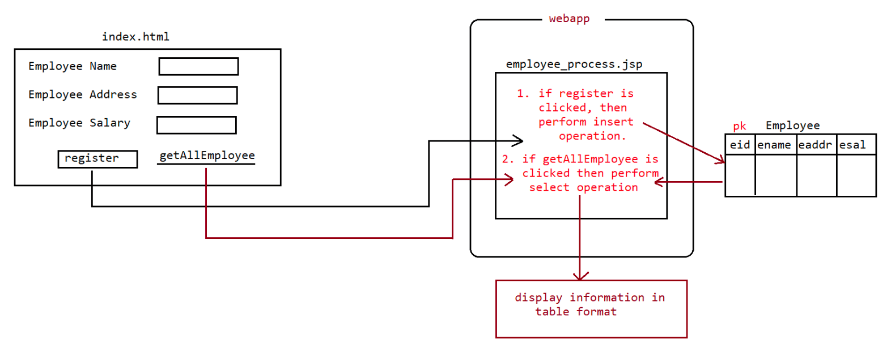

118 JSPActions and JSP Scopes, one project with JSP scopes and action

JSP Standard Actions
=================
JSP -> Java Server pages
It is given by SUNMS to give a technology which would attract front end developers
and main theme of jsp is to avoid
java code as much as possible.
index.jsp
-----------
<%@ page language="java" %>
<%!
public int squareIt(int x){
return x*x;
}
%>
<h1>
The Square of 5 is :: <%= squareIt(5) %><br/>
The Square of 6 is :: <%= squareIt(6) %><br/>
</h1>
This approach has several disadvantages
1. There is no clear cut seperation b/w presentation logic and business logic.
2. Person who is writing this jsp should compulsorily have knowledge of java and
html which may not be possible always.
3. It won't promote code ReUsability.
4. It reduces the readability of the code also.
We can resolve this problem by encapsulating total buisness logic inside java bean.
Calculator.java
--------------------
package in.ineuron.bean;
public class Calculator {
static {
System.out.println("Calculator.class file is loading...");
}
public Calculator() {
System.out.println("Calculator class object is created...");
}
public int squareIt(int x) {
return x * x;
}
}
index.jsp
-----------
<%@ page language="java"%>
<jsp:useBean id="calculator" class="in.ineuron.bean.Calculator"/>
<h1>
The Square of 5 is :: <%= calculator.squareIt(5)%><br/>
The Square of 6 is :: <%= calculator.squareIt(6)%><br/>
</h1>
Advantages of this approach is
1.Seperation of Buisness logic and presentation logic
Presentation logic is available only in jsp where as Buisness logic is
available in java class so readability of the code isimproved.
2. Seperation of responsibilities
Java developers can focus on buisness logic where as HTML page designer can
concentrate on presentation logic.
As a result of which both can work simultaneously and we can reduce the
project development time.
3. It Promotes ReUsability of the code
where ever squareIt() functionality is required we can resuse it in jsp
pages.
JspStandardactions
=================
The main purpose of standard actions is to avoid java code as much as possible
inside jsp.
Instead of java code ,we use tags and those tags internally will do some java logic
and make front end developer work less.
1. <jsp:useBean id =' ' class=' ' scope=' '><jsp:useBean>
This tag is used to create an object/locate an object for a particular
class.
2. <jsp:setProperty name = ' ' property = ' ' value=''/>
This tag is used to set the values for the properties of the bean.
3. <jsp:getProperty name=' ' property=' '/>
This tag is used to get the values from the properites of the bean.
To set the values to the jsp page
http://localhost:9999/JspStandardAction-02/set_value.jsp?
sid=18&sname=kohli&saddress=RCB&sage=35
To get the values from the jsp page
http://localhost:9999/JspStandardAction-02/get_values.jsp
refer: JspStandardAction-02, JspStandardAction-03
2. Reusable components
1. <jsp:include> ====> refer: JspStandardAction-04
Different ways of performing include in jsp
====================================
1. <@include file='header.jsp'>
2. <jsp:include file='header.jsp'>
3. <%
RequestDispatcher rd =reqeust.getRequestDispatcher('./header.jsp');
rd.include(request,response);
%>
4. <%
pageContext.include('header.jsp');
%>
2. <jsp:forward> ======> JspStandardAction-05
Different ways of performing forward in jsp
====================================
1. <jsp:forward file='header.jsp'>
2. <%
RequestDispatcher rd =reqeust.getRequestDispatcher('./header.jsp');
rd.forward(request,response);
%>
3. <%pageContext.forward('header.jsp');
%>
3. <jsp:param> =====> refer: JspStandardAction-06
1. It should be used as subtag for <jsp:include> or <jsp:forward> tags
2. It is very useful to send the data as the addition request params values
from source jsp page to destination
web components.
3. syntax:
<jsp:param name='' value=''/>

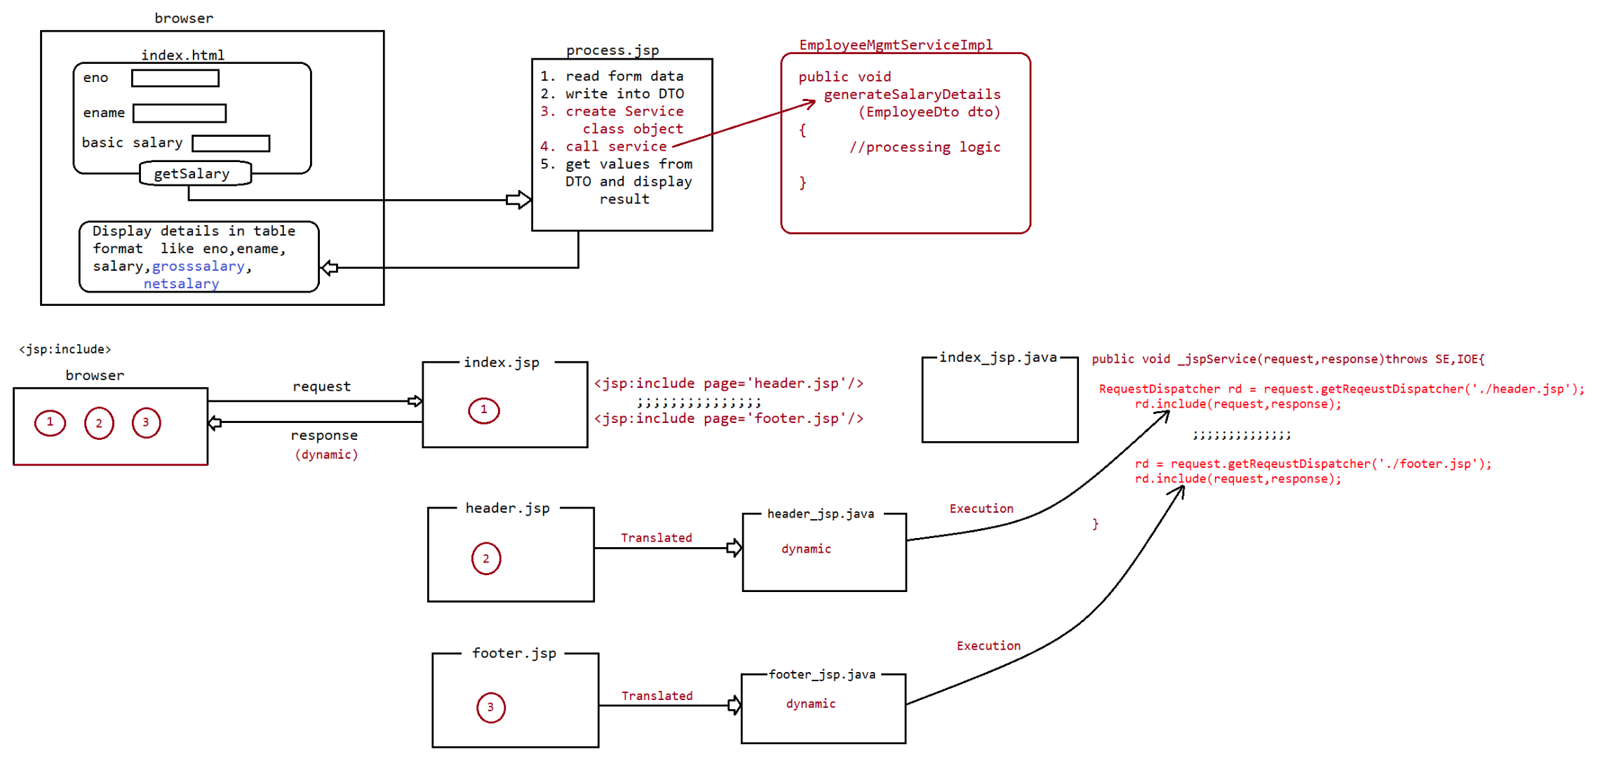
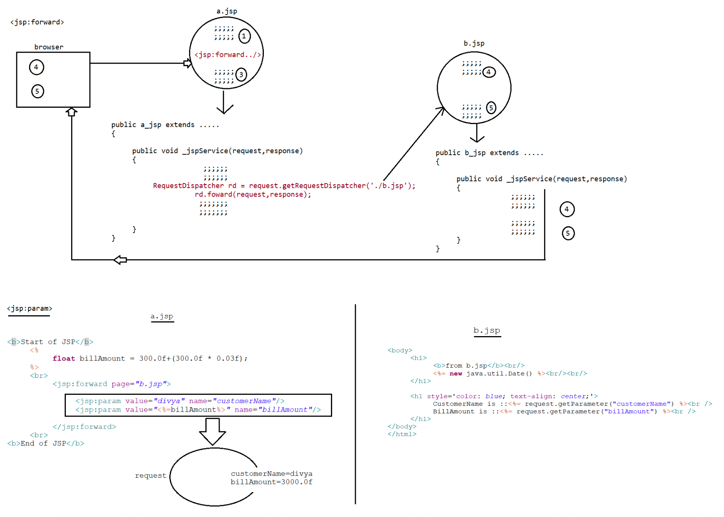

120 Jsp custom actions, JSP scopes and EL

JSP(main theme is to avoid java code as much as possible)
===============================================
Standard actions ===> Predefined actions provided by jsp technology.
Custom actions
These are the jsp actions which are prepared by the developers as per their
application requirement.
syntax: <prefix_Name: tagName>
-----
-----
-----
</prefix_Name>
To work with custom actions we need to use
a.jsp taglib directive
b.TLD file(Taglibrary descriptor)
c. TagHandler class
refer: ***.png
TagHandler class
=============
In custom tags preparation, the main purpose of Tag Handler class is to define the
basic functionality for the
custom tags.
To define the Taghandler class in custom tags preparation JSP API has
provided a predefined library in the form
of javax.servlet.jsp.tagext.* package.
refer: JspCustomAction-01,JspCustomAction-02
Note:
1. To avoid java code inside jsp, we use custom actions but writing a complex logic
using custom actions is tough.
2. To avoid writing the custom actions for commonly use java code there is an API
defined by SUNMS in the form
of "JSTL-API(Java Standard Tag Library)".
3. Using JSTL 90% of java code can be avoided in JSP.
4. Remaining 10% of java code can also be avoided using "EL" inside jsp.
5. JSP => EL + JSTL + HTML code. [so no java code inside jsp]
EL and scopes in JSP
---------------------------
Scopes
In servlets we have 3 scopes
a. Request Scope
b. Session Scope
c. Application Scope
In Jsp addition to this 3 scopes we have
a. request scope(request implicit object)
b. Session scope(session implicit object)
c. application scope(context implicit object)
d. page scope.(page implicit object)
The order of scope is
pagescope<requestscope<sessionscope<applicationscope
What is the difference b/w pageContext.getAttribute("key") vs
pageContext.findAttribute("key")?pageContext.getAttribute(k) => It will search only in page scope,if found returns
value otherwise returns null.
pageContext.getAttribute(k,scope) => It will search in the specified scope if
found return value otherwise it
returns null.
pageContext.findAttribute(k) => It will search in
pagescope,requestscope,sessionscope,applicationscope if found
in any scope particular
value will be returned othewise it would return null value.
refer: JspScopeApp
Expression Language
==================
The main intention of EL is to avoid java code inside jsp
eg:
To print the value of the reques parameter we use
The username is :: ${param.user} ====> request.getParameter("user")
To print the value of any attribute in any scope
The attribute value is :: ${attributeName}===>
pageContext.getAttribute("attributeName",1)
To take the values from context object which is configured in web.xml file we can
use
initParam -> context.getInitParameter('key')
web.xml
-----------
<web-app>
<context-param>
<param-name>user</param-name>
<param-value>root</param-value>
</context-param>
<context-param>
<param-name>pwd</param-name>
<param-value>root123</param-value>
</context-param>
</web-app>
index.jsp
=======
<h1>UserName is :: ${initParam.user }</h1>
<h1>Password is :: ${initParam.pwd }</h1>
<h1>URL is :: ${initParam.url }</h1>
Note: if we are using any variable directly in EL syntax, then that variable should
be in some scope otherwise it
the expression won't be evaulated by JSPEngine.
To search for a particular attribute in the particular scope we can use
a. ${sessionScope.attributeName} ====> pageContext.getAttribute("",3)
b. ${requestScope.attributeName} ====> pageContext.getAttribute("",2)
c. ${applicationScope.attributeName}===> pageContext.getAttribute("",4)
Note: Between JSP and EL the only common implicit object available is "pageContext"
In EL session,request implicit objects are not directly available.
refer: JSPELApp

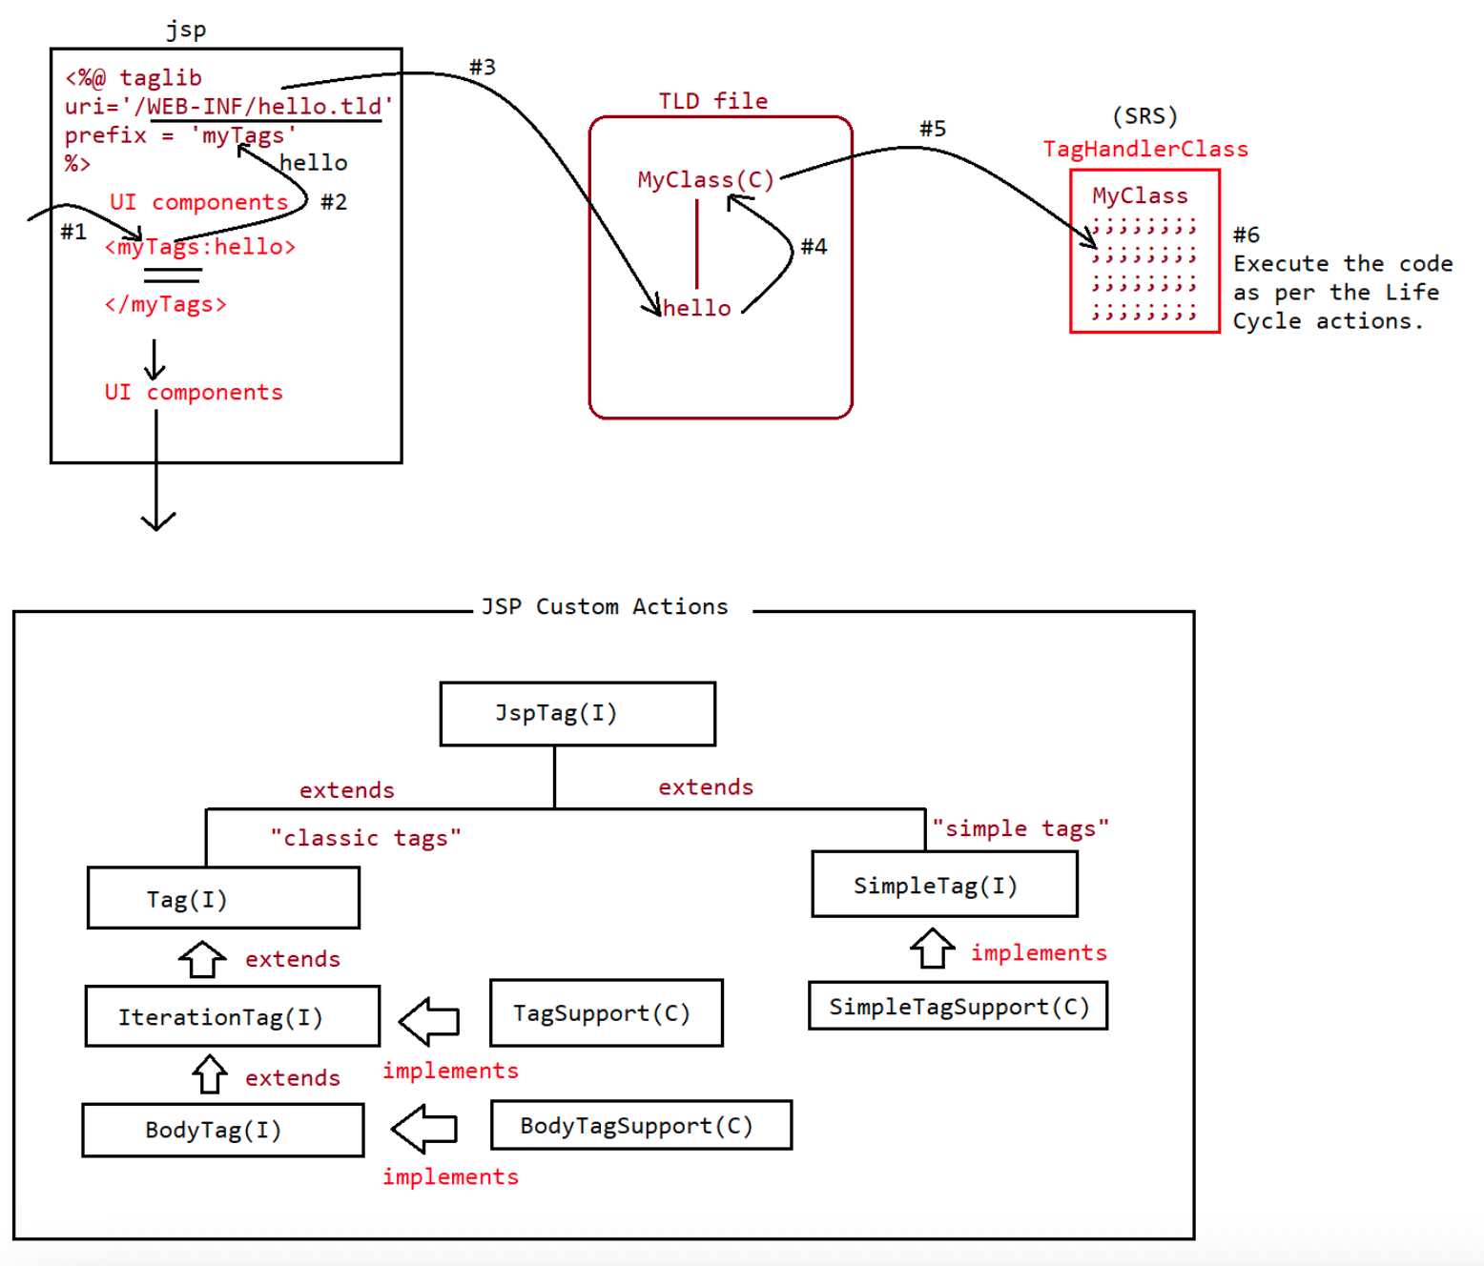
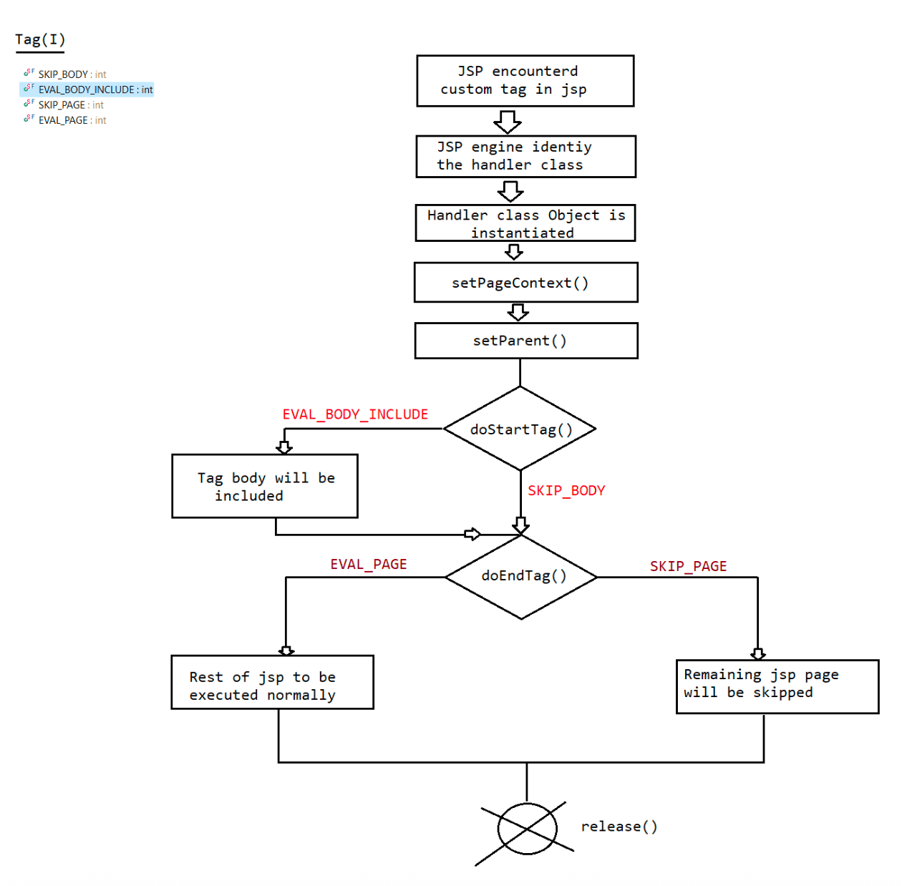
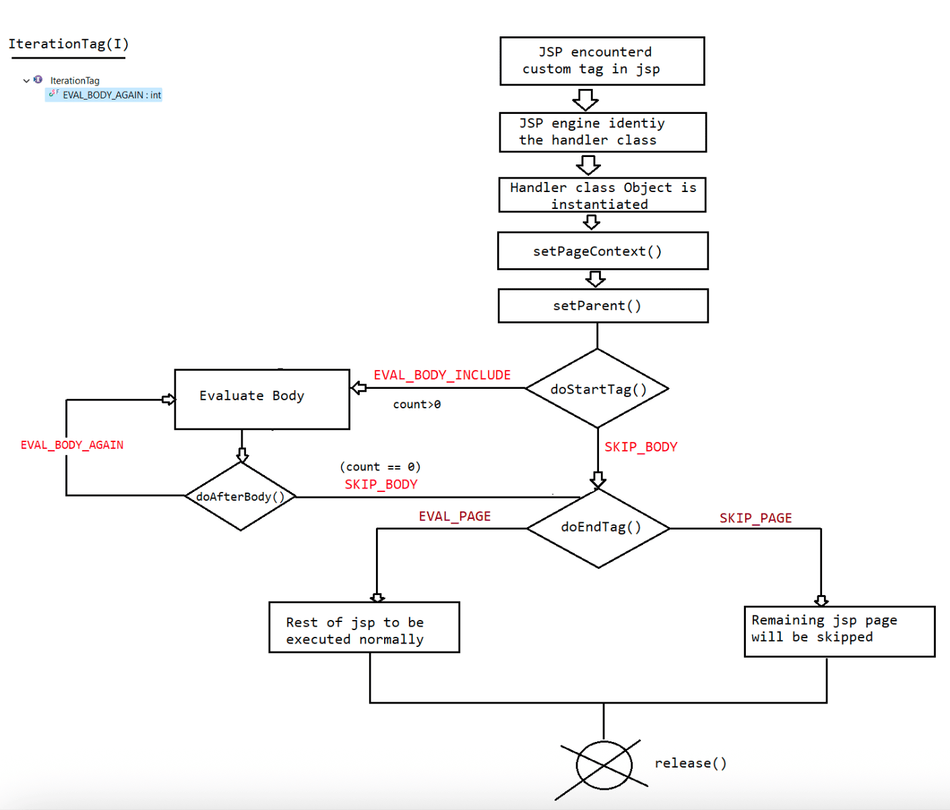

121 JSTL library

Java Standard Tag Library(JSTL)
-----------------------------------------
SUN people encapuslated the core functionality, which is common to many web
application in the form of
JSTL. Programmer can use this predefined library without writing on his own.
The main objective of EL is to remove java code from JSP,but it fails to replace
java code which process some
functionality. This problem we can overcome through "JSTL".
The main theme of JSTL is to remove java code from JSP
JSP = JSTL + EL + HTML.
JSTL library is divided into 5 parts
1. Core library
2. SQL library
3. Functional libray
4. Formatting library
5. XML library (deprecated becoz of xml syntax)
Core Library
==========
It is divided into 4 parts based on functionality
1. General Purpose Tags
2. Conditional Tags
3. Iteration Tags
4. URL Related Tags
Installing JSTL
-------------------
By default JSTL functionality is not available in jsp pages, we can provide JSTL
functionality by placing the following
jar files in webapplication folder.
Tomcat server will give the implementation in 2 jars for JSTL API, these jars
are available in the following location.
location :: C:\Tomcat 9.0\webapps\examples\WEB-INF\lib
Note:
Copy past the jars from that location to our project (./WEB-INF/lib) to make it
available to container
1. General Purpose Tags
a. <c:out>
b. <c:set>
'page')
It is used to write the template text data and expression to jsp.
syntax: <c:out var='' value='' default=''/>
It is used to set the attribute in any scope.(default scope is
syntax: <c:set var='' value='' scope=''/>
c. <c:remove>
It is used to remove the attributes from the particular scope.
syntax: <c:remove var='' scope=''/>
If we don't specify the scope, by default the searching for an
attribute would be done in the following
order
a. page b. request c. session d. applicationd. <c:catch>
This tag can be used to catch an exception within jsp instead of
forwarding to error page.
The risky code we have to place inside the body of syntax::
<c:catch>.
<c:catch>
Risky code
</c:catch>
If the exception raised in the risky code, this tag suppress that exception
object and rest of jsp is executed
normally.
If an exception is raised we can hold that exception object using attribute
called 'var' which is page scope.
refer: core1.jsp,core2.jsp,core3.jsp,core4.jsp
EL operators
==========
1. Arithmetic operators
EL does not support operator overloading, so there is no String
concatination operator.
'+' always acts as addition operator.
eg::
${2+3} =====> 5
${null + 3} ===> 3
${""+3} ===> 3
${iNeuron+3} ===> 3
${"iNeuron"+3} ===> NFE
Note: In Arithmetic operators null is treated as "0".
EmptyString are also treated as "0".
2. - operator
3. * operator
The rules are exactly same as "+" operator.
4. / operator
The rules are exactly same as '+' operator only, but it follows
Floating point arithmetic operation.
${10/2} ===> 5.0
${10 div 2} ==> 5.0
${10/0} ==> Infinity
${0/0} ==> NaN(Not a Number)
Empty Operator
=============
${empty Object}
true => if object is an empty String
if object is an empty array
if object is an empty Collection
if object doesnot exist
otherwise returns false.
EL reserve words
==============
true, false,null,empty,instanceof
gt,lt,ge,le,ne,eq,and,or,mod,div,notNote:
In EL null behaves nicely
1. In arithmetic operators null is treated as zero.
2. In String evaluation null is treated as empty String.
3. In Logical operator null is treated as false.
eg:
${10 + null } ===> 10
${empty null } ==> true
${!null} ------------> true
Conditional tags
============
1. <c:if>
<c:if test ="test_condition" var="" scope=""/>
<c:if test = "test_condition" var="" scope="">
body of the if statement(will be evaulated only is
test_condition is true)
</c:if>
JSTL tags for if-else, switch statement can be executed using the below tags.
2. <c:choose>
3. <c:when>
4. <c:otherwise>
Note:
1. <c:choose> should compulsorily have atleast one <c:when>,but <c:otherwise>
is optional.
2. <c:when> tag implicitly contains break statement, so fall through will
not happen.
3. <c:otherwise> should be at last only.
4. <c:choose> <c:otherwise> won't take any attribute where as <c:when> takes
only one attribute called "test".
Iteration tags
===========
1. <c:forEach> ---> It can be made to work like normal for loop and also foreach
loop.
2. <c:forTokens> ---> It is a specialized foreach loop which works with
StringTokenizer object.
URL Related tags
==============
1. <c:import>
2. <c:url>
3. <c:redirect>
4. <c:param>

122 Introduction to Spring Framework

124 Spring IOC And Dependency Injection XML approach

125 Spring Core XML and Annotation approach

126 JSTL sql library,format library,function library

JSTL(To avoid java code inside jsp)
============================
URL Related tags
1. <c:import>
We can use this tag for importing the response of other pages in the
current page response at
request processing time(dynamic include)
form1: <c:import url=''>
form2: <c:import url='' context = ''/>[To perform cross context
communication]
form3: <c:import url='' var=''/>[To reuse the output of the page
in multiple locations of the current page]
form4: <c:import url=''>
<c:param name='' value=''/>
<c:param name='' value=''/>
</c:import>
2. <c:redirect> => Same as sendRedirect() method
form1: <c:redirect url=''/>
form2: <c:redirect url='' var=''/>
form3: <c:redirect url='' context=''/>[Cross Context
communication]
form4: <c:redirect url=''>
<c:param name='' value=''/>
<c:param name='' value=''/>
</c:redirect>
3. <c:url> => we use this standard action to rewrite url's to append session
information and form parameters
form1: <c:url value='' var='' scope=''/>
form2: <c:url value='' var='' scope='' context=''/>
form3: <c:url value='' var=''>
<c:param name='' value=''/>
<c:param name='' value=''/>
</c:url>
4. <c:param> => To send the parameter data of the request object.
refer: JSTLApp-01
Core libray tags
=============
1. <c:out>
2. <c:set var='' value='' scope=''>
3. <c:remove var='' scope=''>
4. <c:catch var=''>
5. <c:if test='${!empty e}'>
6. <c:choose>,<c:when test=''>,<c:otherwise>
7. <c:forEach var='' items=''>
8. <c:forEachTokens>
9. <c:import>
10.<c:redirect>
11.<c:url var='' value=''/>
12.<c:param name='' value=''>
Note: Commonly used tags no are 4,5,6,7,11 and 12.
SQLTagLibrary
============
It defines several tags for communicating with database.To make sql library available to jsp, we need to write the following sql
directive
<%@taglib uri="http://java.sun.com/jsp/jstl/sql" prefix='sql' %>
The tags of sql library are
a. <sql:setDataSource>
b. <sql:query>
c. <sql:update>
d.<sql:param>
e. <sql:dateParam>
f. <sql:transaction>
Note: Inside JSP,we use JSTL and it is never recomended to use JSTL SQL library
to communicate with database
becoz jsp is meant only for presentation logic not to perform
persitence logic operation.
refer: JSTLApp-02
Function Library
=============
It defines several tags for general purpose String manipulations.
To use Functional library, we have to write the following taglib directive
in jsp
<%@ taglib uri="http://java.sun.com/jsp/jstl/functions" prefix='fn' %>
Important tags in the library are
a. <fn:contains()/>
b. <fn:length()/>
c. <fn:toUpperCase()/>
d. <fn:toLowerCase()/>
e. <fn:substring()/>
f. <fn:startsWith()/>
g. <fn:endsWith()/>
h. <fn:split()/>
i. <fn:join()/>
refer: JSTLApp-03
Format library
============
These are given to enable I18N(InternationalizatioN) on jsp pages
It is useful to display datevalues,numbers,currency values,labels etc
according to current/choose locale
refer: JSTLApp-04
1. <fmt:setLocale>
2. <fmt:formatDate>
3. <fmt: setBundle>
4. <fmt: mesage>
5. <fmt: formatNumber>
Note:
1. basebundle name should reflect in all properties
file(en_US,it_IT,hi_IN,fr_FR,.....)
2. All properties file should have same keys but with different values.
3. enable charset ='utf-8'
4. All the files must have proper extension (.properties)
5. if no matching is found then it will pick the base file called "App.properties".
Technology
=========
JDBC APIServlet API
JSP API

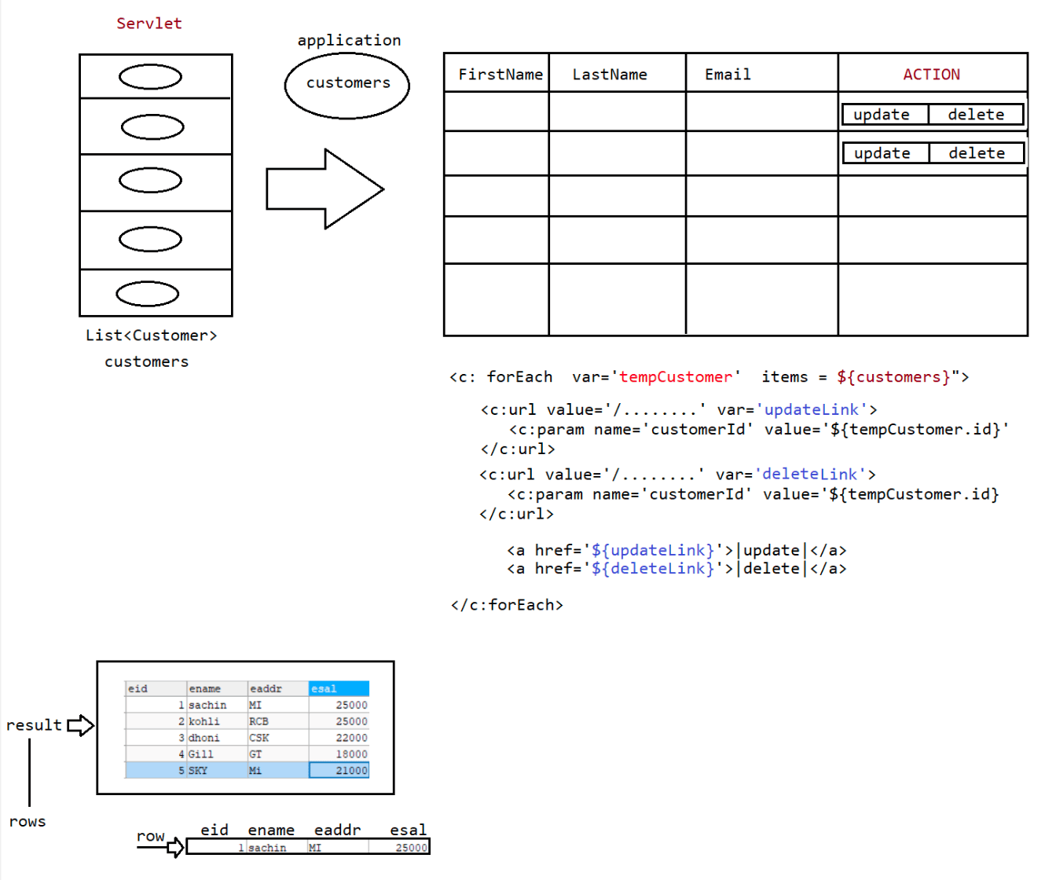

127 Limitations with JDBC, Introduction to ORM tool,hibernate architecture,Project using servlet,jdbc,jstl

Terminologies
-------------------
What is Persistence?
The process of Storing and managing the data for a long time is called
"Persistency".
To Perform Persistencey we use secondary devices like HDD,CD,DVD,ThumbDrivers etc
From the application perspective,we store the information inside
variables/objects,but these objects would vanish once
the application stops its execution.
To achieve persistency we use
1. File Operations(Storing it is HDD)
java.io.*
2. Database(Storing it in the form of Table)
java.sql.*
Terminologies associated with Persistency
==================================
1. Persistence store
It is a place/store where data will be saved and managed for a long
time.
eg: Files,DB s/w(MySQL,Oracle,PostgreSQL,.....)
2. Persistence data
The data of Persistence Store is called 'Persistence Data'.
eg: File info,DB tables and their records.
3. Persistence operation
performed on "Persistence Data".
Insert,update,delete,select there are the operations which are
4. Persistence Logic
as "Persistence Logic".
The logic which is written to perform Persistence operation is called
eg: IO Streams logic(Serialization,DeSerialization)
JDBC code(Technology name is JDBCAPI)
hibernate code
Spring JDBC
Spring ORM(hibernate)
Spring DataJPA(hot cake)
5. Pesistence technology/Framework
The technology/Framework through which we write persistence logic is
called 'PersistenceTechnology/Framework'.
eg: JDBC(Technology)
Hibernate(Framework/tool)
SpringJDBC/SpringORM/SpringDataJpa(framework)
When we already have JDBC Techology, What is the need to go for framework/tool
called ORM?
Limitations of JDBC
--------------------------
1. If we use JDBC to develop persistence logic,we need to write sql queries by
following the syntax of "Database".
DBQueries are specific to Database,this makes JDBC not portable across
mulitple databases.
2. JDBC technology if we use and write a code, there would be a boiler plate code
in our application.
Boiler plate code => A code which would repeat in multiple parts of the
project with no change/small change is calledboiler plate code.
CRUD
=====
1. Load and register the driver(automatic from JDBC4.X)
2. Establish the connection
3. Create PrepareStatement
4. Execute the Query
5. Process the ResultSet
6. Handle the Exception
7. Closing the Resource
Step1,2,3,6,7 boiler plat code becoz it is a common logic.
3. JDBC technology throws only one Exception called "SQLException',but it is a
CheckedException which means u should have
handling logic otherwise code would not compile.
a. try{}catch(SQLException e){}
b. public static void main(String... args) throws SQLException{}
4. JDBC technology has only Exception class called "SQLException",so we don't have
detailed hierarchy of Exceptions related
to different problems.
5. JDBC ResultSet object is not serializable, so we can't send it over the network,
we need to use Bean/POJO to send the data
over the network by writing our own logic.
6. While closing the jdbc connection object, we need to analyze the code allot
otherwise it would result in
"NullPointerException".
eg: Connection con = DriverManager.getConnection(url,user,password)
if(con!=null){.....}
closing the connection object should take place in "finally" block
only.
To make the usage of AutoCloseable, we need to know the syntax of "try
with Resource".
7. Java ====> OOP's based language
Assume we need to send Student object to database, can we write a logic of
Database query at Object level if we use JDBC?
No, Not possible becoz DBqueries always expectes the value,but not the object
directly.
8. JDBC doen't have good support of Transaction Management
a. local
b. global(no support in JDBC)
9. JDBC supports only positional parameters,it is difficult for the user to inject
the values,It doesnot support namedparamaters.
String sqlInsertQuery = "insert into student(`name`,`email`,`city`,`country`)
values(?,?,?,?)";
String sqlInsertQuery = "insert into student(`name`,`email`,`city`,`country`)
values(:name,:email,:city,:country)";
10. To use JDBC, Strong knowledge of SQL is required.
11. JDBC does not supports versioning ,timestamp as inbuilt features
versioning:: keeping track of how many times record got modified.
timestamp:: keep track of when record was inserted and when lastly it
was modified.12. While developing persitence logic using JDBC, we can't enjoy oops features like
a. inheritance
b. polymorphism
c. composition
because jdbc does not allow objects as input values in sqlqueries.
Solution to all these problems is use "ORM".
ORM:- (ORM stands for ): Object Relational Mapping.
It is a theory concept used at database programming to perform operations like
insert. Update, delete and select in object
format only ie. JDBC converts object to primitive data and SQL Query shuld be
written by programmer using primitives,
which is not following OOPs.
ORM says “Do not convert object data, do operations in OOPs. Format
only”.
For this concept programmer should follow mapping rule. Given as
1. className- Must be mapped with – tableName
2. VariableName- Must be mapped with – columnName
** should be done by programmer using XML/Annotations concept.
** Then ORM convert Object ROW
** Here , ORM only generates SQL Query
What is Framework?
Initially when java was introduced, it has only java api to develop standalone
applications.
later group of api's are released under then name jee for developing distrubuted
applications.
Developers faced so many problems while creating projects using java and jee
api's.
jee is a largest set of api's, it was difficult for developers to remember so many
classes and interfaces.
Devleoper needs to write so many boiler plate code to do integration of api's.
To overcome these problem framework was introduced by "thirdparty" vendors.
A framework provides "framework-api" which is an abstraction on top of "java and
jee" api's.
Framework is not a new technology, it is an abstraction which is built on top of
technology.
With frameworks we have the following facility
a. Developer burden will be reduced
b. Project can be deliverd to the client easily
c. Project maintainence would be easy.
How many types of framework are available?
There are 2 types of framework
a. invasive framework
=> Developer has to extend his class from a
superclass or interface supplied by the framework-api.
=> The developer class would be tightly coupled, so
that class can't be moved to new framework
for execution.
eg: Servlet, EJB's,Struts
b. non-invasive framework
=> Developer need not extend his class from a
superclass or interface supplied by the framework-api.
=> The developer class would be loosely coupled, sothat the class can be moved to new framework
for execution.
eg: Hibernate(ORM tool) and Spring.
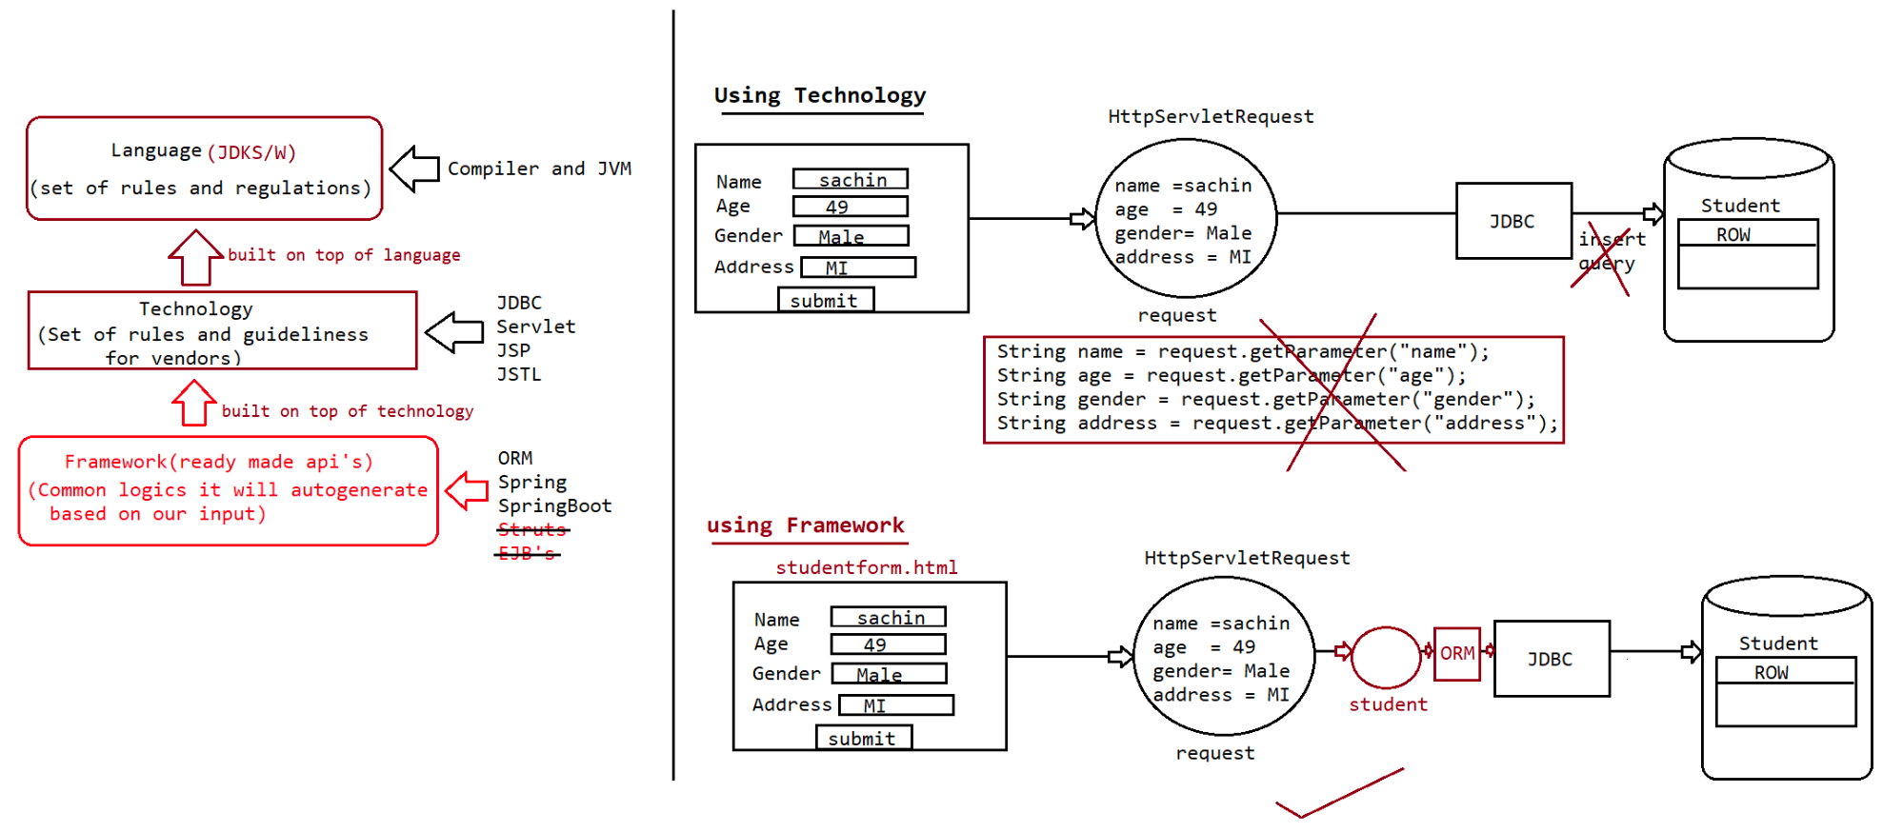
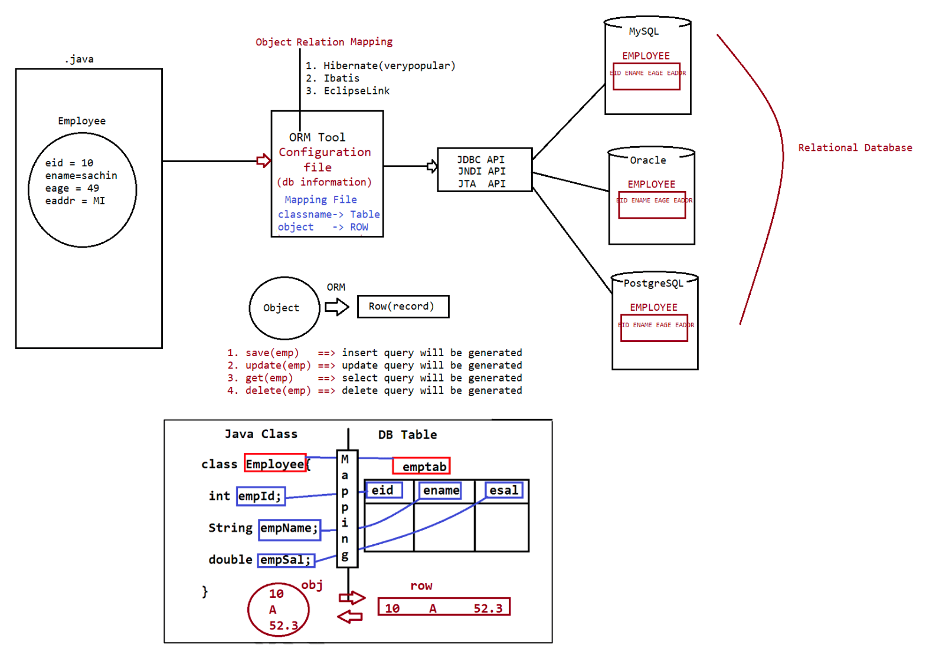
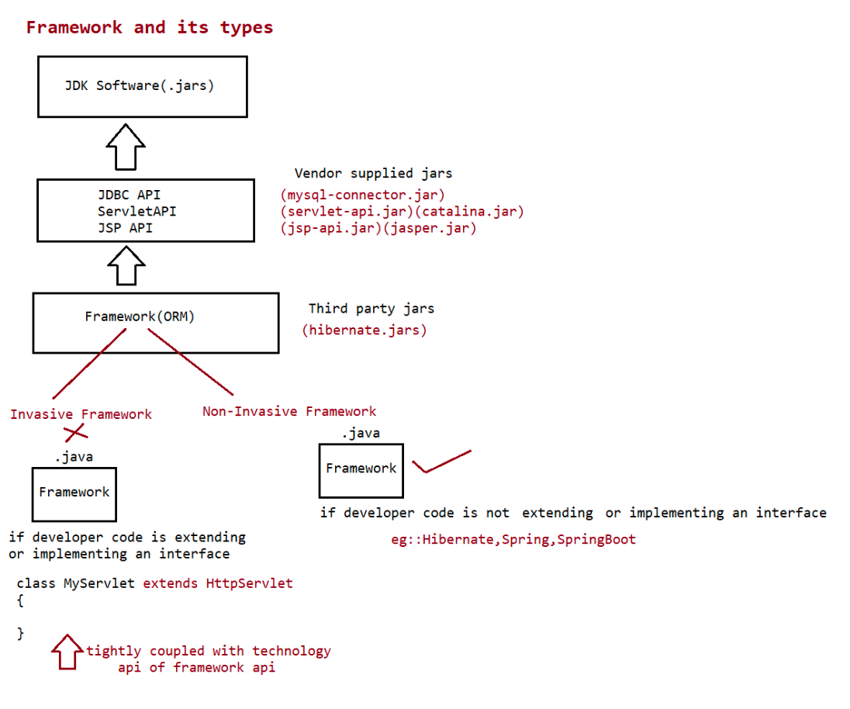

128 Hibernate First Application execution and behind the scenes,working with annotations and configuration files. MVC CRUDApp using JDBC,Servlet,JSP + JSTL

Hibernate(ORM tool/framework)
============================
Language(java)
Technology(JDBC)
Framework(ORM tool)
HibernateArchitecture
==================
refer:******.png
Hibernate Configuration File will provide all the configuration details like driver
class name, driver URL,
Database User name , Database password,.... which we required to establish
connection with database and
to setup JDBC environment.
Hibernate Mapping file will provide all the mapping details like Bean Class name
and Database table name, ID property and
Primary key column , Normal Properties and Normal Columns,....
1) Client Application will perform the following three actions in Hibernate
applications mainly.
2) Activating Hibernate Software, in this case, Hibernate Software will take all
configuration details from hibernate
configuration file and Hibernate Software will set up the required JDBC
Environment to perform database operations.
3) Prepare Persistence Object with the persistence data.
4) Perform Persistence Operation.
When Client Application perform persistence operation, Hibernate Software will
perform the following actions.
1) Hibernate Software will take persistence method call and identify
persistence Object.
2) Hibernate Software will take all mapping details from hibernate mapping
file like database table name and all
column names on the basis of Persistence object.
3) Hibernate Software will prepare database dependent sql query on the basis
of table names and column names and
with the persistence object provided data.
4) Hibernate Software will execute the generated database dependent sql
query and perform the required persistence
operation.
Steps to prepare Hibernate Application:
1) Prepare Persistence Class or Object.
The main intention of Persistence class or object in Hibernate applications is to
manage Persistence data which we want to
store in Database or by using this we want to perform the database operations like
select, update, delete.
In Hibernate applications, to prepare Persistence classes we have to use the
following Guidelines
1) In Hibernate applications Persistence classes must be POJO classes [Plain Old
Java Object], they must not extend or
implement predefined Library.
2) In hibernate Applications Persistence classes must be public, Non abstract and
non-final. Where the main intention to
declare persistence classes as public is to bring persistence classes scope toHibernate software in order to create objects.
Where the main intention to declare persistence classes as Non abstract is to
allow to create Objects for Persistence classes
Where the main intention to declare persistence classes as Non final is to
allow to extend one persistence class to another
persistence class as per the requirement.
3) In Persistence classes all Properties must be declared as per database table
provided columns, where names are not
required to be matched, but, data types must be compatible.
4) In Persistence classes, all properties must be declared as private in order to
improve Encapsulation.
5) In Persistence classes , we must define a separate set of setXXX () and getXXX
() methods for each and every property
6) In persistence classes, we must declare all methods are public.
7) In Persistence classes, if we want to provide any constructor then it must be
public and 0-arg constructor, because,
while creating object for persistence class Hibernate software will search and
execute only public and 0-arg constructor.
8) In Hibernate applications , if we want to provide our own comparison mechanisms
while comparing Persistence objects
then it is suggestible to Override equals(--) method.
9) In Hibernate applications, if we want to provide our own hash code values then
it is suggestible to Overrid hashCode ()
method.
10) In Hibernate applications, we will use POJO classes, which are not extending
and implementing predefined library, but,
it is suggestible to implement java.io.Serializable marker interface in
order to make eligible Persistence object for
Serialization and Deserialization.
11) In Persistence classes, we have to declare a property as an ID property, it
must represent primary key column in the
respective table.
2) Prepare Mapping File.
The main intention of mapping file in Hibernate applications is to provide mapping
between a class,id property and
normal properties from Object Oriented Data Model and a table, primary key column
and normal columns from
Relational data model.
In Hibernate applications, mapping file is able to provide the mapping details like
Basic OR mapping, Component mapping,
inheritance mapping, Collections mapping, Associations mapping,
To prepare mapping file in Hibernate applications we have to provide mapping file
name with the following format.
"POJO_Class_Name.hbm.xml".
The above format is not mandatory, we can use any name but we must provide that
intimation to the hibernate software.
In Hibernate applications, we can provide any no of POJO classes, w.r.t each and
every POJO class we can define a separate
mapping file.
refer: *****.hbm.xml
3) Prepare Hibernate Configuration File
The main purpose of hibernate configuration file is to provide all configuration
details of hibernate application which includes
Jdbc parameters to prepare connection , Transactions configurations,Cache
mechanisms configurations, Connection poolingconfigurations,........
In Hibernate applications, the standard name of hibernate configuration file is
"hibernate.cfg.xml", it is not fixed,
we can provide any name but that name must be given to Hibernate software.
In Hibernate applications, we are able to provide more than one configuration
file , but, for each and every database, that is,
in hibernate applications if we use multiple databases then we are able to prepare
multiple configuration files.
To prepare hibernate configuration file with basic configuration details we have to
use the following XML tags.
refer: hibernate.cfg.xml
4) Prepare Hibernate Client Application
The main intention of Hibernate Client application is to activate Hibernate
Software, creating persistence objects and
performing Persistence operations.
To prepare Client Application in hibernate applications we have to use the
following steps.
1. Create Configuration class object
2. Create Session Factory object
3. Create Session Object
4. Create Transaction object if it is required.
5. Perform Persistence operations
6. Close Session Factory and Session objects.
1. Create Configuration class object
In Hibernate, the main intention of Configuration object is to store all the
configuration details which we provided in
hibernate configuration file.
To represent Configuration object Hibernate has provided a predefined class in the
form of "org.hiberante.cfg.Configuration".
To create Configuration class object we have to use the following constructor from
Configuration class.
public Configuration()
EX: Configuration cfg = new Configuration();
If we use the above instruction in Hibernate applications then we are able to get
an empty Configuration object in heap
memory, it will not include any Configuration details.
If we want to store Configuration details from Configuration file we have to use
either of the following methods.
1. public Configuration configure()
This method will get configuration details from the configuration file with the
name hibernate.cfg.xml.
2. public Configuration configure(String config_file_Name)
This method can be used to get configuration details from hibernate configuration
file with an name, it will be used
when we change configuration file name from hibernate.cfg.xml file to some other
name .
3. public Configuration configure(File file)
This method can be used to get configuration details from a file which is
represented in the form of java.io.File class object.
public Configuration configure(URL url)
This method can be used to get Configuration details from a file which is available
in network represented in the form of
java.net.URL .
EX: Configuration cfg = new Configuration();
cfg.configure();
When we use configure() method then Hibernate Software will search forhibernate.cfg.xml file, if it is available then
Hibernate software will load the content of hibernate.cfg.xml file, parse it and
read content from configuration file to
Configuration object.
2. Create Session Factory object:
In Hibernate, the main intention of Session Factory object is to manage
Connections, Statements, Cache levels, .... and it able
to provide no of Hibernate Session objects.
To represent Session Factory object Hibernate has provided a predefined interface
in the form of "org.hibernate.Session Factory".
To get Session Factory object we have to use the following method from
Configuration class.
public Session Factory buildSessionFactory()
EX: SessionFactory sf = cfg.buildSessionFactory();
In Hibernate applications, if we use multiple Databases then we have to prepare
multiple Configuration files,
multiple Configuration Object, w.r.t this, we have to prepare multiple Session
Factory objects.
Session Factory object is heavy weight and it is thread safe upto a particular
Database, because, it able to allow more than
one thread at a time.
3. Create Session Object:
In Hibernate, for each and every database interaction a separate Session will be
created.
In Hibernate, Session is able to provide no of persistence methods in order to
perform persistence operations.
To represent Session object, Hibernate has provided a predefined interface in the
form of "org.hibernate.Session".
To get Session object, we have to use the following method from Session Factory.
public Session openSession()
EX: Session s =sf.openSession();
In Hibernate, Session object is light weight and it is not thread safe, because,
for each and every thread a separate Session
object will be created.
Difference b/w Session Object vs SessionFactory object?
SessionFactory
It is a heavy weight object containing multiple other objects like
DataSource,Dialect,TxFactory,generators etc.
It is a immutable Object.
ThreadSafe Object is by default.
Created by using buildSessionFactory() method which is designed based
on "builder" design pattern.
Long Lived Object of the application.
It maintains Level-L2 cache.
Session
It is a Light Weigth Object(con++)
It is a mutable Object.
Not ThreadSafe by default.
Created by using openSession() which is designed based on 'factory'
design pattern.
Short lived Object of the application.
It maintains Level-L1 cache.4. Create Transaction Object:
Transaction is a unit of work performed by Front End applications on Back end
systems.
To represent Transactions, Hibernate has provided a predefined interface in the
form of "org.hibernate.Transaction".
To get Transaction object we will use either of the following methods.
1. public Transaction getTransaction()
It will return Transaction object with out begin, where to begin Transaction
we have to use the following method.
public void begin()
2. public Transaction beginTransaction()
It will return Transaction and begin Transaction.
In Hibernate applications, after performing persistence operations we must
perform either commit or rollback operations
inorder to complete Transactions, for this, we have to use the following
methods from Transaction.
5. Perform Persistence Operations:
In Hibernate applications, to perform persistence operations Session has
provided the following methods.
Through hibernate we can perform
a. SRO(Single Row Operation)
a. save()/persist() ========> Insert Operation
b. get()/load() ========> Select Operation
c. update()/saveOrUpdate() => Update Operation
d. delete() =========> Delete Operation
b. Bulk operation(working with mulitple records)
a. HQL/JPQL
b. NativeQuery
c. Criterian API

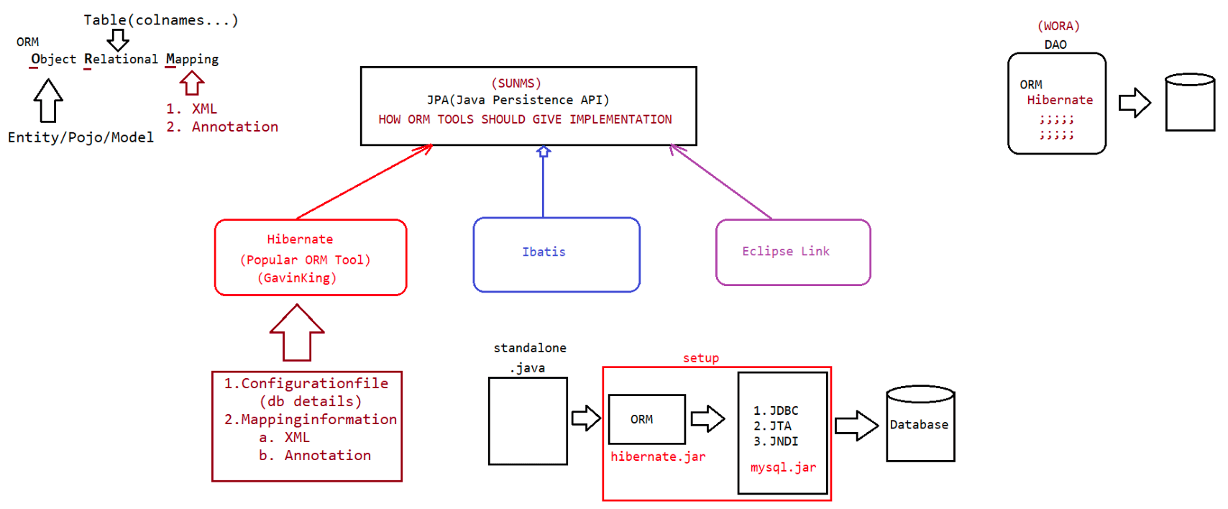
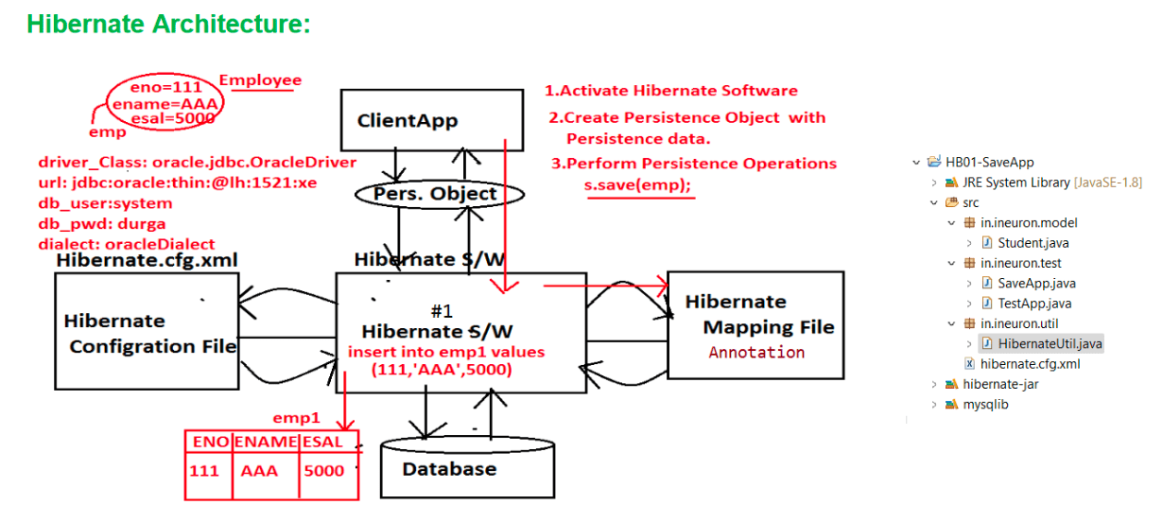
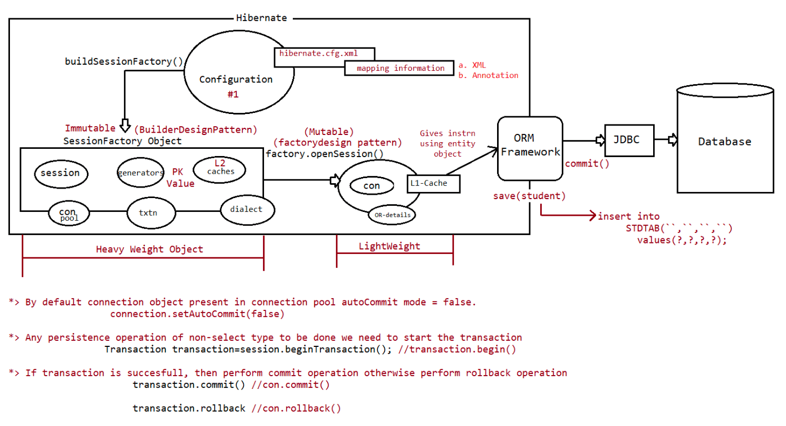

130 Hibernate crud operation api calls and behind the scenes

Language(java)
Technology(JDBC)
Framework ( ORMTool-----> Hibernate)
ORM ===> Do operation only in objects
Hibernate(Object<----> ROW)
1.SRO(Single Row Operation)
a. save()/persist()
b. get()/load()
c. update(),saveOrUpdate()
d. delete()
2.Bulk operation(working with more than one Row)
a. HQL/JPQL
b. NativeQuery
c. Criterian API(mostly used by java developers)
Property
-----------
hibernate.hbm2ddl.auto
ddl=Data definition language(create /alter/drop in SQL)
it has four possible value.
Those are:-
a. validate (default value)
b. create
c. update
d. create-drop
A. validate:- In this case hibernate creates no tables programmer has to create or
modify tables manually.
It is only default value.
hibernate creates always new tables, if table exist then it will be
B. create:- drop.
C. update:- It creates new table if table not exits else uses same tables.
This attribute is commonly used.
D. create-drop:- This option is used for testing process not in development,
it creates a new table an performs operation and at last
table will be drop.
It is just for POC(proof of concept) or for learning
purpose.
Hibernate Persistence operation
===============================
Objects used in hibernate
a. Configuration
b. SessionFactory(heavy weight)
c. Session
d. Transaction
1.SRO(Single Row Operation)
a. save()/persist()
b. get()/load()
c. update(),saveOrUpdate()
d. delete()
a. save()/persist() => These methods are used to perform insert operation.
What is the difference between save() method and persist() method?
Ans:
In Hibernate applications, save() method can be used to insert a record into theDatabase table and it will return
Primary Key value of the inserted record.
This method is from hibernate api.
public Serializable save(Object obj)throws
HibernateException
In Hibernate applications, persist() method can be used to insert a record into
database table and it will not return any value.
This method is from JPA specification.
public void persist(Object obj)throws HibernateException
Note:
@DynamicInsert(value=true) and @DynamicUpdate(value=true)
=> It is used to generate the dynamic query, based on the fields used in the Entity
Object
=> If we want our table name and column name to be same as entity name and field
name then no need to use
@Table(name='') and @Column(name='',length='')
=> During the creation of SessionFactory object, by refereing to mapping
information hibernate will create
pregenerated sql queries for insert,update,delete,select by using all the
fields of the entity class.
=> If we want to avoid that and if we want query to be generated based on the field
injection we do on the entity class
then we need to use @DynamicInsert(value='true') or
@DynamicUpdate(value='true')
Performing select operation in hibernate
----------------------------------------
b. get()/load()
What are the differences between get(-) method and load(-) method?
Ans:
is existed.
1. get() method can be used to retrive a record from database table if the record
If the required record is not existed then get() method will return null
value.
public Object get(String class_Name, Serializable pk_Val)
public Object get(Class class_Type, Serializable pk_Val)
2. get() method is able to perform eager or early loading, that is, it will
interact with database directly and it will retrive data and return
to Hibernate application in the form of Object on the method call.
1. load() method can be used to retreive a record from database table if the record
is existed.
If the required record is not existed then load() method will rise an
Exception like HibernateException.
public Object load(String class_Name, Serializable pk_Val)
public Object load(Class class_Type, Serializable pk_val)
2.load() method will perform Lazy or late Loading , that is, when we access load()
method then a duplicate object will be
created with the primary key value without interacting with database(proxy
object).
When we use other properties of the Object then only it will fetch data from
database table and return that data to
Java application.update(),saveOrUpdate()
-----------------------
updating a record can be done in 3 ways
a. update total object(not prefered)
remember the object exists with the id and update the
entire object.
if the id doesn't exists it would return
'OptimisticLockException'.
b. load the record and update(very useful for partial updation)
c. load and modify the record without using update()[Synrhonization
would exist b/w row and object]
saveOrUpdate()
This method call would first perform
a. select operation
if record found then it performs update operation,
otherwise it performs insert operation
What is the difference between update() method and saveOrUpdate() method?
Ans:
Where update(-) method will perform updation on a record in database table if the
specified record is existed otherwise
it will rise an Exception.
public void update(Object obj)throws HibernateException
Where saveOrUpdate(-) method will insert the specified record in database table if
the specified record is not existed .
If the specified record is existed in database table then it will update the
record.
public void saveOrUpdate(Object obj)throws HibernateException
delete()
--------
It can be done in 2 ways
a. perform deletion by supplied id value directly
It generates sql select query, if the record exists it
would generate delete query, otherwise it won't
generate delete query and it won't throw any Exception.
b. load and delete the record[prefered]
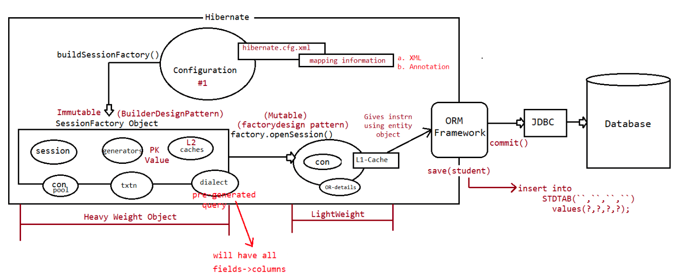
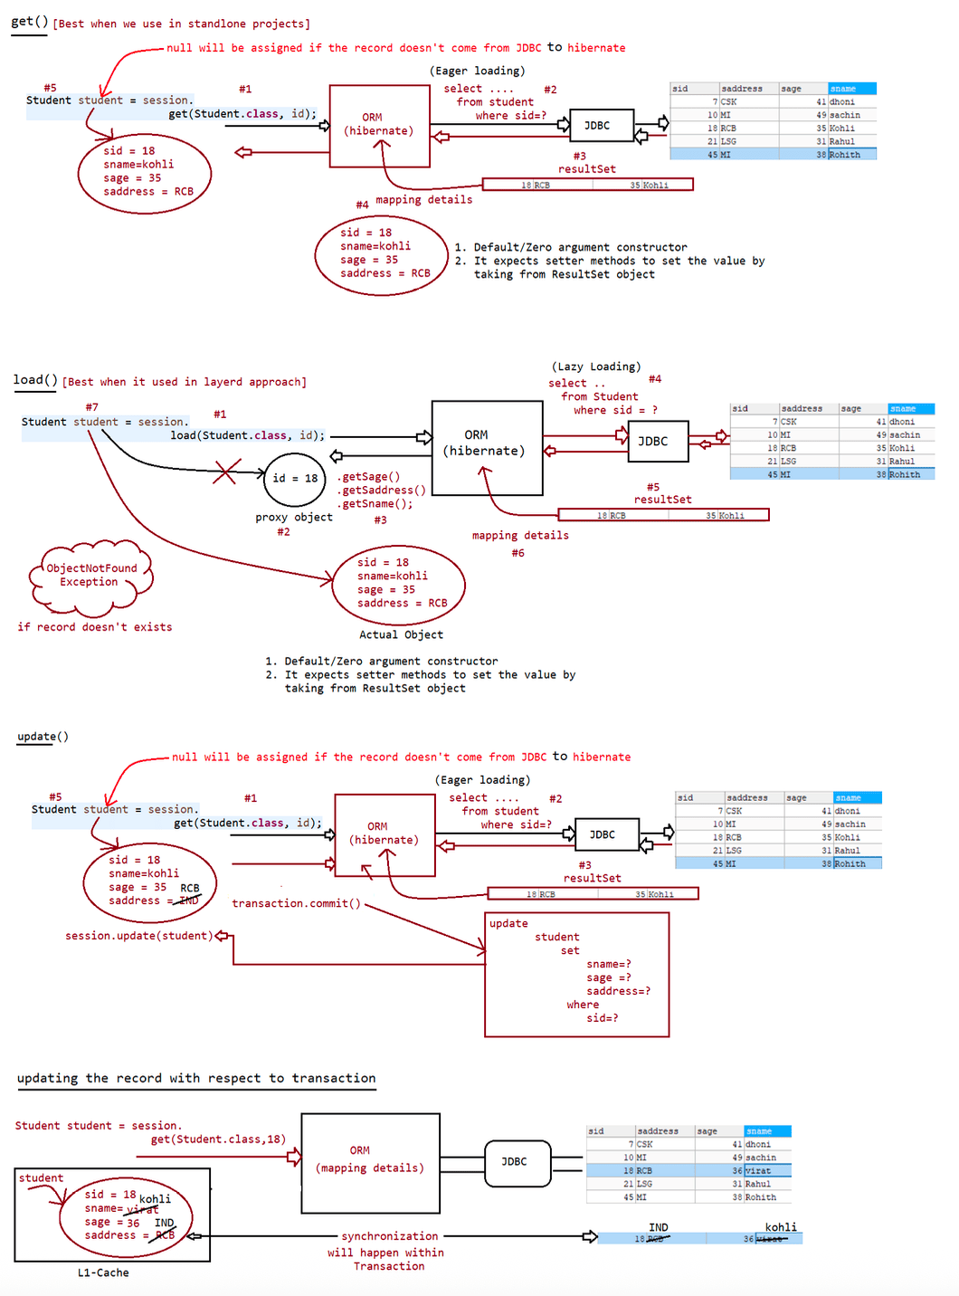

131 Hibernate configuration using pure java, properties ,XML approach | generators in hibernate | Hibernate CRUD app using layered approach

@DynamicUpate(value=true)
It is used to generate the update query only for the fields on which the setter
injection is
performed.
Entity object fields are
sid,sname,sage,saddress
The entity object setter method used is main method is
student.setSaddress("RCB");
Query generated is
update
Student
set
saddress=?
where
sid=?
Note: Within the transaction, persitence object would be synchronized to a row in
the database.
Alternative ways available to configure ORM
-------------------------------------------
a. using Programmatic approach(Pure java approach)
b. using Properties file(application.properties)
c. using XML approach(hibernate.cfg.xml)
1) Programmatic Approach
In Programmatic approach, to provide configuration details, first we have to create
Configuration class object then we
have to set all hibernate properties to Configuration class object explicitly by
using the following method.
public void setProperty(String prop_Name, String prop_Val)
To add mapping file name and location to Configuration file we have to use the
following method.
public void addResource(String mapping_File_Name)
Note: If we are using annotations in place of mapping file then we have to use the
following method to add annotated class.
public void addAnnotatedClass(Class class)
In Programatic approach, if we want to change configuration details like connection
properties or database properties,....
then we have to perform modifications in JAVA code, if we perform modifications in
JAVA code then we must
recompile the java application , it is not suggestible in enterprise applications.
To overcome the problem we have to use Declarative approach.
2) Declarative approach:
In Declarative approach, we will provide all configuration details in either
properties file or in XML file then we will send
configuration details to Hibernate application.
There are two ways to provide configuration details to Hibernate Applications in
Declarative Approach.
1) By using properties file.
2) By Using XML file.
1) Using properties file in Declarative Approach:
In This approach, to provide all hibernate configuration details , we have todeclare a properties file with the default name
"hibernate.properties" under "src" folder . In this context, when we create
Configuration class object ,
Hibernate Software will search for the properties file with the name
"hibernate.properties" and get all the configuration
details into Configuration class object.
In this approach we must add mapping file explicitly to Configuration File by using
the following method.
public void addResource(String mapping_File-Name)
Note:
If we change name and location of properties file from hibernate.properties to some
other "abc.properties" then we have
to give that intimation to Hibernate software, for this, we have to create
FileInputStream and Properties class object
then we have to set Properties object to Configuration class object by using the
following method.
public void setProperties(Properties p)
Note:
In hibernate applications, if we use "properties" file then we are able to provide
only hibernate connection propeties,
dialect propeties,... , but, we are unable to provide mapping properties,...
through properties file, to provide mapping properties
we have to use java methods like addResource(--) or addAnnotatedClass(--) methods
from Configuration class.
In Hibernate applications, if we want to provide all configuration details in
declarative manner then we have to use XML file approach.
If we want to use xml file to provide all configuration details then we have to use
configure() method to get all configuration
details from xml file. Here configure() method will search for xml file with the
default name hibernate.cfg.xml under src folder inorder to get configuration
details.
If we change the default name and location of hibernate configuration file then we
have to pass that name and location to configure(--) method as parameter.
Note:
if we place all the above
approach(hibernate.cfg.xml,hibernate.properties,programmatic approach) then which
one will be applied to set up the jdbc environment by Hibernate?
=> cfg.configure() is called in the code after setting the properties then
hibernate.cfg.xml file will be used,otherwise programming
logic(cfg.setProperty()) will be used.
Primary Key Generation Algorithms in Hibernate
========================================
Primary key is single column or Collection of columns in a table to recognize the
records individually.
In Database applications, to perform the database operations like retriving a
record, updating a record, deleting a record,....
we need primary key and its value.
In Database applications, we are unable to give option to the users to enter
primary key values , because there is no
guarantee for the data entered by the users whether it is unique data or not, but,
in Database tables onlyunique values are accepted by primary key columns.
To give guarantee for uniqueness in primary key values we have to use Primary key
generation algorithms.
Almost all the Persistence mechanisms like Hibernate, Ibatis, Open JPA,
Toplink,.... are having their own implementation for
primary key generation algorithms.
Hibernate has provided support for the following primary key generation algorithms
inorder to generate primary key values.
1. assigned(default)
2. increment
3. sequence
4. identity
5. hilo(removed from HB5.X)
6. native.
7. seq-hilo
8. select
9. UUID
10.GUID
11. foreign
Hibernate has represented all the above primary key generation algorithms in the
form of a set of predefined classes provided
in "org.hiberante.id" package.
If we want to use any of the above algorithms in Hibernate applications then we
have to configure that algorithms in
hibernate mapping file by using the following tags.
There are 3 types of generators in hibernate
1. Hibernate supplied generators
a. @GeneratedValue
b. @GenericGenerator
2. JPA supplied generators
a. @GeneratedValue
3. Custom generator(** realtime projects)
1. assigned
This algorithm is default primary key generation algorithm in hibernate
applications, it will not required configurations in
mapping file.
This algorithm will not have its own mechanism to generate primary key value , it
will request to Client Application to
provide primary key value explicitly.
This algorithm is able to support for any type of primary key values like short,
int, long, String,.....
This algorithm is supported by almost all the databases like Oracle, MySQL,
DB2, ......
This algorithm is not required any input parameter.
This algorithm is represented by Hibernate in the form of a predefined class
"org.hibernate.id.Assigned".
@Id
@GenericGenerator(name = "gen1", strategy = "assigned")
@GeneratedValue(generator = "gen1")
private Integer eid;
2.
incrementThis primary key generation algorithm is able to generate primary key value by
incrementing max value of the primary key column.
New_Val = max(PK_Column)+1
This alg is able to generate primary key values of the data types like short, int,
long,...
This alg is not required any input parameter to generate primary key values.
This alg is supported by almost all the databases which are supporting numeric
values as Primary key values.
This alg is representned by Hibernate Software in the form of a short name
"increment" and in the form of a predefined class like
"org.hibernate.id.IncrementGenerator".
@Id
@GenericGenerator(name = "gen1",strategy = "increment") // To specify details HB
Specific generator
@GeneratedValue(generator = "gen1") // To apply generators on @Id field
private Integer eId;
3. sequence
This primary key generation algorithm is able to generate primary key value on the
basis of the sequence provided by the underlying Database.
This alg is able to generate primary key values of the data types like short, int,
long,...
This alg required "sequence" input parameter with the sequence name as value
inorder to generate primary key value.
If we have not provided any sequence name as input parameter then this alg is able
to take "hibernate_sequence" as default sequence name,
here developers must create "hibernate_sequence" in database explicitly.
This alg is supported by almost all the databases which are supporting sequences
like Oracle, DB2,....
This alg is represented by Hibernate Software in the form of a short name like
"sequence" and in the form of a predefined class like
"org.hibernate.id.SequenceGenerator".
1>
@Id
@GenericGenerator(name = "gen1", strategy = "sequence",
parameters ={
@Parameter(value =
"eid_seq",name="sequence_name")
}
)
@GeneratedValue(generator = "gen1")
private Integer eid;
2>
@Id
@GenericGenerator(name = "gen1", strategy = "sequence")
@GeneratedValue(generator = "gen1")
private Integer eid;
4.
identity
This alg is able to generate primary key values on the basis on the underlying
database table provided identity column.
Note:Identity column is a primary key Column with "auto_increment" capability.
This alg is able to provide the primary key values of the data types like short,
int, long,....
This alg is not required any input parameter.
This alg is supported by almost all the databases which are supporting Identity
column.
EX: MySQL.
To represent this alg, Hibernate has provided "identity" as short name and
"org.hibernate.id.IdentityGenerator" as predefined class.
@Id
@GenericGenerator(name = "gen1",strategy = "identity") // To specify details HB
Specific generator
@GeneratedValue(generator = "gen1") // To apply generators on @Id field
private Long policyId;
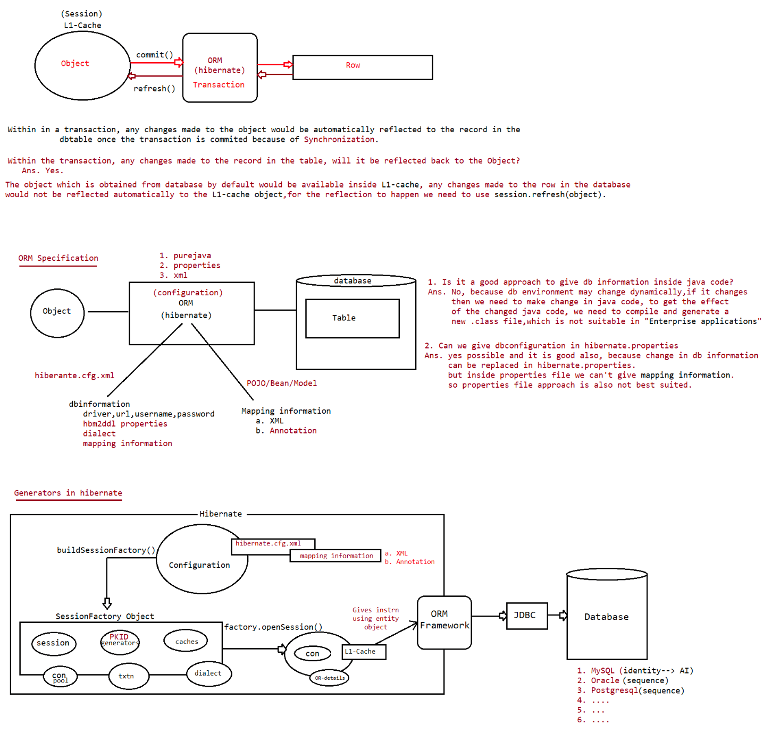

132 jpa generators,custom generators in mysql and oracle,date and time insertion,Object versioning

5.native
This alg is able to generate primary key value by selecting a particular primary
key generation alg depending on the database
which we used.
This alg is not having its own alg to generate primary key value.
It will select "SequenceGenerator" alg if we are using Oracle database,
"IdentityGenerator" alg if we are using MySQL database and "TableHiLoGenerator" if
we are using some other database which is not supporting SequenceGenerator and
IdentityGenerator.
This Primary key generator is able to generate primary key values of the data types
like short, int, long,...
This primary key generator is supported by almost all the databases.
To represent this mechanism, Hibernate has provided a short name in the form of
"native", Hibernate has not provided any
predefined class.
JPA(Java Persistence API) generators
------------------------------------
1. These are given by SUNMS JPA specification
2. It will work with all ORM Frameworks
3. We can specify the generators directly using @GeneratedValue(supplied by JPA)
4. It give supports to 4 generators
a. identity b.sequence c.table d.auto
1. IDENTITY:
This value of GenerationType enum will represent IdentityGenerator or "identity"
primary key generation algorithm to generate
primary key value on the basis of the underlying database provided identity column.
@Id
@GeneratedValue(strategy = GenerationType.IDENTITY)
private Integer eid;
Output
create table Student (
sid integer not null auto_increment,
saddress varchar(255),
sage integer,
sname varchar(255),
primary key (sid)
) engine=InnoDB
2. SEQUENCE :
This constant from GenerationType enum is able to represent SequenceGenerator or
"sequence" primary key generation algorithm
inorder to gtenerate primary key value on the basis of the sequence which we
defined in database.
To configure "sequence" name we have to use "@SequenceGenerator" annotation with
the following members.
1. name: It will take logical name of the @SequenceGenerator.
2. sequenceName: it will take "sequence" name provided by underlying database.
To apply @SequenceGenerator to @GeneratedValue annotation we have to use
"generator" member in "@GeneratedValue" annotation.
eg#1.
@Entity
public class Student {@Id
@GeneratedValue(strategy = GenerationType.SEQUENCE)
private Integer sid;
}
Hibernate: create sequence hibernate_sequence start with 1 increment by 1
create table Student (
sid number(10,0) not null,
saddress varchar2(255 char),
sage number(10,0),
sname varchar2(255 char),
primary key (sid)
)
eg#2.(sequence already exists and if we want to use that sequence)
@Entity
public class Student {
@Id
@SequenceGenerator(name = "gen1", sequenceName = "JPA_SID_SEQ", initialValue
= 5, allocationSize = 5)
@GeneratedValue(generator = "gen1", strategy = GenerationType.SEQUENCE)
private Integer sid;
}
Hibernate:
select
JPA_SID_SEQ.nextval
from
dual
eg#3.(hibernate creates a sequence called SID_SEQ_GEN with initialValue=1,
allocationSize=50)
@Entity
public class Student {
@Id
@SequenceGenerator(name = "gen1", sequenceName = "SID_SEQ_GEN")
@GeneratedValue(generator = "gen1", strategy = GenerationType.SEQUENCE)
private Integer sid;
}
Hibernate: create sequence SID_SEQ_GEN start with 1 increment by 50
Hibernate:
select
SID_SEQ_GEN.nextval
from
dual
Note: If we are using MySQL,best suited is "GenerationType.IDENITY".
If we are using Oracle,best suited is "GenerationType.SEQUENCE".
If we are not aware of what databse algorithm supports to generate primary
key then go for "GenerationType.AUTO".
CUSTOM GENERATORS IN HIBERNATE:-
To specify our own format for PrimaryKey use custom Generators concept.
Ex:- Student ID: SAT-85695
Employee ID: EMP-5754
PAN CARD ID: DYBPM1887kAll are used as Primary key and they are implemented using Custom Generators
Steps to implement custom Gneratores
1. Create one new public class with any name and any package.
2. Implement above class with interface IdentifierGenerator(org.hibernate.id)
3. Override method generate() which returns PrimaryKey value as
java.io.Serializable
4. In model class use @GenericGenerator and provide strategy as your full class
name.
5. Finally in test class , create model class object and save.
@Entity
public class Student {
@Id
@GenericGenerator(name = "gen1", strategy =
"in.ineuron.idgenerator.StudentGenerator")
@GeneratedValue(generator = "gen1")
private String sid;
}
public class StudentGenerator implements IdentifierGenerator {
@Override
public Serializable generate(SharedSessionContractImplementor arg0, Object
arg1) throws HibernateException {
System.out.println("StudentGenerator.generate()");
String id = "IN-01";
return id;
}
}
Hibernate:
insert
into
Student
(saddress, sage, sname, sid)
values
(?, ?, ?, ?)
Object inserted to the database with the id :: IN-01
Task
Create an application for the customer, where customer id should be
c001,c002,....c009, c010,........c099, c100.....c199,.....
refer:: HB-12-Hibernate-CustomGeneratorsApp
Samplecode
----------
import java.io.Serializable;
import java.text.SimpleDateFormat;
import java.util.Date;
import java.util.Random;
import org.hibernate.HibernateException;
import org.hibernate.engine.spi.SessionImplementor;
import org.hibernate.id.IdentifierGenerator;
public class MyGen implements IdentifierGenerator {
@Override
public Serializable generate(SessionImplementor session, Object object)
throws HibernateException {
String date =new SimpleDateFormat("yyyy-mm-dd").format(new Date());int num=new Random().nextInt(1000);
String Prefix1 = "Ineuron-";
String Prefix2 = "HB";
return Prefix1+date+Prifix2+"-"+num ;//Ineuron-06-03-2023-HB-123
}
}
Composite-id primary key in hibernate
=====================================
In a database we use a primary key to identify one row uniquely among multiple rows
stored in the table.
In most of the cases single column of a table in enough to identify unique row in a
table.
In some cases, we need combination of two or more columns is needed to uniquely
identify a row, it is called as "composite-key".
To represent composite-key we need to use annotation called "@Embeddable(It is
optional),@EmbededId".
Steps : To implement Composite PrimaryKey:-
1. Define one new class used as Primary key data Type, it must implement
java.io.Serializable.
2. Move (define) all variables in above class which are involved in composite
Primary key creation.
3. On top of this class add @Embeddable annotation.
4. Make HAS-A relation between model Class and DataType class
5. Apply @EmbeddedId Annnotation over HAS-A relation.
*** use hbm2ddl.auto=create(for first time)
6. Write test class and create object and save to Entity.
refer:: HB-13-HibernateCompositeIdApp
Working with Date values
========================
While dealing with DOB,DOM,DOJ,billDate etc we need to insert and retrieve the
value
Hibernate provides abstraction towards inserting the date value,we need not to do
multiple conversions as how we did in JDBC.
JDBC Approach
=============
Enduser
|
Stringvalue
|
SimpleDateFormat.parse()
|
java.util.Date(C)
|
java.sql.Date(C)
|
pstmt.setDate(date)
To work with Date and Time values, just take the type of properties from jdk8
api,no need to specify extra annotations.
LocalDate doj;
LocalDateTime dob;
LocalTime dom;refer:: HB-14-HibernateDateOperation
Versioning
=========
=> To keep track of how many times object/record is loaded and modified using
hibernate.
=> It generates the special column of type numeric based special number property of
Entity class to keep track of modification
=> This special property will be initialized to zero and it will incremented for
every updation.
=> To configure this property we need to use @Version annotation.
eg:
@Version
private Integer versionCount;
refer:: HB-15-HibernateVersioningApp
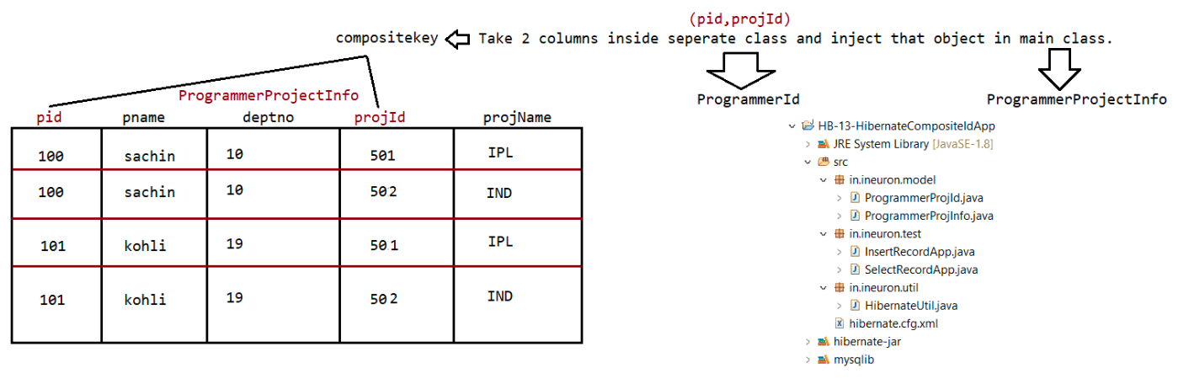

133 timestamping , connection pooling, merge() vs update() ,different types of caching, entity object lifecycle, hibernate crud operation project with connection pooling

Tommo and day after tommo(09/03/2023) => holiday
Extra class :: 11/03/2023(saturday) ==> Timings 7.30pm to 11.00pm
===========================================================================
Object Time Stamping
====================
=> It allows to keep track of Object is saved and Object is lastly updated.
usecase: Keep track of when the back account is opened and lastly updated.
=> We use 2 annotations like
1. @CreationTimeStamp => To hold object/record creation date and time.
2. @UpdateTimeStamp => To hold when the object is lastly modified /updated.
@CreationTimeStamp
LocalDateTime openingDate;
@UpdatetimeStamp
LocalDateTime lastUpdate;
=> In annotation driven environment we can apply both Versioning and TimeStamp
feature.
refer:: HB-16-HibernateTimeStampingApp
Caching in hibernate
====================
=> It is most important feature/benefit of hibernate.
=> It reduces the no of trips b/w application and database, it improves the
performance of the application.
=> Hibernate maintains cache at 2 levels, so it improves the peformance.
=> When an application wants the data from the database, then hibernate looks for
the object at the L1-cache,if not then
it looks for the object at L2-cache and if not then it would go for "database".
Methods associated with cache are
a. session evict(object) b. session.clear() objects from cache.
=> To remove particular object from cache.
=> To clean the cache or to remove all
c. session.contains(object) => To check particular object exists in the cache.
L1Cache(inbuilt cache)
This cache is associated with session object, we can't disable it as it is
inbuilt present in Session object.
refer:: HB-17-HibernateCachingApp
L2Cache(configurable cache)
It is associated with SessionFactory object,so it is called as "GlobalCache".
It is configurable cache which we can enable/disable.
We have multiple providers supporting L2Cache
a. EH_cache(It support inmemory and diskcaching)
b. swarmcache
c. oscache
L2Cache Concurency strategies
=============================
1. read-only : caching will work for read only operation
2. nonstrict-read-write : caching will work for read and write but only at a time.
3. read-write : caching will work for read and write simultaneously.4. transactional : caching will work for transaction.
In Annotation driven environment, keep the annotation at the top most class
level
@Cache(usage = CacheConcurrencyStrategy.READ_ONLY)
hibernate.cfg.xml
----------------
<!-- For each cache -->
<property name="cache.use_second_level_cache">true</property>
<property name="net.sf.ehcache.configurationResourceName">ehcache.xml</property>
<property
name="hibernate.cache.region.factory_class">org.hibernate.cache.ehcache.EhCacheRegi
onFactory</property>
<property name="hibernate.cache.use_query_cache">true</property>
ehcache.xml
----------
<ehcache>
<diskStore path="java.io.tmpdir"/>
<defaultCache
maxElementsInMemory="100"
eternal="false"
timeToIdleSeconds="10"
timeToLiveSeconds="30"
overflowToDisk="true"
/>
</ehcache>
refer:: HB-18-HibernateCaching-L2
Entity Object Life Cycle diagram/3 states of Entity Object
----------------------------------------------------------
1. Transient State
2. Persistent State/Attached State
3. Detached State
Transient state
---------------
Here the object of the Entity not bound or linked with Session object.
Here the object don't have id value and it doesn't hold /represent any Db table
data.
eg: Product p = null;
Product p = new Product();
Persistent State
---------------
Here the object is linked with Session.its placed in L1 cache of Session Object.
Contains id value and it represents the record in the db table having
synchornization.
All persistence operations takes place by bringing Object into this state.
eg: save(),saveOrUpdate(),load(),get(),persist()
Detached State
--------------
Previously persistent ,but not now.
Contains id value, but does not represents the record in the db table and it does
not maintain synchornization also.session.close(),session.clear(),session.evict()
eg: Product p =new Product();//p-> Transient state
session.save(p);//p -> persistent state
transaction.commit()
session.close()//Detached state
What is the difference b/w session.saveOrUpdate() and session.merge()?
saveOrUpdate()
=> First select operation(based on id),if it is succesfull then it
performs update operation
otherwise it would perform insert operation.
merge()
1. Version1=> (same as saveOrUpdate)
=> First select operation(based on id), if it exists, then it performs
update operation
otherwise it would perform insertion operation.
2. Version2 => (upon we performing the loading explicitly,if we want to perform
update operation)
refer:: HB-19-MergeOperationApp
Connection Pooling in Hibernate
-------------------------------
=> SessionFactory object holds jdbc connection pool having set of readymade jdbc
connection objects and uses them in creation
of hibernate objects.
=> By default hibernate app uses hibernate built in jdbc connection pool which is
not suitable for production environment,becoz
of performance issues.
hibernate.cfg.xml
-----------------
<!-- Connection provider to work with hikaricp -->
<property
name="connection.provider_class">org.hibernate.hikaricp.internal.HikariCPConnection
Provider</property>
<!-- HikariCP settings -->
<property name="hikari.connectionTimeout">50000</property>
<property name="hibernate.hikari.minimumIdle">10</property>
<property name="hibernate.hikari.maximumPoolSize">20</property>
<property name="hibernate.hikari.idleTimeout">30000</property>
refer: HB-20-ConnectionPool
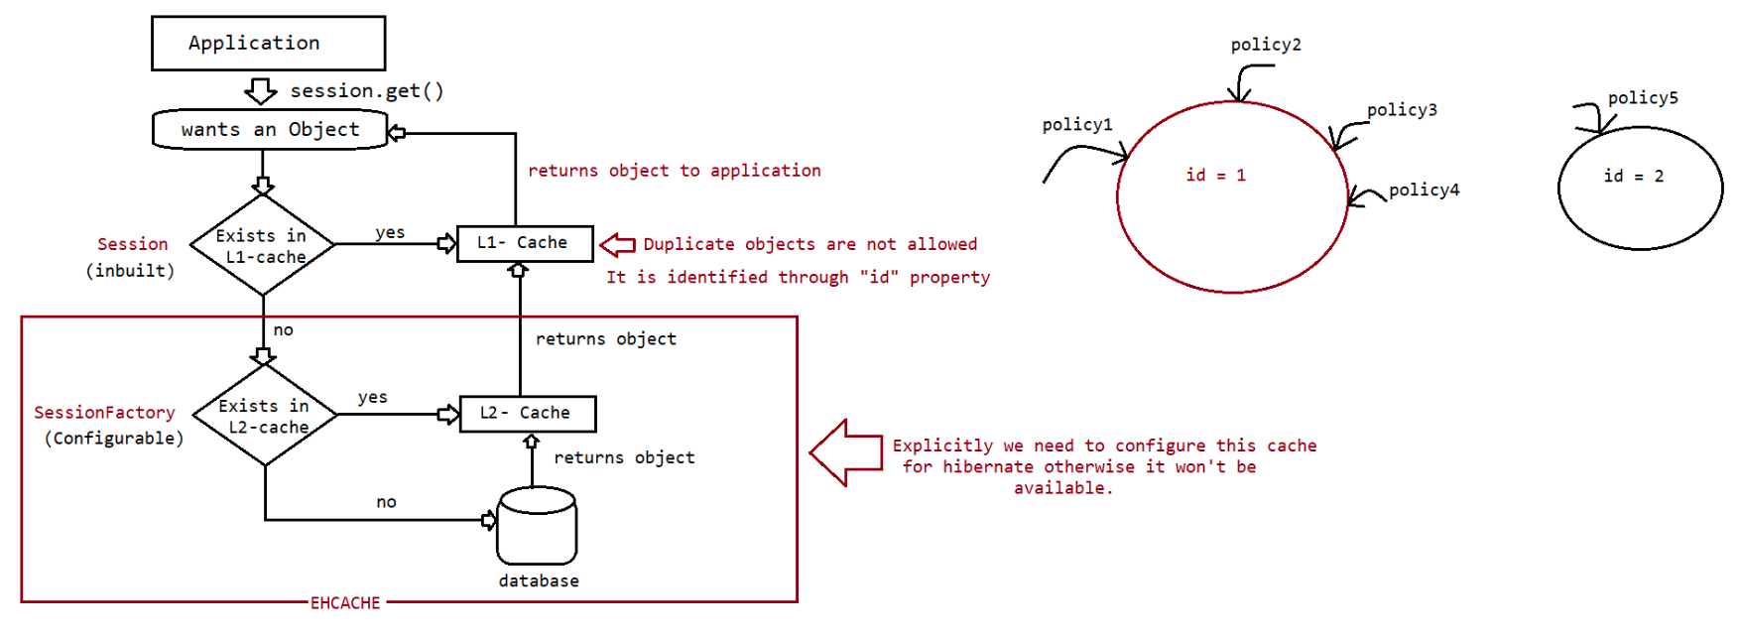
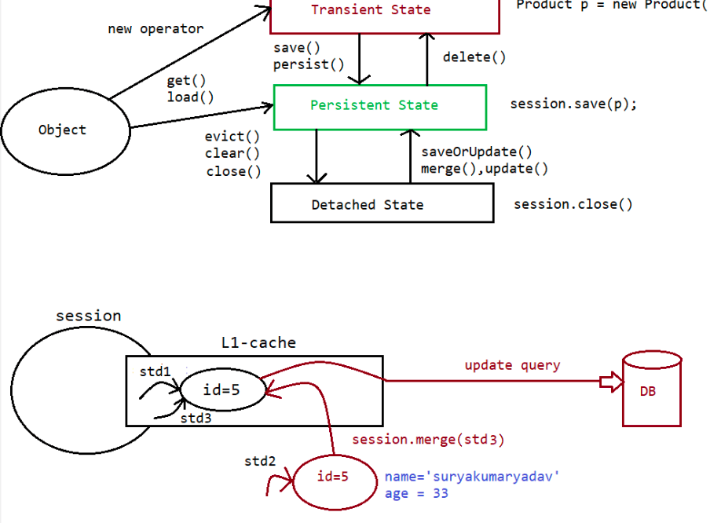

135 Interaction with multiple db,working with Lob operation,locking in hibernate,bulk operation in hibernate

Interaction with more than 1 DBS/w using hibernate
==================================================
UseCase:: copy one bank customer details to another bank(when banks get merged)
transfer money from one account to another account(both accounts
belongs to different bank)
refer: HB-21-InteractionwithMulitpleDB
Working with LOB's
==================
=> Images,audiofile,videofiles are called BinaryLargeObjects(BLOB) because they
internally manage the data as binary information.
=> textfiles,rich text files and etc are called CharacterLargeObjects(CLOB) because
they internally manage the data in the form of
character type of data.
=> BLOB (byte[] + @Lob)
=> CLOB (char[] + @Lob)
Code for reading byte data and character data
---------------------------------------------
byte imageContent[]=null;
char textContent[]=null;
try( FileInputStream fis=new FileInputStream("marriage.jpg")){
//prepare byte[] from image file
imageContent=new byte[fis.available()];
fis.read(imageContent);
//prepare char[] form text file
File file=new File("resume.txt");
try(FileReader reader=new FileReader(file)){
textContent=new char[(int) file.length()];
reader.read(textContent);
}//try2
}//try1
catch(IOException ioe) {
ioe.printStackTrace();
}catch(Exception e) {
e.printStackTrace();
}
}
Code for Writing byte data and character data to a file
-------------------------------------------------------
//create Dest image file having byte[] imageContent
fos=new FileOutputStream("store/photo.jpg");
fos.write(seeker.getPhoto());
//Create a Dest resume.txt file having char[] textContent
writer=new FileWriter("store/resume.txt");
writer.write(seeker.getResume());
fos.flush();
writer.flush();
refer:: HB-22-HibernateLobOperationLocking
-------
If multiple threads/app's simultaneously accessing and manipulating the records
then there is a possibility of getting
concurrency problem.
To avoid this problem, we need to lock the record in hibernate.
Locking can be done in 2 ways
a. optimistic locking
=> Allows second thread/apps simultaneously to access
and modify the record, first app notices the modification
and throws Exception
=> To use this feature we need to enable @Version
annotation in entity class.
b. pesimistic locking
=> First thread/app locks the record,so if the second
thread tries to access and modify the record then it
would result in "Exception".
=> To use this feature we need to use
session.get(,,LockMode.UPGRADE_NOWAIT) as the third argument value.
Optimistic Lock
===============
client1.java
After getting the record, make the thread to sleep for 30seconds
client2.java
Get the same record and make some changes.
refer:: HB-23-HibernateOptimisticLocking
Pesimistic Lock
===============
client1.java
After getting the record(use session.get(,,LockMode.UPGRADE_NOWAIT),
make the thread to sleep for 30seconds
client2.java
Get the same record(use session.get(,,LockMode.UPGRADE_NOWAIT) and make
some changes.
refer:: HB-24-HibernatePesimiticLocking
Bulk operation in hibernate
---------------------------
To select or mainpulate one/more record or object having our choice as criteria
value, we need to go for this bulk operation concept
a. HQL/JPQL
b. Native SQL
c. Criteria API
Note: JPQL=> It is a specification given by SUNMS which speaks about the rules to
develop object based query Language
HQL=> It is an implementation of JPQL by hibernate.
1. HQL [Hibernate Query Language]
=> HQL is a pwerfull query language provided by Hibernate inorder to perform
manipulations over multiple records.=> HQL is an object oriented query language, it able to support for the object
oriented features like
encapsulation,polymorphism,...., but, SQL is structered query language.
=> HQL is database independent query language, but, SQL is database dependent query
language.
=> In case of HQL, we will prepare queries by using POJO class names and their
properties, but, in case of SQL, we will prepare
queries on the basis of database table names and table columns.
=> HQL queries are prepare by using the syntaxes which are similar to SQL queries
syntaxes.
=> HQL is mainly for retrival operations , but, right from Hibernate3.x version we
can use HQL to perform insert , update and
delete operations along with select operations, but, SQL is able to allow any
type of database operation.
=> In case of JDBC, in case of SQL, if we execute select sql query then records are
retrived from database table and these
records are stored in the form of ResultSet object, which is not implementing
java.io.Serializable , so that, it is not possible
to transfer in the network,but, in the case of HQL, if we retrive records then
that records will be stored in Collection objects,
which are Serializable bydefault, so that, we are able to carry these objects in
the network.
=> HQL is database independent query language, but, SQL is database dependent query
language.
=> In case of Hibernate applications, if we process any HQL query then Hibernate
Software will convert that HQL Query into database
dependent SQL Query and Hibernate software will execute that generated SQL
query.
Note: HQL is not suitable where we want to execute Database dependent sql queries
EX: PL/SQL procedures and functions are totally database dependent, where we are
unable to use HQl queries.
Note:
eg: SQL> SELECT * FROM EMP WHERE EMPNO>? AND EMPNO<?
HQL> FROM in.ineuron.model.Employee WHERE eno>? AND eno<?
SQL> DELETE FROM EMP WHERE EMPNO=?
HQL> DELETE FROM in.ineuron.model.Employee WHERE eno=?
SQL>SELECT ENO,ENAME FROM EMPLOYEE
HQL>SELECT eno,ename FROM in.ineuron.model.Employee
SQL>UPDATE EMPLOYEE SET ENAME=?,ESAL=? WHERE ENO=?
HQL>UPDATE in.ineuron.model.Employee SET ename=?,esal=? WHERE eno=?
refer:: HB-25-HQLAPP
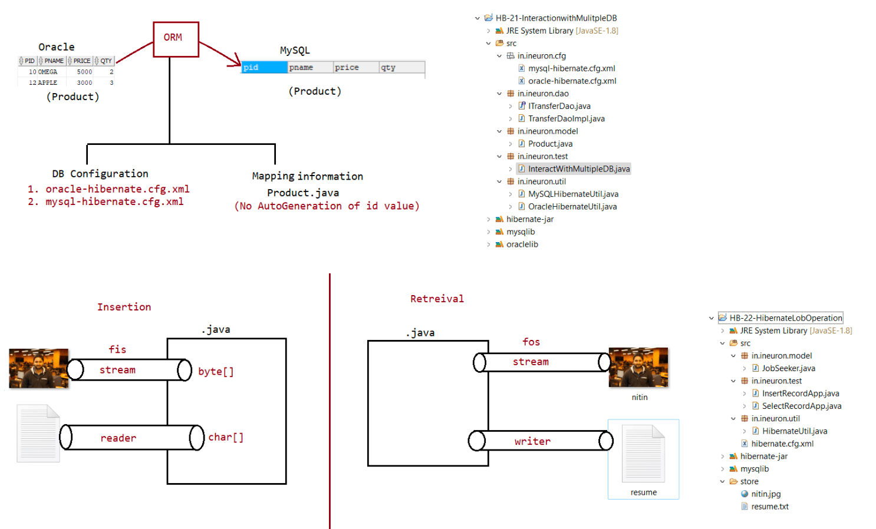
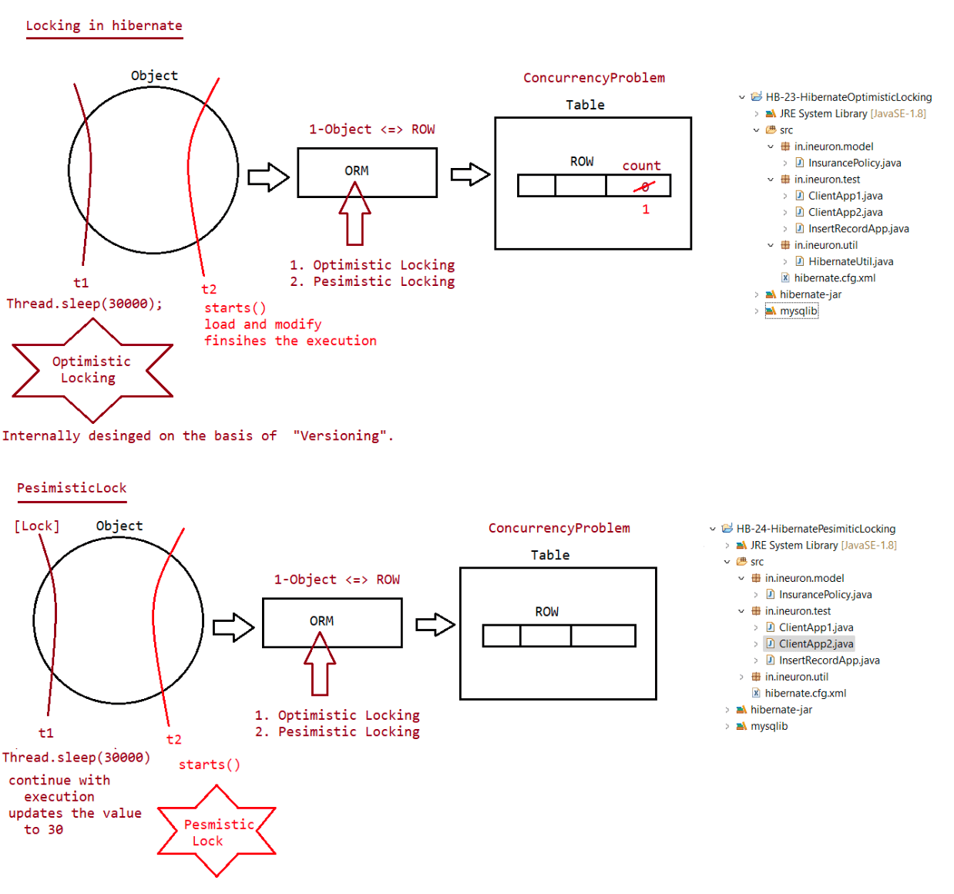
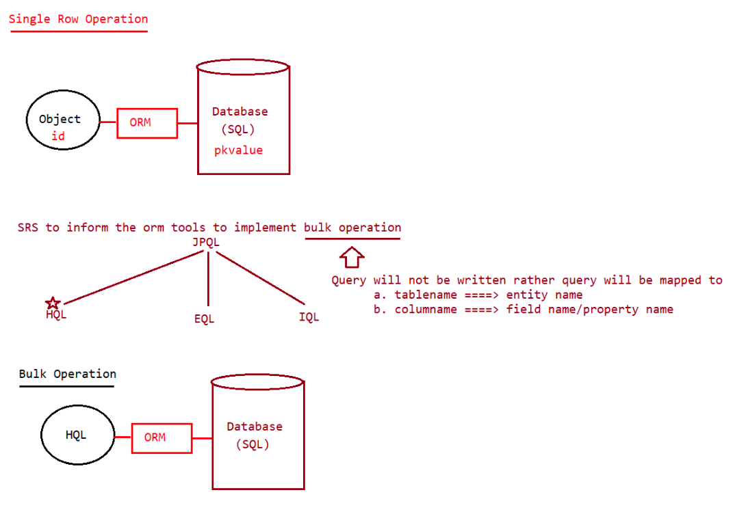
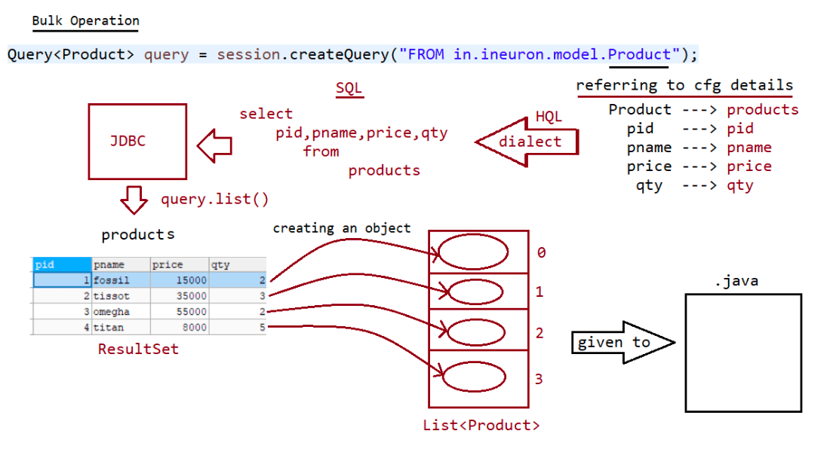

137 Bulk operation in hibernate,Executing HQL non select operation,NamedQuery, Servlet+JSP+Hibernate integration

Bulk operation in hibernate
---------------------------
To select or mainpulate one/more record or object having our choice as criteria
value, we need to go for this bulk operation concept
a. HQL/JPQL
b. Native SQL
c. Criteria API
Note: JPQL=> It is a specification given by SUNMS which speaks about the rules to
develop object based query Language
HQL=> It is an implementation of JPQL by hibernate.
1. HQL [Hibernate Query Language]
=> HQL is a pwerfull query language provided by Hibernate inorder to perform
manipulations over multiple records.
=> HQL is an object oriented query language, it able to support for the object
oriented featureslike encapsulation, polymorphism,.... ,
but, SQL is structered query language.
=> HQL is database independent query language, but, SQL is database dependent query
language.
=> In case of HQL, we will prepare queries by using POJO class names and their
properties, but, in case of SQL , we will prepare queries
on the basis of database table names and table columns.
=> HQL queries are prepare by using the syntaxes which are similar to SQL queries
syntaxes.
=> HQL is mainly for retrival operations , but, right from Hibernate3.x version we
can use HQL to perform insert , update and delete operations
along with select operations, but, SQL is able to allow any type of database
operation.
=> In case of JDBC, in case of SQL, if we execute select sql query then records are
retrived from database table and these records are stored in
the form of ResultSet object, which is not implementing java.io.Serializable ,
so that, it is not possible to transfer in the network,
but, in the case of HQL, if we retrive records then that records will be stored
in Collection objects, which are Serializable bydefault, so
that, we are able to carry these objects in the network.
=> HQL is database independent query language, but, SQL is database dependent query
language.
=> In case of Hibernate applications, if we process any HQL query then Hibernate
Software will convert that HQL Query into database
dependent SQL Query and Hibernate software will execute that generated SQL
query.
Note: HQL is not suitable where we want to execute Database dependent sql queries
EX: PL/SQL procedures and functions are totally database dependent, where we are
unable to use HQl queries.
Note:
eg: SQL> SELECT * FROM EMP WHERE EMPNO>? AND EMPNO<?
HQL> FROM in.ineuron.model.Employee where eno>? and eno<?
SQL> DELETE FROM EMP WHERE EMPNO=?
HQL> DELETE FROM in.ineuron.model.Employee where eno=?
SQL>SELECT ENO,ENAME FROM EMPLOYEE
HQL>SELECT eno,ename from in.ineuron.model.EmployeeSQL>UPDATE EMPLOYEE SET ENAME=?,ESAL=? WHERE ENO=?
HQL>UPDATE in.ineuron.model.Employee SET ename=?,esal=? Where eno=?
HQL SELECT: we can use select queries to fetch data DB tables (Multiple rows).
Final output is given by Hibernate is java.util.List(no.of rows=no.of objects -----
>stored in List Collection only)
FULL LOADING :-select all columns using Query(HQL/SQL) is known as Full loading
(One Full row = One Complete Model class Object).
So final output will be List<T>, T=Type/Model-Class-Name
PARTIAL LOADING : selecting one column (=1 column) or more then one columns (>1
column) is known as Partial loading.
Final outoput is given as:=
1 column : List<DT DT=DataType of varivales/colum
>1 column : List<Object[]>
Selecting all records
---------------------
Session session = sessionFactory.openSession();
Query<Employee> query = session.createQuery("from in.ineuron.Employee");
System.out.println("Using list() method");
System.out.println("-------------------------");
List<Employee> list = query.list();
System.out.println("ENO\tENAME\tESAL\tEADDR");
System.out.println("------------------------------");
for(Employee e: list) {
System.out.print(e.getEno()+"\t");
System.out.print(e.getEname()+"\t");
System.out.print(e.getEsal()+"\t");
System.out.println(e.getEaddr());
}
Selecting only one record
-------------------------
try(Session ses=HibernateUtil.getSf().openSession()){
String hql="select ename from in.ineuron.model.Employee";
Query q=ses.createQuery(hql);
List<String>list=q.list();
for(String s:list){
System.out.println(s);
}
}catch(Exception ex){}
Selecting multiple record
-------------------------
try(Session ses=HibernateUtil.getSf().openSession()) {
String hql="select ename,eaddr from in.ineuron.model.Employee";
Query q=ses.createQuery(hql);
List<Object[]>list=q.list();
for(Object[]ob:list){
System.out.println(ob[0]+","+ob[1]);
}
}catch(Exception ex){}or
list.forEach(row-> {
}
for(Object obj: row)
System.out.print(obj+":");
System.out.println();
)
Named Parameters:- it is used to provide a name in place of ? symbole, to indicate
data comes at runtime.
* This is new concept in Hibernate, not exist in JDBC
* Name should be unique in HQL (duplicates not allowed )
**** We can use variableName as parameter name also.
• Name never gets changed if query is changed.
• To pass data at runtime code is : setParameter(name,data)
• Syntax is : name (colon name)
Usage of Named Parameter
------------------------
try(Session ses=HibernateUtil.getSf().openSession()) {
String hql="from in.ineuron.model.Employee where eid=:id or
ename=:name";
Query q=ses.createQuery(hql);
q.setParameter("id",10);
q.setParameter("name","sachin");
List<Employee>list=q.list();
list.forEach(System.out::println);
}catch(Exception ex){}
In clause:- To work with random rows in DB table use in-clause.
Syntax:
Select ....from ... Where column in (values);
• To handle this in Hibernate
• Used named parameters
• Create values collection
• Call setParameterList method
============code=========
Test class:// cfg,sf,ses
String hql=”from in.ineuron.model.Employee where empId in (:id)”;
Query q=ses.createQuery(hql);
List<Integer> al=Arrays.asList(10,12,14,8);
q.setParameteList(“id”,al);
List<Employee> e=q.list();
e.forEach(System.out::println);
uniqueResult():-
This method is used for select HQL operation.
If query returns one row data then choose this method instead of query.list()
method.
• if will save memory, by avoiding list object for one row data.
Program to demonstrate uniqueResult()-------------------------------------
try(Session ses=HibernateUtil.getSf().openSession()) {
String hql="from in.ineuron.model.Employee where eid=:id";
Query q=ses.createQuery(hql);
q.setParameter("id",10);
Employee employee=(Employee)query.uniqueResult();
if(employee!=null)
System.out.println(employee);
else
System.out.println("Record not found for the given id :: "+id);
}catch(Exception ex){}
Not recomended from JDK8.0,because we have a new API called "Optional(I)".
Optional(C)-> This api is very useful to hold the object, where it would
check the availablity of the object without explicitly performing
NullPointerException.
Program to demonstrate uniqueResultOptional()
---------------------------------------------
try(Session ses=HibernateUtil.getSf().openSession()) {
String hql="from in.ineuron.model.Employee where eid=:id";
Query q=ses.createQuery(hql);
q.setParameter("id",10);
Optional<Employee> opt=(Employee)query.uniqueResultOptional();
if(opt.isPresent())
System.out.println(opt.get());
else
System.out.println("Record not found for the given id :: "+id);
}catch(Exception ex){}
refer:: HB-25-HQLSelectAPP
Executing HQLNon Select Queries
-------------------------------
HQL NON=SELECT OPERATION:- HQL supports non-select operations like
a. Update multiple rows
b. Delete multiple rows
c. Insert operation[Copy rows from one table to another table (backup data)]
• Use method executeUpdate():int return no.of rows effected
• It supports named parameters.
Note: HQL insert query is not given directly, because linking generators with HQL
insert query is not possible.
To link with generators we need to use session.save() method only.
Code for update operation
-------------------------
Transaction tx = null;
try (Session ses = HibernateUtil.getSf().openSession()) {
tx=ses.beginTransaction();
Employee emp=new Employee();
String hql="update in.ineuron.model.Employee set ename=:name,esal=:sal
where eid=:id";
Query q=ses.createQuery(hql);
q.setParameter("name", "sachin");
q.setParameter("sal", 3345);
q.setParameter("id", 10);int count=q.executeUpdate();
tx.commit();
System.out.println(count);
} catch (Exception ex) {
ex.printStackTrace();
}
Code for Delete opearation
--------------------------
Transaction tx = null;
try (Session ses = HibernateUtil.getSf().openSession()) {
tx=ses.beginTransaction();
Employee emp=new Employee();
String hql="delete in.ineuron.model.Employee where eid=:id";
Query q=ses.createQuery(hql);
q.setParameter("id", 10);
int count= q.executeUpdate();
tx.commit();
System.out.println(count);
} catch (Exception ex) {
ex.printStackTrace();
}
refer:: HB-26-HQLNonSelectApp
Code for Insert operation
-------------------------
Query query = session.createQuery("insert into
in.ineuron.model.PremiumInsurancePolicy(policyId,policyName,company,policyType,tenu
re)
select
i.policyId,i.policyName,i.company,i.policyType,i.tenure from InsurancePolicy as i
where
i.tenure>=:min");
Transaction tx = session.beginTransaction();
query.setParameter("min",5);
int rowCount = query.executeUpdate();
tx.commit();
NamedHQL Queries
----------------
=> So far Our HQL Query is specific to one Session Object becoz Query object
created having hard coded HQL Query on session object.
=> To make our HQL query accessible and executable through multiple session objects
of multiple DAO classes or client apps we need to go
for "NamedHQL".
=> we defined HQL query in Entity class using
@NamedQuery(name="HQL_INSERT_QUERY",query="....")
@Entity
@NamedQuery(name="HQL_TRANSFER_POLICIES",query="insert into
in.ineuron.model.PremiumInsurancePolicy(policyId,policyName,company,policyType,tenu
re) select
i.policyId,i.policyName,i.company,i.policyType,i.tenure from InsurancePolicy
as i wherei.tenure>=:min"")
public class PremiumInsurancePolicy implements Serializable
{
private Long pid;
private String policyName;
private String policyType;
private String company;
private Integer tenure;
}
Query query= session.getNamedQuery("HQL_TRANSFER_POLICIES");
query.setParameter("min",10);
int rowCount = query.executeUpdate();
refer:: HB-27-HQLInsertQuery
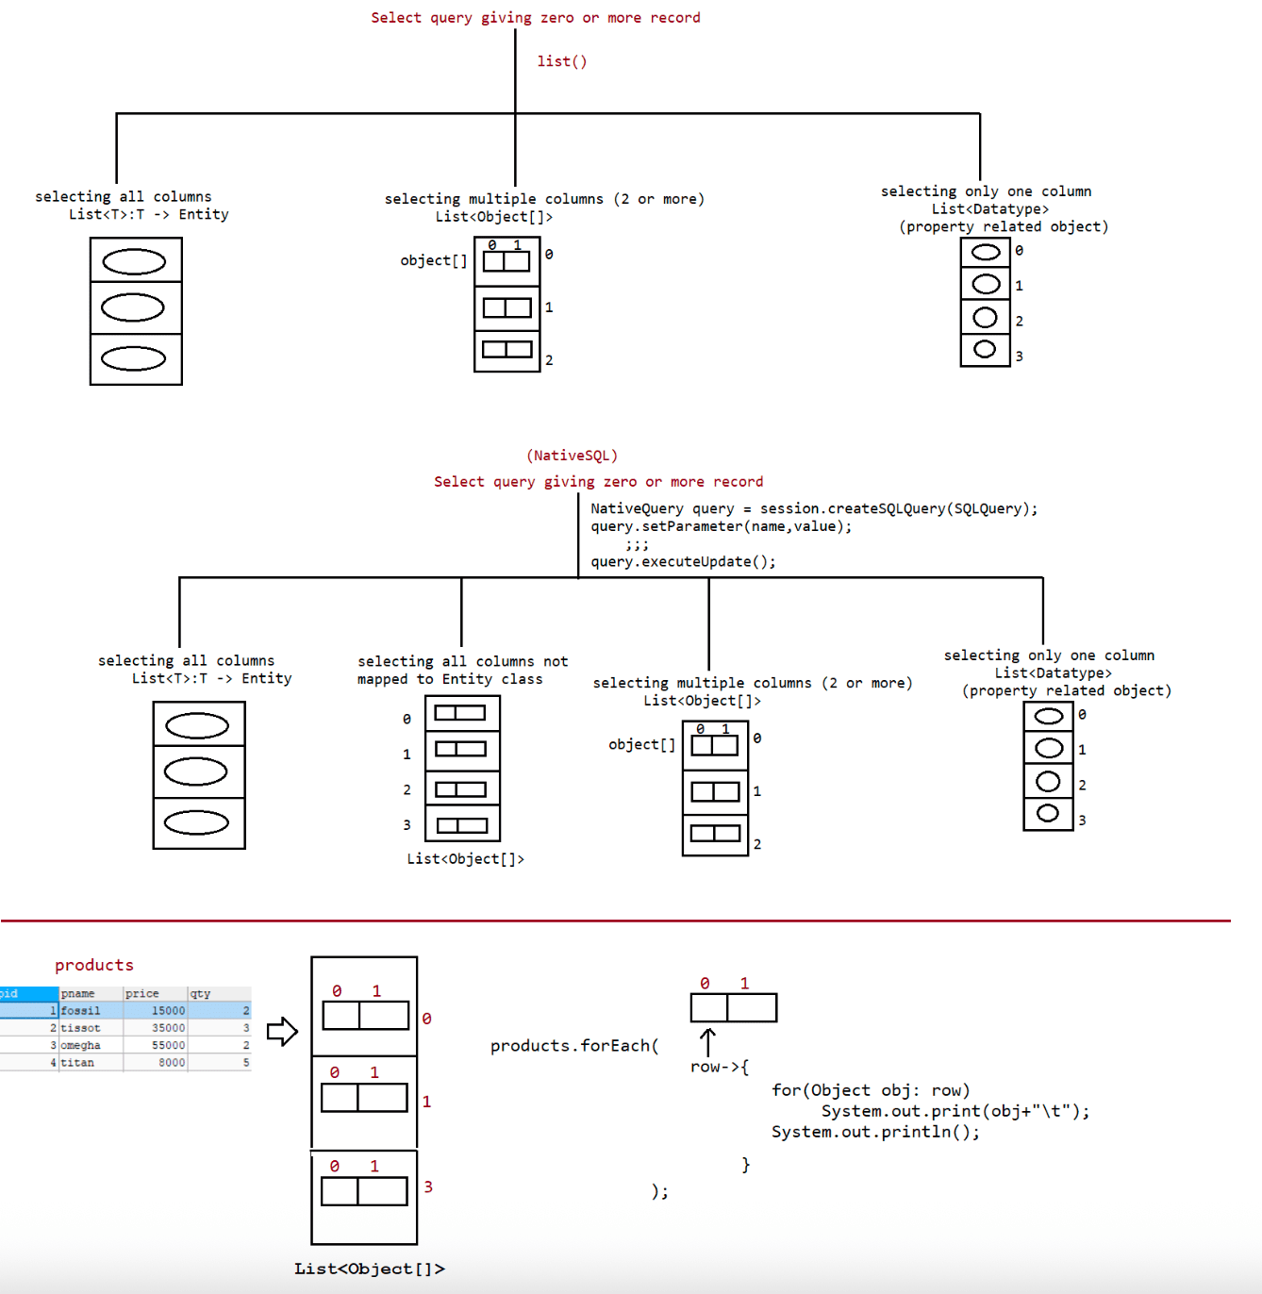

138 NativeSQL , NamedNativeSQL,Executing StoredProcedure , CriterianAPI, Difference b w HQL,NativeSQL , Criterian API,Project of Servlet+Hibernate+JSP+HikariCP connection pooling

Hibernate
Don't write SQL Query(DB specific)
Hibernate
a. SRO(Single Row Operation)
b. Bulk Operation
a. HQL(Hibernate Query Language)=> Write query using Entityname
and properties.
b. By writing NativeSQL query => Write query using Tablename
and column names.
c. Using Criterian API(Pure java code).
NativeSQL
---------
=> This is another bulk operation technique to perform both select and non select
operation.
=> With this native sql, we can execute sql commands on database for bulk
operations.
=> The two reasons to give NativeSQL in hibernate is
a. For programmer convinence
b. To migrate jdbc application as hibernate application easily.
=> The only problem with nativesql is it makes hibernate application "Database
dependent".
=> To run sql command we need to first create SQLQuery object, we can create this
by using createSQLQuery().
=> For select operation we call list()/getResultList() and for non-select operation
we call executeUpdate().
=> These queries performance is good as they go to database directly for execution.
=> These queries will be written specifically by using db tablename and db column
names.
select query without using Entity object
----------------------------------------
NativeQuery<Object[]> query = session
.createSQLQuery("select * from employee where
eid>=:id1 and eid<=:id2");
query.setParameter("id1", 1);
query.setParameter("id2", 7);
List<Object[]> emps = query.list();
emps.forEach(row -> {
for (Object obj : row) {
System.out.print(obj + "\t");
}
System.out.println();
});
select query using Entity object
--------------------------------
NativeQuery<Employee> query = session
eid>=:id1 and eid<=:id2");
query.setParameter("id1", 1);
query.setParameter("id2", 7);
query.addEntity(Employee.class);
List<Employee> emps = query.list();
emps.forEach(System.out::println);
Select particular column from a table
.createSQLQuery("select * from employee where-------------------------------------
NativeQuery<Object[]> query = session
.createSQLQuery("select ename,esalary from
employee where eid>=:id1 and eid<=:id2");
query.setParameter("id1", 1);
query.setParameter("id2", 7);
query.addScalar("ename", StandardBasicTypes.STRING);
query.addScalar("esalary", StandardBasicTypes.INTEGER);
List<Object[]> emps = query.list();
emps.forEach(row -> {
for (Object obj : row) {
System.out.print(obj + "\t");
}
System.out.println();
});
Note: It is a good practise to bind EntityQuery result with Entity class and
Scalary query results with Hibernate data types.
Query<T>(I)
|
| extends
|
NativeQuery<T>(I)
Performing insert query(need transaction object)
------------------------------------------------
NativeQuery query = session.createSQLQuery(
"insert into
employee(`ename`,`eage`,`eaddress`,`esalary`)values(:name,:age,:addr,:sal)");
query.setParameter("name", "nitin");
query.setParameter("age", 30);
query.setParameter("addr", "RCB");
query.setParameter("sal", 1500);
rowCount = query.executeUpdate();
NamedNativeQuery
---------------
@Entity
@NamedNativeQuery(name = "SQL_INSERT_QUERY",
query = "insert into
employee(`ename`,`eage`,`eaddress`,`esalary`)values(:name,:age,:addr,:sal)")
public class Employee implements Serializable {
;;;;;
;;;;;
;;;;;
}
NativeQuery query = session.getNamedNativeQuery("SQL_INSERT_QUERY");
query.setParameter("name", "hyder");
query.setParameter("age", 28);
query.setParameter("addr", "RCB");
query.setParameter("sal", 2000);
rowCount = query.executeUpdate();
Working with StoredProcedure----------------------------
=> To make persistence logic/buisness logic reusable across multiple modules of the
project by keeping logic in db software, then we need to
go for StoredProcedure.
=> The syntax of stored procedure varies from database to database
a. Oracle(PL/SQL)
b. MySQL
When we work with StoredProcedure we use 3 types of params like
a. IN(default mode)
b. OUT
c. INOUT
Getting the complete resultList
===============================
CREATE DEFINER=`root`@`localhost` PROCEDURE `P_GET_PRODUCT_BY_NAME`(IN name1
VARCHAR(20), IN name2 VARCHAR(20))
BEGIN
SELECT pid,pname,price,qty FROM products WHERE pname IN (name1,name2);
END$$
DELIMITER ;
To call a procedure we use
CALL `P_GET_PRODUCT_BY_NAME`("fossil","tissot")
code
----
ProcedureCall procedureCall =
session.createStoredProcedureCall("P_GET_PRODUCT_BY_NAME", Product.class);
String name1 = "fossil";
String name2 = "tissot";
procedureCall.registerParameter(1, String.class,
ParameterMode.IN).bindValue(name1);
procedureCall.registerParameter(2, String.class,
ParameterMode.IN).bindValue(name2);
List<Product> products = procedureCall.getResultList();
products.forEach(System.out::println);
Getting the record on the basis of id
=====================================
CREATE DEFINER=`root`@`localhost` PROCEDURE `P_GET_PRODUCT_DETAILS_BY_ID`(IN id
INT,OUT NAME VARCHAR(20),
OUT rate INT, OUT qnt INT)
BEGIN
SELECT pname,price,qty INTO NAME,rate,qnt FROM products WHERE pid = id;
END$$
DELIMITER ;
To call a procedure we use
CALL `P_GET_PRODUCT_DETAILS_BY_ID`(1,@name,@rate,@qnt)
SELECT @name,@rate,@qnt
Code
----
ProcedureCall procedureCall =session.createStoredProcedureCall("P_GET_PRODUCT_DETAILS_BY_ID");
Integer id = 1;
procedureCall.registerParameter(1, Integer.class, ParameterMode.IN).bindValue(id);
procedureCall.registerParameter(2, String.class, ParameterMode.OUT);
procedureCall.registerParameter(3, Integer.class, ParameterMode.OUT);
procedureCall.registerParameter(4, Integer.class, ParameterMode.OUT);
String pname = (String) procedureCall.getOutputParameterValue(2);
Integer price = (Integer) procedureCall.getOutputParameterValue(3);
Integer qty = (Integer) procedureCall.getOutputParameterValue(4);
System.out.println("PID\tPNAME\tPRICE\tQTY");
System.out.println(id+"\t"+pname+"\t"+price+"\t"+qty);
Criterian api
-------------
It is another technique to perform bulk operations.
Using Criterian api we can perform only select operations.
Even by using HQL we can perform select operation by writing select query.
If we directly write HQL select query, then we need to tune the query for better
performance.
we can read the same data from database by constructing query in multiple ways, but
performance is important.
Performance: reading the data with small amount of time.
In Hibernate applications, to avoid totally query langugaes like SQL and
HQL,....and to provide the complete Persistence logic in the form of JAVA code we
must use "Criterion API".
Criterian api does not supports StoredProcedure.
Criterian api does not supports NamedQuery,NamedNativeQuery.
There are 2 modes of Writing Criterian API
a. HB QBC/Criteria API(specific to hibernate only and we can use to work only
for select operation)
b. JPA QBC/Criteria API(common to all ORM frameworks,we can perform both
select and non-select operation)
1. Create Criteria Object:
Criteria object is a central object in Critera API, it able to manage HQl query
repersentation internally and it has provided predefined methods to
defined query logic.
To create Criteria object we have to use the following method from Session.
public Criteria createCriteria(Class cls);
EX: Criteria c = session.createCriteria(Employee.class);
Note: It is equalent to the HQL query internally "from
Employee".
2. Prepare Criterion objects and add that Criterion objects to Criteria object:
Criterion is an object , it able to manage a single Conditional expression in
database logic.
To create Criterion object we have to use the following methods from
"org.hibernate.Restrictions" class.
public static Criterion isEmpty(String property)
public static Criterion isNotEmpty(String property)
public static Criterion isNull(String property)
public static Criterion isNotNull(String property)public static Criterion in(String property, Object[] obj)
public static Criterion in(String property, Collection c)
public static Criterion between(String property, Object min_Val, Object
max_Val)
public static Criterion between(String property, Object[] obj)
public static Criterion eq(String property, Object val)
public static Criterion ne(String property, Object val)
public static Criterion lt(String property, Object val)
public static Criterion le(String property, Object val)
public static Criterion gt(String property, Object val )
public static Criterion ge(String property, Object val)
-----
-----
To add a particular Criterion object to Criteria object we have to use the
following method.
public void add(Criterion c)
EX:
Criterion c1 = Restrictions.ge("esal", 60000);
Criterion c2 = Restrictions.le("esal", 90000);
c.add(c1);
c.add(c2);
Note: With the above steps, Critera object is able to prepare the query like "from
Employee where esal>=6000 and esal<=9000".
3. Create Projection objects , add Projection objects to ProjectionList and add
ProjectionList to Criteria object:
The main intention of Projection object is to represent a single POJO class
property.
To get Projection object with a particular Property name we have to use the
following method from "Projections" class.
public static Projection projection(String pro_Name)
To create ProjectionList object we have to use the following method from
Projections class.
public static ProjectionList projectionList()
To add Projection object to ProjectionList we have to use the following method from
ProjectionList class.
public void add(Projection p)
To set ProjectionList to Criteria object we have to use the following method.
public void setProjection(ProjectionList pl)
Ex:
ProjectionList pl = Projections.projectionList();
pl.add(Projections.property("eno"));
pl.add(Projections.property("ename"));
pl.add(Projections.property("esal"));
pl.add(Projections.property("eaddr"));
c.setProjection(pl);
EX: With the above , Criteria object is able to prepare HQL query internally like
below.
"select eno, ename, esal, eaddr from Employee where esal
>=6000 and esal<=90000".
4) Provide a particular Order to the query:
To represent a particular Order over the results, we have to use either asc(-) or
desc(-) methods from "Order" class.public static Order asc(String prop_Name)
public static Order desc(String prop_Name)
To add Order object to Criteria object we have to use the following method.
public void addOrder(Order o)
EX:
Order o = Order.desc("ename");
c.addOrder(o);
Note: With this, Criteria object is able to create HQl query like
"select eno, ename, esal, eaddr from Employee where esal >=6000 and
esal<=90000 order by desc(ename)"
Scalar Projection
-----------------
Criteria criteria = session.createCriteria(Employee.class);
Criterion c1 = Restrictions.le("salary", 65000);
Criterion c2 = Restrictions.gt("salary", 6000);
criteria.add(c1);
criteria.add(c2);
ProjectionList projectionList = Projections.projectionList();
projectionList.add(Projections.property("eid"));
projectionList.add(Projections.property("ename"));
projectionList.add(Projections.property("eage"));
criteria.setProjection(projectionList);
Order order = Order.desc("ename");
criteria.addOrder(order);
List<Object[]>emps = criteria.list();
emps.forEach(row->{
for (Object obj : row) {
System.out.print(obj+"\t");
}
System.out.println();
});
Adding multiple condition with or,AND
-------------------------------------
Criteria criteria = session.createCriteria(Employee.class);
Criterion cond1 = Restrictions.between("salary",6000,65000);
Criterion cond2 = Restrictions.in("ename", "sachin","kohli");
Criterion cond3 = Restrictions.ilike("eaddress","R%");
Criterion finalCond = Restrictions.or(Restrictions.and(cond1,cond2),cond3);
criteria.add(finalCond);
List<Employee> list = criteria.list();
list.forEach(System.out::println);
Adding only one column
----------------------
Criteria criteria = session.createCriteria(Employee.class);Criterion c1 = Restrictions.eq("eaddress", "RCB");
criteria.add(c1);
PropertyProjection property = Projections.property("ename");
criteria.setProjection(property);
List<String> emps = criteria.list();
emps.forEach(System.out::println);
HQL/JPQL
--------
1. Persistence logic is DB independent
2. Query will be written using Entity classname and property name.
3. Supports only named params.
4. Supports both select and non-select queries.
5. It is not suitable for calling storedprocedure.
NativeSQL
--------
1. It is dependent
2. Query will be written using DBTablenames and column names.
3. Supports only named params.
4. Supports both select and non-select queries.
5. It is suitable for calling storedprocedure.
CriteriaAPI
----------
1. It is database independent
2. Query will be written using Entity classname and property name.
3. It won't support params
4. Only select operation using HB-QBC
5. It is not suitable for calling storedprocedures.
Remaining topics of hibernate
-----------------------------
Filters,SoftDeletion
Pagination
ORMapping(uni-directional,BiDirectional using joins)
a. OnetoOne
b. OnetoMany
c. ManytoOne
d. ManytoMany

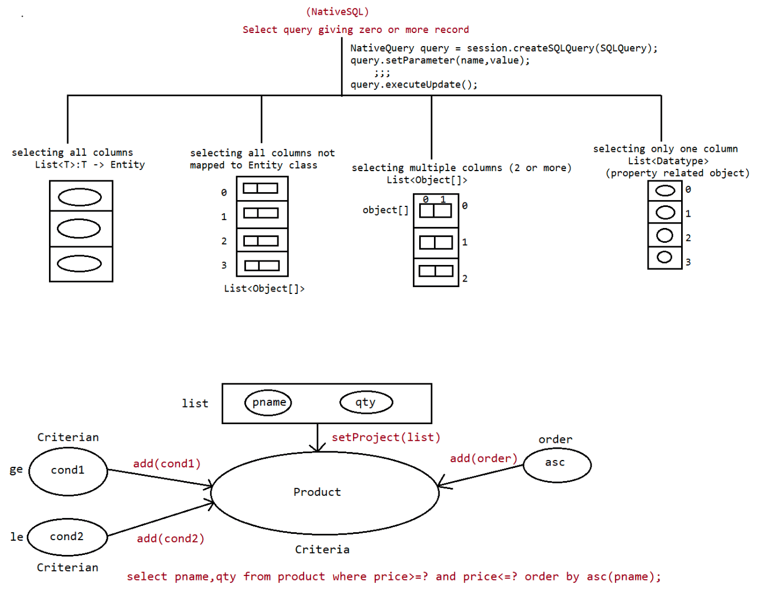

140 Hibernate filters , soft deletion, hibernate pagination

HBFilters
---------
It is a named,parameterized global condition that can be enabled or disabled on
session object.
This concept is very useful to execute SQLQuery without implicit condition.
use cases :The blocked,closed account should not participate in any Query
execution.
note: In real time application, blocked/closed account would not be deleted
from the table rather status would be marked as closed/blocked.
This is called as "SoftDeletion".
BankAccount.java
----------------
@Entity
@Table(name = "bankaccount")
@FilterDef(name = "FILTER_BANKACCOUNT_STATUS", parameters = {
@ParamDef(type = "string", name = "accType1"),
@ParamDef(type = "string", name = "accType2")
}
)
@Filter(name = "FILTER_BANKACCOUNT_STATUS", condition = "STATUS NOT
IN(:accType1,:accType2)")
public class BankAccount implements Serializable {
}
SelectApp.java
--------------
Filter filter = session.enableFilter("FILTER_BANKACCOUNT_STATUS");
filter.setParameter("accType1", "blocked");
filter.setParameter("accType2", "closed");
Query<BankAccount> query = session.createQuery("FROM in.ineuron.entity.BankAccount
WHERE balance>=:amt");
query.setParameter("amt", 2000.0f);
List<BankAccount> resultList = query.getResultList();
resultList.forEach(System.out::println);
System.out.println();
session.disableFilter("FILTER_BANKACCOUNT_STATUS");
Query<BankAccount> query1 = session.createQuery("FROM in.ineuron.entity.BankAccount
WHERE balance>=:amt");
query1.setParameter("amt", 2000.0f);
List<BankAccount> result = query1.getResultList();
result.forEach(System.out::println);
Soft Deletion in hibernate
-------------------------
It is not about deleting the record from the table, it is all about marking the
record from DB table as deleted.
When we close the account in the bank, they would not actually delete the record,
rather the record would be marked as "blocked".
When we perform soft deletion, for a call of session.delete() 'delete query' should
not be executed rather 'update query' should be executedTo do so we need to configure as shown below
a.
@Entity
@Table(name = "bankaccount")
@SQLDelete(sql = "UPDATE bankaccount SET status='closed' WHERE accno=?")
@Where(clause = "STATUS NOT IN ('blocked','closed')")
public class BankAccount implements Serializable {
}
b.
session = HibernateUtil.getSession();
transaction = session.beginTransaction();
BankAccount account = new BankAccount();
account.setAccno(6);
session.delete(account);====> update query will be generated..
c.
Query<BankAccount> query = session.createQuery("From
in.ineuron.entity.BankAccount");
List<BankAccount> accounts = query.getResultList();
accounts.forEach(System.out::println);
Output
======
select
bankaccoun0_.accno as accno1_0_,
bankaccoun0_.balance as balance2_0_,
bankaccoun0_.holderName as holderna3_0_,
bankaccoun0_.status as status4_0_
from
bankaccount bankaccoun0_
where
(
bankaccoun0_.STATUS NOT IN (
'blocked','closed'
)
)
BankAccount [accno=7, holderName=dhoni, balance=44000.0, status=active]
d.
Query query = session.createQuery("UPDATE in.ineuron.model.BankAccount set
status='closed' where accno=:no");
query.setParameter("no", 1234);
rowCount = query.executeUpdate();
In the above case, if we keep delete query,then by referring to entity update query
won't be executed.
so if we use HQL,NativeSQL,QBC logics then we need to explicity write "update sql
query" for soft deletion.
Note: while working with @SQLXXXX annotations/custom queries execution takes place
only for single row operation,
Pagination----------
=> The process of displaying huge no of records page by page is calle pagination.
=> It would avoid loading of all records,load only those records/objects that are
required to display in the current page to
improve the performance.
eg: Gmail inbox,report generation, google search results ......
Using HQL/NativeSQL/QBC we can achieve pagination as shown below
================================================================
Query<InsurancePolicy> query = session.createQuery("from
in.ineuron.model.InsurancePolicy");
//pagination settings
query.setFirstResult(0);
query.setMaxResults(3);
List<InsurancePolicy> insurance = query.list();
insurance.forEach(System.out::println);
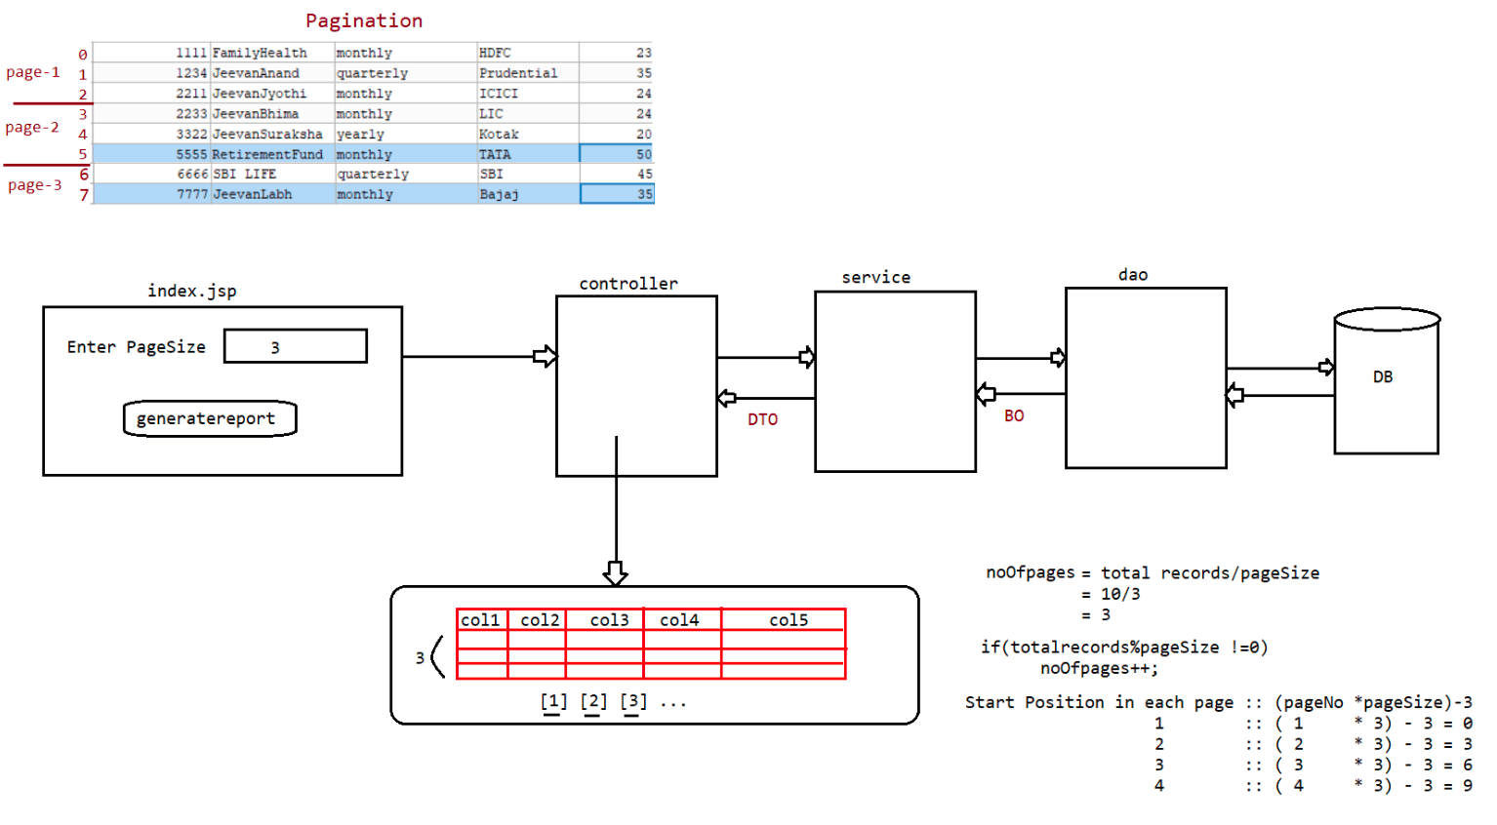

141 Pagination in hibernate ,reverse engineer in hibernate,Advanced OR Mapping

UserInput => pageSize(3)=> No of records to be displayed in each page
parameter => pageNo([1],[2],[3],....)=> Service layer would generate
pageCount(In how many pages the records should be displayed)=>
Service layer would generate
Sequence flow
-------------
scope(session)
Controller =======pageSize=========> Service ====pageSize=======> DAO =========>
Database
|
|
|scope(request)
| pageNo from link
| pagesCount
| listDTO
report.jsp
code for generating hyperlinks
------------------------------
<c:if test="${pageNo>1 }">
<b><a href='./controller?pageNo=${pageNo-1}&s1=link'>previous</a>
&nbsp;&nbsp;</b>
</c:if>
<c:forEach var='i' begin='1' end='${pagesCount}' step="1">
<b><a href='./controller?pageNo=${i}&s1=link'>[${i}]</a> &nbsp;&nbsp;</b>
</c:forEach>
<c:if test="${pageNo<pagesCount }">
<b> <a href='./controller?pageNo=${pageNo+1}&s1=link'>next</a>
&nbsp;&nbsp;</b>
</c:if>
Hibernate ReverseEngineering
----------------------------
Entity class <====== ORM <====== Table already available
To do ReverseEngineering we use Hiberante tools from jbosss.
To install plugin we need to do the following steps
a. Go to help menu
b. Go to eclipse market place
c. In the search box, type as jboss plugin.
d. install jboss tools 4.2.6 plugin
Steps to perform ReverseEnginnering in eclipse
---------------------------------------------
1. Change the perspective from java environment to hibernate
Open perspective, choose hibernate and click on open
2. Select the project
Click on file, new option
a. choose hibernate.cfg.xml file, provide suitable information
b. choose hibernate console configuration and provide suitable
information.c. choose hiberante reverse engineering file to choose the table
for which model should be should generated
3. Now click on run configuration of hibernate
a. choose hibernate configuration and supply details like
1. choose the console configuration name
2. choose the output directory(project name till src
folder)
3. click on check box (Reverse engineer from jdbc
connection)
4. write the package name where the model should be
generated(in.ineuron.model)
5. choose revenge.xml file which is generated in the
previous steps.
6. click on run option.
Advanced ORMapping
------------------
There are multiple mismatches b/w Java and RDBMS like, we can keep entity classes
in composition or inheritance, but we can't keep table names in inheritance or
composition,but we need to map entity classes of composition or inheritance with 1
or more db table by taking the support of "OR" mapping
a. Component mapping[Entity classes are in composition]
b. Inheritance mapping[Entity classes are in inheritance]
c. Collection mapping[Entity classes are having collection with
mapping]
d. Association mapping[Entity classes are in relation like 1---*,*---
1,1----1,*----*]
Component Mapping
-----------------
1. The property that is pointing to single column in db table is called "Simple
property".
2. The property that is pointing to multiple columns of the db table having sub
properties is called "Component property".
3. Component Mapping in java side is represented as "HAS-A" relationship.
eg#1.
package in.ineuron.model;
import javax.persistence.Embedded;
import javax.persistence.Entity;
import javax.persistence.GeneratedValue;
import javax.persistence.GenerationType;
import javax.persistence.Id;
import javax.persistence.Table;
@Entity
@Table(name = "student")
public class StudentInfo {
@Id
@GeneratedValue(strategy = GenerationType.IDENTITY)
private Integer sid;
private String sname;
private Integer sage;@Embedded
private Address address;
//setters,getters,toString
}
Address.java
------------
package in.ineuron.model;
import javax.persistence.Embeddable;
@Embeddable
public class Address {
private String countryName;
private String stateName;
private String cityName;
//setters,getters and toString
}
output
create table student (
sid integer not null auto_increment,
cityName varchar(255),
countryName varchar(255),
stateName varchar(255),
sage integer,
sname varchar(255),
primary key (sid)
) engine=InnoDB
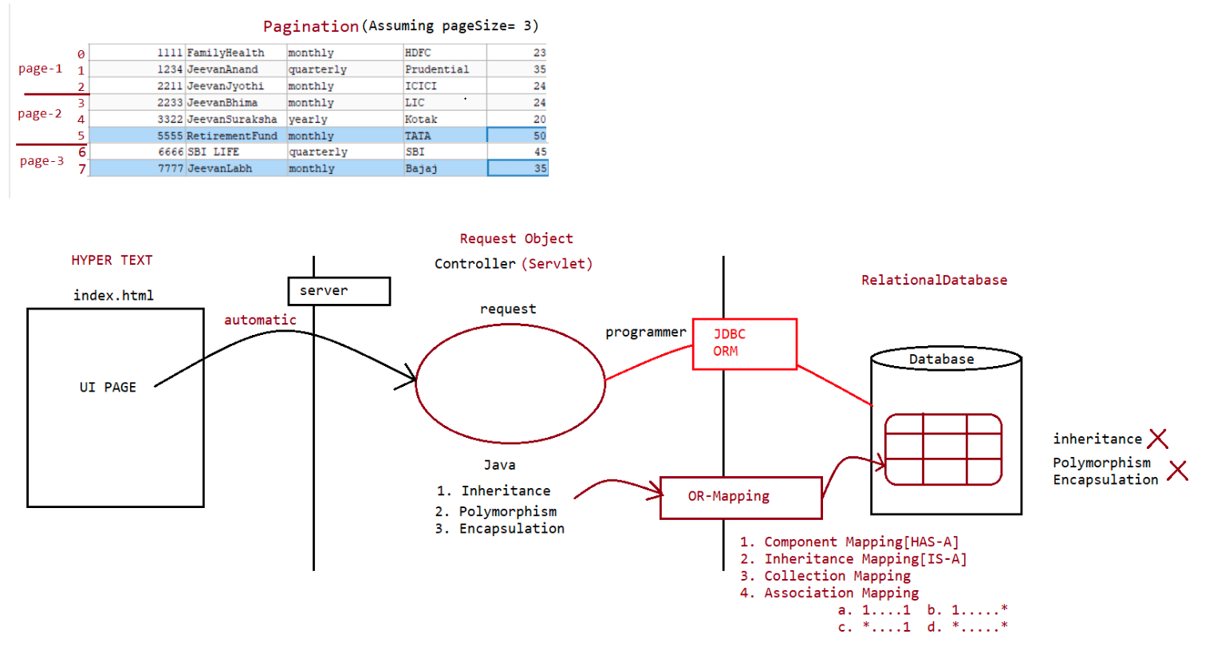

142 Advanced OR Mapping, inheritance mapping, collection mapping, Association Mapping

OR-Mapping
a. Composition Mapping(HAS-A) ======> @Embeded,@Embedable
b. Inheritance Mapping(IS-A)
c. Collection Mapping(List,Set,Map)
d. Association Mapping
a. 1...* b. *.....1
c. 1...1 d. *......*
Inheritance Mapping(IS-A)
=========================
1.@Inheritance(strategy = InheritanceType.SINGLE_TABLE)
2.@Inheritance(strategy = InheritanceType.JOINED)
3.@Inheritance(strategy = InheritanceType.TABLE_PER_CLASS)
4.@DiscriminatorColumn
5.@DisciriminatorValue
6.@PrimaryKeyJoinColumn
Table per Class(single table)
-----------------------------
Inheritance Mapping
-------------------
1. TABLE PER CLASS HIERARCHY:
This design provides single table for all model classes. It will considers all
classes variables as column names and takes one extra column “Discriminator” which
provides information like “Row related to which model class”.
=> Discriminator column can be int type or String/char type.
For IS-A Relation Mapping enum and Annotation are given as:
enum: InheritanceType
Annotation: @Inheritance
For TABLE PER CLASS HIERATCHY DESIGN CODE:
@Inheritance(strategy= InheritanceType.SINGLE_TYPE)
For single table design, we should also provide extra column ‘name,type and value’
using code:
Annotation.: @DiscriminatorColumn
Enum : DiscriminatorType
Code look like:
@DiscriminatorColumn(name=”obType”,discriminatorType= DiscriminatorType.STRING )
For object value code is:
@DiscriminatorValue(“-----------“)
Code
----
@Entity
@Table(name = "commonTab")
@Inheritance(strategy = InheritanceType.SINGLE_TABLE)
@DiscriminatorColumn(name = "objType", discriminatorType =
DiscriminatorType.STRING)
@DiscriminatorValue(value = "STD")
public class Student {
}@Entity
@DiscriminatorValue(value = "ADD")
public class Address extends Student {
}
@Entity
@DiscriminatorValue(value = "CLS")
public class Classes extends Student{
}
TABLE PER SUB CLASS:-
=> In this case hibernate creates table for every child case along with parent
class.
=> On saving data, parent data stored at parent table and child data stored at
child table.
=> Parent table and child table is connected using PK-FK column. FK column also
called as key column.
Code
----
Payment.java
============
@Entity
@DiscriminatorColumn(name = "paymentmode", length = 10)
@Inheritance(strategy = InheritanceType.JOINED)
public abstract class Payment implements Serializable {
@Id
@GeneratedValue
private Integer pid;
}
CardPayment
===========
@Entity
@PrimaryKeyJoinColumn(name = "payment_id",referencedColumnName = "pid")
@DiscriminatorValue("CARD")
public class CardPayment extends Payment {
private Long cardNo;
private String cardType;
private String paymentGatewa
}
ChequePayment
=============
@Entity
@DiscriminatorValue("cheque")
@PrimaryKeyJoinColumn(name = "payment_id",referencedColumnName = "pid")
public class ChequePayment extends Payment {
private Integer chequeNo;
private String chequeType;
private LocalDate expiryDate;
}
TestApp.java
============CardPayment payment = new CardPayment();
payment.setAmt(45000.0f);
payment.setCardNo(24567L);
payment.setCardType("credit");
payment.setPaymentGateway("VISA");
ChequePayment payment2 = new ChequePayment();
payment2.setAmt(9000f);
payment2.setChequeNo(15744);
payment2.setChequeType("self");
payment2.setExpiryDate(LocalDate.of(2021, 10, 21));
session.save(payment);
session.save(payment2);
TABLE PER CONCRETE CLASS
This design creates independent tables for every class in IS-A relation including
parent class variable.
@Entity
@Inheritance(strategy = InheritanceType.TABLE_PER_CLASS)
public abstract class Payment implements Serializable {
private static final long serialVersionUID = 1L;
@Id
@GeneratedValue
private Integer pid;
private float amt;
}
@Entity
public class ChequePayment extends Payment {
private static final long serialVersionUID = 1L;
private Integer chequeNo;
private String chequeType;
private LocalDate expiryDate;
}
@Entity
public class CardPayment extends Payment {
private static final long serialVersionUID = 1L;
private Long cardNo;
private String cardType;
private String paymentGateway;
}
TestApp.java
============
CardPayment payment = new CardPayment();
payment.setAmt(45000.0f);
payment.setCardNo(24567L);
payment.setCardType("credit");
payment.setPaymentGateway("VISA");ChequePayment payment2 = new ChequePayment();
payment2.setAmt(9000f);
payment2.setChequeNo(15744);
payment2.setChequeType("self");
payment2.setExpiryDate(LocalDate.of(2021, 10, 21));
session.save(payment);
session.save(payment2);
Output
create table CardPayment (
pid integer not null,
amt float not null,
cardNo bigint,
cardType varchar(255),
paymentGateway varchar(255),
primary key (pid)
) engine=InnoDB
create table ChequePayment (
pid integer not null,
amt float not null,
chequeNo integer,
chequeType varchar(255),
expiryDate date,
primary key (pid)
) engine=InnoDB
Note:since the Payment class is abstract and we are not doing any operation,db
table won't be created for Payment class.
since new table is created for every class,we don't need any discriminator
value.
Collection Mapping in Hibernate:
=> It is all about taking collection type properties with Strings/Wrappers in
Entity class.
=> For every collection property one seperate child table will be created having FK
pointing PK Col of Entity class db table(parent table).
=> The child table for Collection property(List/Set/Map) will have min 2
columns(Set) and max 3 columns(List/Map).
=> Set Collection child table contains
a. element column b. foreign key column(no index column)
=> List/Map collection child table contains
a. element column b. foreign key column c. index column.
Note: Collection are of two types
a. Indexed Collection => List/Map
b. Non-Indexed Collection => Set
On every collection property we must add
a. @ElementCollection=> Specifying element column name.
b. @CollectionTable => Specify child table name and FK column name.
c. @OrderColumn => To specify the list index column name.
d. @MapKeyColumn => To specify the map index column name.

